|  |  |  |  |  |  |
| --- | --- | --- | --- | --- | --- |
| **Confidentiality Level** | | *PU - Publish* | **TC ID / Revision** | 00278847/C | |
| **Document Status** | | *Document Released* | **Document No.** | N/A | |
| **WBS code** | | 5.1.0.0 | | | |
| **PBS code** | | E.E5.LUX.PBT.2.1 | | | |
| **Project branch** | | *Engineering & Scientific documents (E&S)* | | | |
| **Document Type** | | *Requirements Specification Document (RSD)* | | | |
| ***[RSD product category B]***  ***Positioning System for LUIS EUV Beam Transport***  ***TP20\_018***    Keywords  LUX; Beam Transport; Positioning System | | | | | |
|  | **Position** | | | | **Name** |
| **Responsible person** | Senior Researcher\_RP2 | | | | Dong Du Mai |
| **Prepared by** | Senior Researcher\_RP2 | | | | Dong Du Mai |

|  |  |  |  |
| --- | --- | --- | --- |
| RSS TC ID/revision | Date of Creation | Date of Last Modification | Systems Engineer |
| 021890/A.001 | 23.9.2020 | 23.9.2020 | Amélie Grudinová |
| 021890/A.002 | 29.9.2020 | 29.9.2020 | Amélie Grudinová |

|  |  |  |  |
| --- | --- | --- | --- |
| ****Reviewed By**** | | | |
| Name (Reviewer) | Position | Date | Signature |
| Alexander Molodozhentsev | LUX Team Leader | [*Informed via mail and TC*](http://tc-web:3000/#/com.siemens.splm.clientfx.tcui.xrt.showObject?page=Reviewers&pageId=tc_xrt_Reviewers&uid=k4HAghVE44rC6D) | |
| Adam Wolf | Head of Engineering Support Group | [*Informed via mail and TC*](http://tc-web:3000/#/com.siemens.splm.clientfx.tcui.xrt.showObject?page=Reviewers&pageId=tc_xrt_Reviewers&uid=k4HAghVE44rC6D) | |
| Martin Laub | Chief Engineer | [*Informed via mail and TC*](http://tc-web:3000/#/com.siemens.splm.clientfx.tcui.xrt.showObject?page=Reviewers&pageId=tc_xrt_Reviewers&uid=k4HAghVE44rC6D) | |
| Lucie Kaletusová | Clean Rooms Specialist | [*Informed via mail and TC*](http://tc-web:3000/#/com.siemens.splm.clientfx.tcui.xrt.showObject?page=Reviewers&pageId=tc_xrt_Reviewers&uid=k4HAghVE44rC6D) | |
| Viktor Fedosov | Head of Quality and Risk Management | [*Informed via mail and TC*](http://tc-web:3000/#/com.siemens.splm.clientfx.tcui.xrt.showObject?page=Reviewers&pageId=tc_xrt_Reviewers&uid=k4HAghVE44rC6D) | |
| Veronika Olšovcová | Safety Team Manager | [*Informed via mail and TC*](http://tc-web:3000/#/com.siemens.splm.clientfx.tcui.xrt.showObject?page=Reviewers&pageId=tc_xrt_Reviewers&uid=k4HAghVE44rC6D) | |
| Lukáš Brabec | Team Leader of Vacuum and Cryogenics | [*Informed via mail and TC*](http://tc-web:3000/#/com.siemens.splm.clientfx.tcui.xrt.showObject?page=Reviewers&pageId=tc_xrt_Reviewers&uid=k4HAghVE44rC6D) | |
| Ladislav Půst | Manager Installation of Technology | [*Informed via mail and TC*](http://tc-web:3000/#/com.siemens.splm.clientfx.tcui.xrt.showObject?page=Reviewers&pageId=tc_xrt_Reviewers&uid=k4HAghVE44rC6D) | |
| Jiří Kubricht | Lawyer | [*Informed via mail and TC*](http://tc-web:3000/#/com.siemens.splm.clientfx.tcui.xrt.showObject?page=Reviewers&pageId=tc_xrt_Reviewers&uid=k4HAghVE44rC6D) | |

|  |  |  |  |
| --- | --- | --- | --- |
| ****Approved by**** | | | |
| Name (Approver) | Position | Date | Signature |
| Alexander Molodozhnetsev | X RAY Team Leader | *[2020-09-29 Approved via TC](http://tc-web:3000/" \l "/com.siemens.splm.clientfx.tcui.xrt.showObject?page=Reviewers&pageId=tc_xrt_Reviewers&uid=0XJAghHr44rC6D)* | |

|  |  |  |  |  |
| --- | --- | --- | --- | --- |
| ****Revision History / Change Log**** | | | | |
| Change No. | Made by | Date | Change description, Pages, Chapters | TC rev. |
| 1 | Mai Dong-Du | 21.9.2020 | Draft | A |
| 2 | Amélie Grudinová | 23.9.2020 | Version for review | B |
| 3 | Amélie Grudinová | 29.9.2020 | Final version | C |

Table of Content

[1. Introduction 4](#_Toc52281539)

[1.1. Purpose 4](#_Toc52281540)

[1.2. Scope 4](#_Toc52281541)

[1.3. Terms, Definitions and Abbreviations 4](#_Toc52281542)

[1.4. Definition of Translational and Rotational axes 5](#_Toc52281543)

[1.5. References to Standards 5](#_Toc52281544)

[2. Functional, Performance and Design Requirements 5](#_Toc52281545)

[2.1. General EUV-PoS Requirements 5](#_Toc52281546)

[2.2. EUV-PoS Configuration and Design Requirements 7](#_Toc52281547)

[2.3. Environmental Requirements 9](#_Toc52281548)

[3. Delivery Requirements 9](#_Toc52281549)

[4. Safety Requirements 9](#_Toc52281550)

[5. Quality control 10](#_Toc52281551)

[5.1. Quality Reports (QRs) 10](#_Toc52281552)

[5.2. Documentation and Data Control 10](#_Toc52281553)

[5.3. Nonconformity Control System 11](#_Toc52281554)

[5.4. Acceptance 11](#_Toc52281555)

# Introduction

## Purpose

This Requirements Specification Document (RSD) lists the technical requirements and constraints of product applying in RA2 & RA3 of ELI project. This can lead to the identification of product interfaces with the ELI science based technology and ELI building facility. This RSD also acts as the parent document for the technical requirements that need to be addressed in lower level design description documents.

## Scope

This RSD contains all of the technical requirements: functional, performance, operational & design, transportation & installation, safety & quality requirements for the product **Positioning System for Photon Beam Transport** (further **“EUV-PoS”**), tender number **TP20\_018**.

The product is an integral part of the standalone **LUIS Beamline** and will be installed in the E5 Experimental Hall. This product is registered in the PBS software under the following PBS code: **E.E5.LUX.PBT.2.1**.

**This product is a product Category B**

Category B is an Off-the-shelf Product with customization (e.g., product performance) that does not require any design modifications of the product. If there is no need in conducting specific tests regarding the product’s performances the Supplier shall verify all requirements defined by appropriate RSD within own outgoing inspection and testing procedure. All non-conformances (if any) must be addressed by the Supplier in a timely manner.

## Terms, Definitions and Abbreviations

For the purpose of this document, the following abbreviated terms are applied:

| **Abbreviation** | **Meaning** |
| --- | --- |
| CA | Contracting Authority (Institute of Physics AV CR, v. v. i.) |
| E5 | Experimental hall 5 |
| ELI | Extreme Light Infrastructure |
| EUV | Extreme Ultraviolet |
| NCR | Nonconformity Report |
| PBS | Product Breakdown Structure (code of ELI-Beamlines) |
| QR | Quality Report |
| RH | Relative Humidity |
| RMS | Root Mean Square |
| RSD | Requirements Specification Document |

## Definition of Translational and Rotational axes

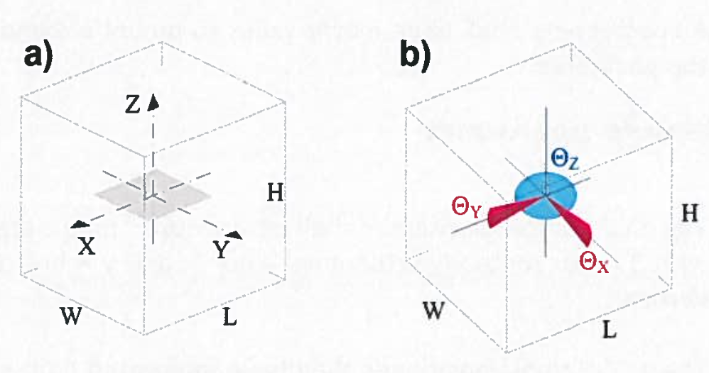

Figure : Schematic drawing for definition of (a) translation and (b) rotation axis.

## References to Standards

If this document includes references to standards or standardized/ standardizing technical documents the CA allows/permits also another equal solution to be offered.

# Functional, Performance and Design Requirements

The **EUV-PoS** is the central part of the EUV photon beam transport as a part of the LUIS experimental setup.

## General EUV-PoS Requirements

REQ-030947/A

The **EUV-PoS** shall consist of following components:

* Linear positioner (rail) with the ability to handle several carriages (independently operated/controlled)  
  Travel range: ≤400 mm   
  The total length of the rail will be determined during the design phase by the CA.
* Carrier platforms (carriage)
* Hexapod or comparable construction to enable multi-degree-of-freedom operation. The degrees-of-freedom shall include:
  + rotation along x/y/z-axis
  + x/y/z (linear)
  + customizable pivot-point
* Iris diaphragm
* Rotary stages
* Feedthrough flanges for connectors combined in following groups (if feasible):
  + 1x feedthrough flange for all linear positioners (rails)
  + 2x feedthrough flange for hexapods or comparable constructions
  + 3x feedthrough flange for irises (each)
  + 3x feedthrough flange for rotary stages (each)  
    Amount: 2 or more (if necessary)  
    Acceptable flange types: DN 100 ISO-F, DN 100 ISO-K, DN 40 ISO-KF  
    Acceptable connector types: D-Sub 9, D-Sub 15, or LEMO 16
* Motion control units
* Control software

*Note:   
All positioning systems shall be vacuum-compatible. Required level of vacuum compatibility for the* ***EUV-PoS*** *is defined bellow in REQ-030958/A.*

REQ-030948/A

Cables (with connectors) between the positioners and the vacuum feedthroughs shall have length at least 1000 mm.

REQ-030949/A

Cables shall have the same vacuum compatibility as positioners.

*Note: See REQ-030958/A.*

REQ-030950/A

All positioners shall have metric holes to mount a sample/device on the positioner.

REQ-030951/A

The motion control units shall be delivered with EU compatible power supplies.

REQ-030952/A

The motion control units shall be delivered with cables between vacuum feedthroughs and the control units.

## EUV-PoS Configuration and Design Requirements

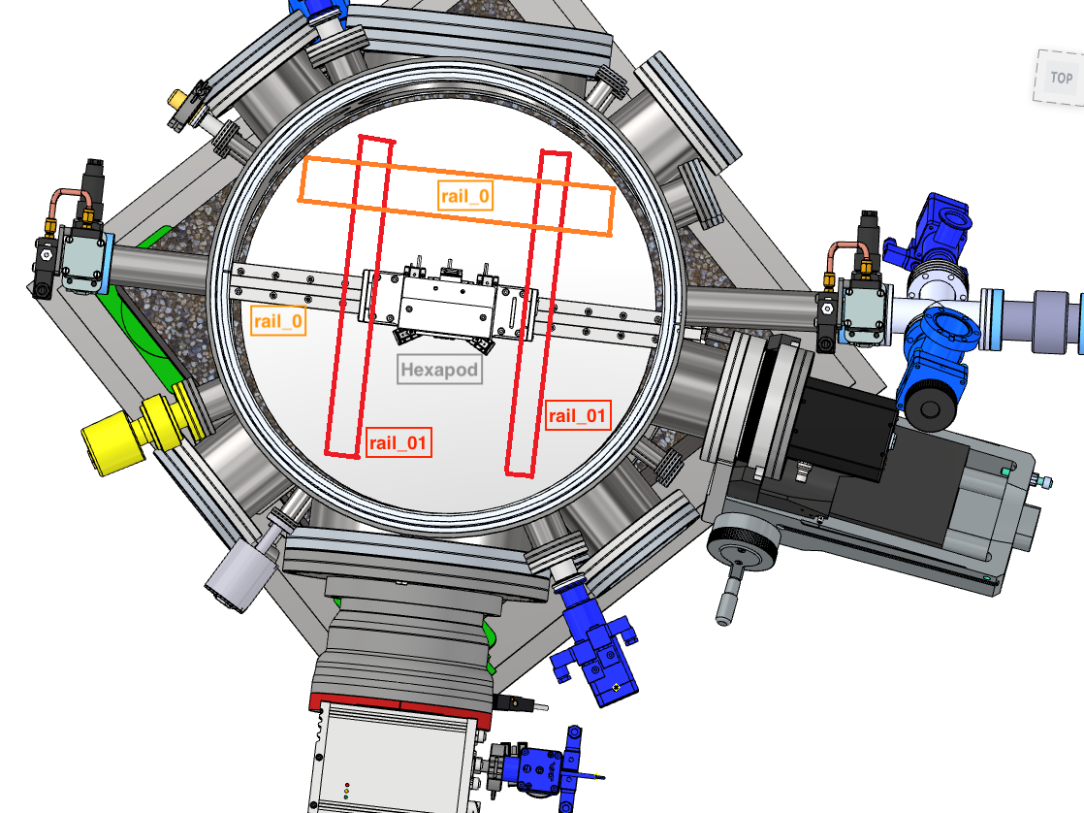

Figure : Design outline of the EUV-PoS. Please note, that linear positioners (rails) and one Hexapod are depicted in the sketch. Beam direction is from left to right.

The **EUV-PoS** configuration as described below is a functional design owned by ELI Beamlines.

REQ-030953/A

All Hexapods shall be mounted on one linear positioner (further **“rail\_0”**). This implicates, that

* at least two carrier platforms (carriages) are needed for the Hexapods
* the carrier platforms (carriages) should be operated independently from each other
* Travel axis of **rail\_0**: Y.

REQ-030954/A

Rail\_0 shall be installed perpendicular on a rail system (further **“rail\_1”**) to enhance the needed number of degrees-of-freedom of the **EUV-PoS**.

Travel axis of **rail\_1**: X.

REQ-030955/A

The design of **rail\_1** shall provide a stable and precise movement of **rail\_0.**

* Over-all travel range of any rails in each direction: up to 450 mm
* Carrier platform (carriage) precision shall not be affected by any potential leverage effect

REQ-030956/A

Components shall fulfill minimal requirements stated in following specifications.

Hexapod specifications:

* Travel range x/y-axis [mm]: >45
* Travel range z-axis [mm]: >12
* Tilt range x: >40°
* Tilt range y: >30°
* Tilt range z: >40°
* Encoder: closed-loop
* Closed-loop repeatability [nm]: ±15 (for 1 mm travel)
* Closed-loop repeatability [µrad]: ±10

Linear positioner (rail):

* Travel range x/z-axis [mm]: up to 450
* Encoder: closed-loop
* Closed-loop repeatability [nm]: ±200

Rotary positioner (single unit):

* Aperture [mm]: 82
* Material: Aluminum
* Encoder: closed-loop
* Closed-loop resolution [µ°]: 5
* Blocking torque [Ncm]: >15
* Normal force [N]: 20
* Quantity: 3

Iris Diaphragm (single unit):

* Aperture [mm]: 0…22
* Material: Titanium base
* Encoder: closed-loop
* Closed-loop repeatability [µm]: 20 (unidirectional)
* Quantity: 3

REQ-030957/A

The load capacity of the Hexapods shall be sufficient to handle 700g samples.

## Environmental Requirements

REQ-030958/A

Vacuum compatibility shall be 10-6 mbar or better.

REQ-030959/A

The **EUV-PoS** shall be designed for operation in vacuum and at atmospheric pressure with relative humidity level within an interval from 30 % to 50 %.

REQ-030960/A

The **EUV-PoS** shall be designed for operation at a temperature range from 20 °C to 40 °C.

REQ-030961/A

The Supplier and the CA shall agree on the cleaning method to clean the **EUV-PoS** without decreasing the positioner’s functionality and to avoid contamination of clean space.

*NOTE: The cleaning methods may use high gas flow (dry and clean air or N2) and specialized chemical cleaning liquids (alcohol, Isopropyl alcohol, demineralized water).*

# Delivery Requirements

REQ-030962A

The transportation to the final destination (ELI Beamlines) of the **EUV-PoS** shall be conducted by the Supplier.

REQ-030963/A

The **EUV-PoS** shall be delivered in a protective package, preferably a Polyethylene Terephthalate Glycol (PETG) container, preventing damage and contamination and a minimum of two plies separate clean films. Prior to delivery, the EUV-PoS shall be cleaned so that all its components fulfil the requirements of the cleanrooms of class 7 according to ČSN EN ISO 14644 (or equivalent, e.g. EN ISO 14644).

# Safety Requirements

REQ-030964/A

The Supplier shall supply a Declaration of Conformity or any other equivalent document legally recognized and accepted in the Czech Republic for each product type if the appropriate legislation determines the Supplier's obligation to have a Declaration of Conformity (or the equivalent document) for the purposes of a Device sale in the Czech Republic to fulfil the requirements of 2001/95/EC directive or applicable Czech law.

# Quality control

## Quality Reports (QRs)

REQ-030965/A

The Supplier shall perform a factory verification of the **EUV-PoS** and provide corresponding **specific quality reports (I, II)** proving that the requirements have been met:

1. **Functionality report (including accuracy and precision)**
2. **Dimensional report** providing information about a measured physical dimension of the manufactured product.

*NOTE 1: The results of the factory verification of the* ***EUV-PoS*** *shall be provided to the CA in the corresponding specific QRs before delivery.*

*NOTE 2: The results shall be in print as well as in digital format.*

## Documentation and Data Control

REQ-030966/A

The Supplier shall provide the Product Manual as part of the delivered Device. Completeness of the Manual shall be approved by the CA. The Manual shall include the instructions and descriptions regarding the following procedures:

* transport;
* handling and cleaning (see REQ-030961/A);
* storage;
* installation and;
* safe operation and maintenance procedures.

REQ-030967/A

The Supplier shall provide information of outgoing check control of the Product. At least this information shall comprise declaration about execution of outgoing check and declaration of conformity with technical requirements defined by the product RSD and completeness of the Product.

*NOTE: Alternatively the Supplier might provide the CA the information detailed enough to prove meeting all requirements stipulated herein (e.g.: catalogue/technical data sheets, product manuals or other similar documentation).*

## Nonconformity Control System

REQ-030968/A

The Supplier shall establish and maintain a nonconformity control system compatible with ČSN EN ISO 9001 (or equivalent, e.g. EN ISO 9001).

## Acceptance

Acceptance will be carried out by the CA upon delivery of the final product not obviously damaged during transport. The basis for acceptance will be completed VCD summarizing the overall verification results together with relevant documentation supporting the verification (i.e. QRs, approved manufacturing drawings, Product User Manual and etc.).

In case of successful acceptance phase, the CA will provide to the Supplier signed acceptance protocol. In case of unsuccessful acceptance stage the CA will provide to the Supplier Nonconformity Report (NCR) and process in accordance with REQ-030968/A shall be applied.

REQ-030969/A

The Acceptance phase shall demonstrate the following:

* The final product has been successfully verified by the Supplier and the results of this process have been documented in an appropriate way through QRs (see chapter 5.1);
* All detected nonconformities have been solved in accordance with REQ-030968/A;
* The final product is free of fabrication errors and is ready for the intended operational use.