po 23.08.2021 17:26
czorders@thermofisher.com
Dobry den,
Dekujeme Vam za Vasi objednavku. Chtela bych Vas poprosit o prekontrolovani poctu objednanych produktu a potvrzeni konecne ceny objednavky:
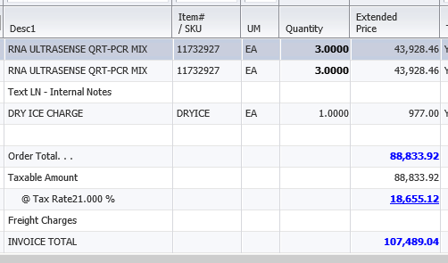
Objednavku jsem uz zadala do naseho systemu, jakmile od Vas obdrzime potvrzeni, muzeme ji hned aktivovat.
Dekuji Vam a preji pekny den,

xxxxxxxxxxxxxxxx
Customer Care – Zákaznické Centrum

Thermo Fisher Scientific
Life Technologies Czech Republic s.r.o.
V Celnici 1031/4
11000 Praha, Czech Republic
Tel: (+420Fax: (+420) 227-204-750

czorders@thermofisher.com
www.lifetechnologies.com

Sent 23/08/2021 16:21| Subject: Formulář objednávky vydané VÚVeL; From: xxxxxxxxxxxxxxxx To: (newaccounts@invitrogen.com; czorders@lifetech.com; ); Cc: ();
CAUTION: This email originated from outside of Thermo Fisher Scientific. If you believe it to be suspicious, report using the Report Phish button in Outlook or send to SOC@thermofisher.com.

