Confidentiality Level |  | BL - Restricted for internal use | TC ID / Revision |  | 00303032/C
Document Status |  | Document Released | Document No. |  | N/A
OBS code |  | 914 L4 ATON Laser
PBS code |  | RA1.L4.CMP1.10PW.OM
Project branch |  | Engineering & Scientific documents (E&S)
Document Type |  | Specification (SP)
[RSD product category A]

Compact high-accuracy and high-rigidity piezo positioners with position encoders
TP21_041
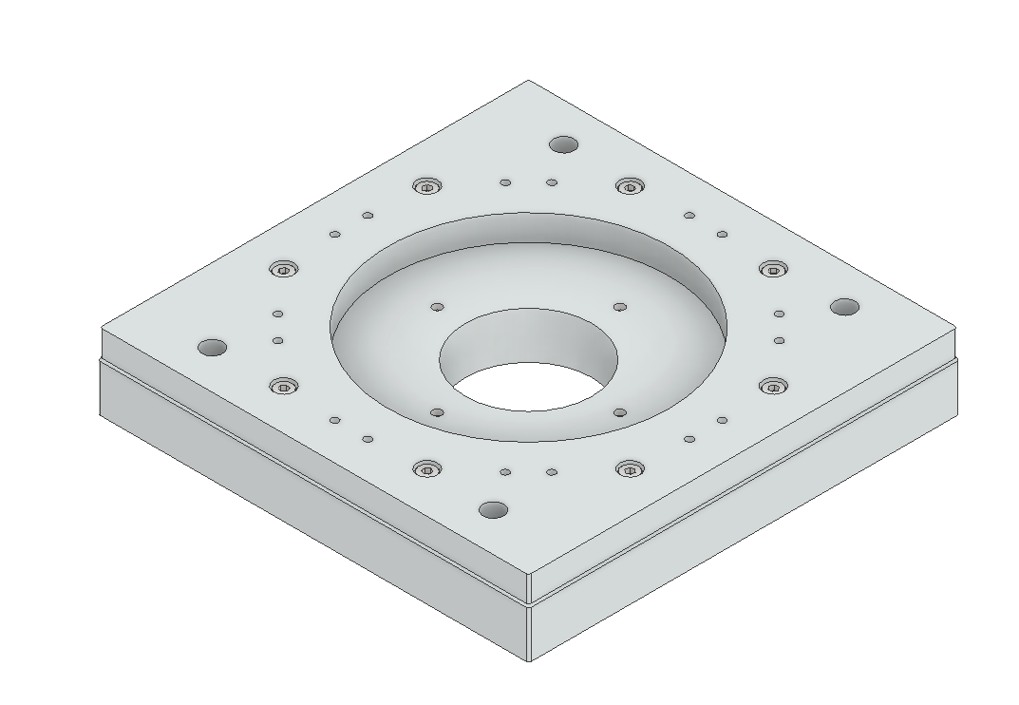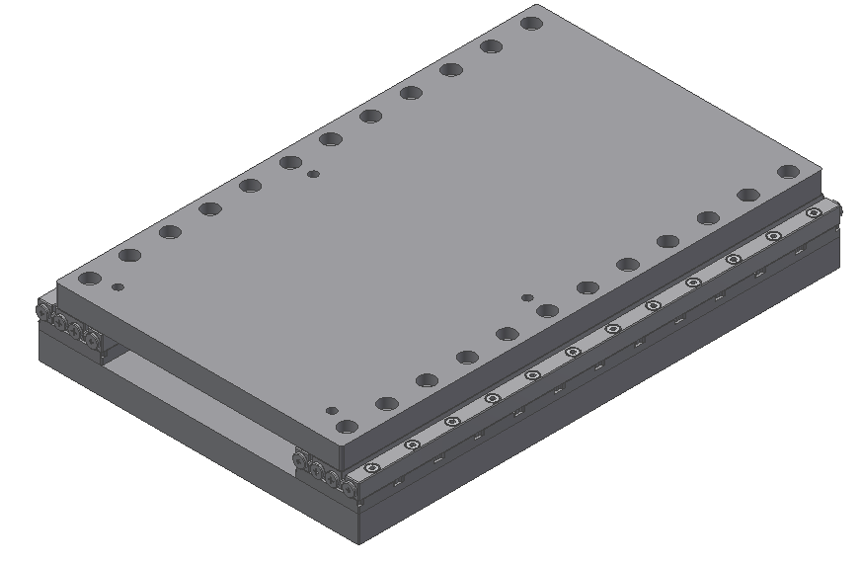

Keywords
N/a

 | Position |  |  | Name
Responsible person | Head of department of Laser Systems / Senior Scientist |  |  | Bedřich Rus
Prepared by | Research Assistant |  |  | Petr Szotkowski

RSS TC ID/revision | RSS - Date of Creation | RSS - Date of Last Modification | Systems Engineer
022592/A.001 | 14.06.2021 | 14.06.2021 | A. Kuzmenko
022592/A.002 | 16.06.2021 | 16.06.2021 | A. Kuzmenko
Reviewed By
Name (Reviewer) | Position | Date | Signature
Jack Naylon | Group leader of Laser Control Systems / Senior Scientist | INFORMED (Category A)
Martin Laub | Head of department of Construction and Design Support
Pavel Bakule | Group Leader of L1 Allegra Laser/ Deputy of Head of Department
Petr Brabenec | Designer
Veronika Olšovcová | Group Leader of Safety
Viktor Fedosov | Group Leader of Quality and Planning


Approved by
Name (Approver) | Position | Date | Signature
Bedřich Rus | Head of department of Laser Systems / Senior Scientist

Revision History / Change Log
Change No. | Made by | Date | Change description, Pages, Chapters | TC rev.
1 | P. Szotkowski,  P. Tůma | 10.06.2021 | RSD draft creation | A
2 | P. Tůma,  A. Kuzmenko | 14.06.2021 | RSD update; Version for review | B
3 | A. Kuzmenko | 16.06.2021 | RSD update; Final version | C

Content

1. Introduction 4
1.1. Purpose 4
1.2. Scope 4
1.3. Terms, Definitions and Abbreviations 4
1.4. References to standards 5
1.5. Summary of Purchase Requirements 5
2. General Functional and Performance requirements 5
2.1. Rotary positioners parameters 5
2.2. Rotary positioners with aperture parameters 6
2.3. Linear positioners parameters 6
2.4. Connector and cables 6
2.5. Vacuum Suitability 7
3. Delivery requirements 7
4. Safety Requirements 7
5. Quality Requirements 8
5.1. General Quality Requirements 8

Introduction

Purpose
The Contracting Authority, Fyzikální ústav AV ČR, v.v.i. (FZU), is undertaking the ELI Beamlines project in the Czech Republic with the objective of building state of the art laser technologies to implement research in the field of laser-matter interaction.
The aim of this public contract is to procure, for use in the project, vacuum compatible high-precision and compact, high rigid and straightness piezo positioners with position encoder meeting the requirements specified in the following sections.

Scope
This RSD contains all of the technical requirements: functional, performance, delivery, safety and quality requirements for the following product (tender number - TP21_041): Compact, high rigid and straightness piezo positioners with position encoder (further referred to as “Positioner” or “Positioners” in plural).
The Positioners are integral parts of the L4 compressor optomechanics and will be located in the L4c hall. These Positioners are registered in the PBS database under the following PBS code: RA1.L4.CMP1.10PW.OM.
The Positioners are a products Category A according to the ELI Beamlines RSD categories. The category A is an Off-the-shelf Product without the necessity of modifications and necessity to be subjected to a verification programme (review of design, inspection and testing) for ELI applications by the actual project specifications. All verification activities performed by a supplier shall be executed in accordance with the supplier’s plan of outgoing inspection and tests. The verification of all specified parameters listed in this RSD shall be undertaken by the supplier before delivery to the ELI Beamlines facility. Furthermore, the Positioners may be subject to testing and verification upon delivery to the ELI Beamlines facility by qualified personnel. All non-conformances (if any) must be addressed by the supplier in a timely manner.

Terms, Definitions and Abbreviations
For the purpose of this document, the following abbreviations apply:

Abbreviation | Meaning
CA | Contracting Authority (Institute of Physics AV CR, v. v. i.)
ELI | Extreme Light Infrastructure
RGA | Residual Gas Analysis
RSD | Requirements Specification Document
HV | High Vacuum
UHV | Ultra High Vacuum
LEMO | LEMO connector
D-SUB | D-SUB connector

References to standards
If this document includes references to standards or standardized/ standardizing technical documents the CA allows/permits also another equal solution to be offered. If a supplier offers another equal solution the CA shall not reject its bid, once the supplier by appropriate means in the bid proves that the offered supplies, services or works meet in an equivalent manner the requirements including references to standards or technical documents.

Summary of Purchase Requirements

The Contracting Authority’s requirement is for:
- 15 in number high-precision high-load vacuum compatible piezo electrical positioners:
  - 7 in number rotary positioner
  - 4 in number rotary positioner and large central aperture
  - 4 in number linear positioner
- Cables, sensors and controllers:
  - 15 cables and connectors for the positioners
  - 4 adapter cables
  - 4 pieces of sensor module
  - 2 pieces of positioner controllers (with two channels)
  - 1 rack housing
  - 4 adapter cables at least 6m long
The positioners must be designed and manufactured specifically for use in a high vacuum environment (vacuum pressure 10⁻⁶ mbar or better).
The piezo motor electrical characteristics and wiring connections must be fully detailed in accompanying technical documentation.

General Functional and Performance requirements

Rotary positioners parameters

REQ-032110/A
The positioner shall provide single axis rotation motion driven by piezo motor.
REQ-032111/A
The positioner shall provide unlimited rotation motorized travel.
REQ-032112/A
The positioner shall provide blocking torque at least 10 N and maximal normal force 25 N.
REQ-032113/A
The positioner shall provide resolution at least 1 µ° in open loop mode and at least 15 µ° in closed loop mode.
REQ-032114/A
The outer dimensions of the body of the positioner shall not exceed
92 mm (length) x 92 mm (width) x 19 mm (height).

Rotary positioners with aperture parameters

REQ-032115/A
The positioner shall provide single axis rotation motion driven by piezo motor.
REQ-032116/A
The positioner shall provide unlimited rotation motorized travel.
REQ-032117/A
The positioner shall provide clear aperture > 80 mm.
REQ-032118/A
The positioner shall provide blocking torque at least 15 N and maximal normal force 20 N.
REQ-032119/A
The positioner shall provide resolution at least 0,5 µ° in open loop mode and at least 5 µ° in closed loop mode.
REQ-032120/A
The outer dimensions of the body of the positioner shall not exceed 120 mm (length) x 120 mm (width) x 12 mm (height).

Linear positioners parameters

REQ-032121/A
The positioner shall provide at least 100 mm of linear motorized travel.
REQ-032122/A
The positioner shall provide axial load capacity of at least 20 N over the whole travel.
REQ-032123/A
The positioner shall provide resolution at least 1 nm in open loop mode.
REQ-032124/A
The outer dimensions of the body of the positioner shall not exceed
92 mm (length) x 152 mm (width) x 17 mm (height).

Connector and cables

REQ-032125/A
The positioners shall be equipped with vacuum compatible cables and vacuum compatible push-pull connectors (e.g. LEMO connector or equivalent) for connecting to the extension cable. Extension cables should be ended by vacuum compatible push-pull connectors (e.g. LEMO connector or equivalent) on one side and vacuum compatible 15-pin D-SUB connector on the other side to be connected to feed-through flange from vacuum side to air side. Positioner cable must be at least 120 cm long. Extension cable must be 200 cm long.
REQ-032126/A
The positioners shall be equipped by integrated optical position sensor to measure absolute position of positioner.
REQ-032127/A
A description of cable wires or connector pins, including piezo motor electrical characteristics and time sequence of the piezo motor driving signals, shall be included in the accompanying technical documentation.

Vacuum Suitability

REQ-032128/A
The positioner shall be compatible with vacuum pressures of 10⁻⁶ mbar or better.
NOTE: Any movable parts of the positioner may be lubricated only by UHV compatible lubricant.
REQ-032129/A
All components of the positioner shall be constructed from clean materials proven by Residual Gas Analysis (RGA).

Delivery requirements

REQ-032130/A
All components of the positioners shall be cleaned according to a procedure suitable for installation into high-vacuum before packing in contamination-free wrappings.
REQ-032131/A
All components shall be suitable for use in cleanrooms of class 5 according to ČSN EN ISO 14644 (equivalent to EN ISO 14644). All components shall be delivered in a protective package preventing damage and contamination and in a minimum of two plies of clean packaging.

Safety Requirements

REQ-032132/A
The Supplier shall supply an (EU/ES) Declaration of Conformity for each product type and declare by the conclusion of the contract that the product complies with the general safety requirements stipulated by applicable Czech law – Act no. 22/1997 Coll. or by EU Directive 2001/95/EC (e.g. fulfilment of the requirements stipulated by the Czech Government Regulation no. 481/2012 Coll. or EU directive 2011/65/EU and by the Czech Government Regulation no. 118/2016 Coll. or EU directive 2014/35/EU).
REQ-032133/A
The Supplier shall supply a Declaration of Conformity for each product type and declare that the product comply with requirements stipulated by the Czech Government Regulation no. 117/2016 Coll. or by EU Directive 2014/30/EU on electromagnetic compatibility.
REQ-032138/A
The positioners shall meet the requirements of the ČSN EN 61326-1 standard (equivalent to EN 61326-1) on Electrical Equipment for Measurement, Control and Laboratory Use.
NOTE: The conformity of positioners to the mentioned standard shall be documented by the Supplier in the Declaration of Conformity.

Quality Requirements

General Quality Requirements

REQ-032134/A
The Supplier shall provide the Product Manual as part of the delivered System. Completeness of the Manual shall be approved by the CA. The Manual shall include the instructions and descriptions regarding the following procedures:
- transport, handling, storage, disassembling and cleaning;
- installation and calibration (see REQ-032126/A and REQ-032135/A);
- safe operation, maintenance and disposal procedures;
- description of cable wires or connector pins (see REQ-032127/A);
- list of spare parts, specialized tools, equipment and materials for proper maintenance or repair (if relevant);
- user manual for the software or libraries and for communication protocols.
NOTE: The manual can be supplied in the hardcopy or PDF formats.
REQ-032135/A
The Supplier shall provide factory test report sheet (outgoing check of the product). This information shall comprise declaration of conformity with the technical requirements defined by this RSD and completeness of the product.
REQ-032136/A
The Supplier shall establish and maintain a nonconformity control system compatible with ČSN EN ISO 9001 (or equivalent, e.g. EN ISO 9001).

