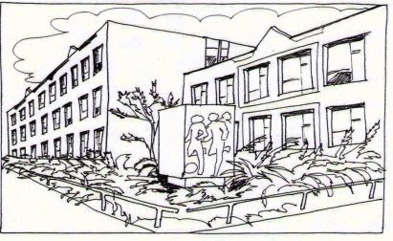
Základní škola Ústí nad Labem,
Anežky České 702/17, příspěvková organizace
400 07 Ústí nad Labem

IČ: 44555474
tel.: 475 500 032, 606 841 265
e-mail: zsanceske@volny.cz

QUICK IT
Ing. Martin Durchánek
Ke Třem křížům 154/1
400 07 Ústí nad Labem
IČ: 03427617

Objednávka č. 37/2017

Dobrý den,

na základě Vaší cenové nabídky ze dne 14.3.2017 (66.445,--Kč) objednáváme u Vás:
Server Dell PowerEdge T330, Intel® Xeon® E3-1240 v5 3.5GHz, 8GB UDIMM, 2133MT/s ECC, 2x 1TB 7.2K RPM SATA 6Gbps 3.5in, 5Yr Basic Warranty - Next Business Day |  |  |  | ks | 1,00 | 35590,00 | 43 063,90 Kč
Windows Server 2016 Acdmc 16xcore |  |  |  | ks | 1,00 | 6823,00 | 8 255,83 Kč
Práce (odhad) |  |  |  | ks | 25,00 | 500,00 | 15 125,00 Kč
 |  |  | Konečná cena: |  |  |  | 66 445 Kč
Děkujeme za vyřízení naší objednávky.

S pozdravem

V Ústí nad Labem 16.3.2017 Mgr. Jindra Šteflová
ředitelka školy

