A. Server DELL PE T340
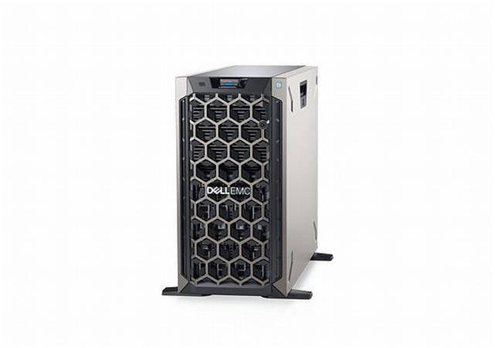

DELL PE T340 / E-2236 / 32GB / 4x 4TB NLSAS / H730P_2GB /iDRAC9,Ent/ 2xGL / 2x495W / 5Y NBD

HW konfigurace a specifikace serveru:

Komponenty:
1 PowerEdge T340 MLK Motherboard
1 Intel Xeon E-2236 3.4GHz, 12M cache, 6C/12T, turbo (80W)
1 iDRAC,Legacy Password
1 iDRAC Group Manager, Disabled
1 MOD,CBL,SAS,PERC,T340
1 MOD,BZL,FRT,MET,SCTY,TWR,T440
1 Performance Optimized
1 2666MT/s UDIMMs
2 16GB 2666MT/s DDR4 ECC UDIMM
1 iDRAC9,Enterprise
4 4TB 7.2K RPM NLSAS 12Gbps 512n 3.5in Hot-plug Hard Drive
1 PERC H730P RAID Controller, 2GB NV Cache, Adapter, Full Height
1 Standard Heatsink for PE T330/T340
1 No Internal Optical Drive
2 C13 to C14, PDU Style, 10 AMP, 6.5 Feet (2m), Power Cord
1 MOD,PWR SPLY,495W,RDNT,DELTA
1 Trusted Platform Module 2.0
1 Asset Tag - ProSupport (Website, barcode, Onboard MacAddress)
1 PowerEdge T340 CE,CCC,BIS Marking
1 On-Board LOM
1 Casters
1 No RAID
1 Producer Recycling Fund Contribution

Software:
1 Performance BIOS Settings
1 No Systems Documentation, No OpenManage DVD Kit

Služby:
1 Next Business Day 12MONTHS
1 ProSupport Next Business Day Onsite Service Initial, 12 mesícu
1 ProSupport Next Business Day Onsite Service Extension, 48 mesícu
1 Keep Your Hard Drive, 60 mesícu

Cena v Kč bez DPH: 82 900,-
B. Licence k serveru – se slevou pro školství (Academic)

Produkt: Windows Server 2019 Core Standard - 16 Core - Academic
Cena v Kč bez DPH: 6 900,-

Produkt: Windows Server 2019 CAL User - Academic
Cena v Kč bez DPH/1 lic.: 240,-
Cena v Kč bez DPH/20 lic.: 4 800,-

Cena v Kč bez za licence celkem: 11 700,-

Cena celkem: 94.600,- Kč bez DPH

Všechny nabízené produkty splňují specifikaci dle zadání. Zavazujeme se naplnit technické a záruční požadavky na server.

