Partnership Agreement – 2020-1-CZ01-KA203-078200 VERSION 08: 20 JANUARY 2021

Erasmus+ Programme

Partnership Agreement

VERSION 08: 20 JANUARY 2021 DEFINITIVE

Partnership Agreement

2020-1-CZ01-KA203-078200
European Collaborating Astronomer ProjectS: Espana-Czechia-Slovakia

The present Partnership Agreement, hereinafter referred to as “the Agreement”, is made and entered into by and between,

Astronomickýústav AV ČR, v.v.i. Fričova 298
251 65 Ondřejov Česká republika Organisation ID: E10158719 Erasmus ID: N/A

hereinafter referred to as the “coordinator”, represented for the purposes of signature of the Agreement by prof. Vladimír Karas, director, the legal representative as defined in the Grant Agreement 2020-1-
CZ01-KA203-078200

and the following beneficiaries:

- Masarykova Univerzita – established in Czech Republic Organisation ID: E10208978
Erasmus ID: CZ BRNO05

- Univerzita Komenského v Bratislave – established in Slovakia Organisation ID: E10208633
Erasmus ID: SK BRATISL02

- Astronomický ústav Slovenskej Akadémie vied – established in Slovakia Organisation ID: E10213049
Erasmus ID: N/A

- Instituto de Astrofísica de Canarias – established in Spain Organisation ID: E10208491
Erasmus ID: N/A

- Univerzita Karlova – estabilished in Czech Republic Organisation ID: E10209245
Erasmus ID: CZ PRAHA07

hereinafter referred to as the “beneficiaries”, represented for the purposes of signature of this Agreement by their legal representatives, according to the Mandates previously signed and attached to the Grant Agreement (here in Annex II).

Where a provision applies without distinction to the "coordinator" and the "beneficiaries", for the purpose of this Agreement they will be collectively referred to as the "beneficiaries".

The parties hereby have agreed as follows:

Article 1
Subject of the Partnership Agreement

  - This Agreement defines the terms that govern the relations between the parties, by establishing their rights and obligations, and lays down the rules of procedure for the work to be carried out in order to successfully implement the Erasmus+ project titled European Collaborating Astronomer ProjectS: Espana-Czechia-Slovakia (hereinafter referred to as the “project” ).

  - The coordinator and the beneficiaries, undertake to do everything in their power to carry out the work programme forming the subject of this Agreement, which falls within the framework of the Grant Agreement 2020-1-CZ01-KA203-078200, concluded between the coordinator and the Dům zahraniční spolupráce (hereinafter referred to as the "National Agency"), related to the above-mentioned project.

  - The subject matter of this Agreement and the related work programme are detailed in the annexes of the Grant Agreement. The respective Grant Agreement terms and conditions, related annexes, shall form an integral part of the present Agreement, and take precedence over it (see Article 20 of the present Agreement for the list of annexes).

  - The coordinator and the beneficiaries shall be bound by the terms and conditions of this Agreement, the Grant Agreement and any further amendments of the latter.

Article 2 Duration

  - This Agreement shall enter into force on the date the last party signs, but shall have retroactive effect from the starting date of the eligibility period laid down in the Grant Agreement. This Agreement becomes effective on the date of its publication in the Czech Contracts Register in accordance with Act No. 340/2015 Sb., on special conditions for the effect of some contracts, the publication of such contracts and the register of contracts (the Contracts Register Act), as amended. The contracting parties expressly stipulate that Astronomický ústav AV ČR, v.v.i. assumes responsibility for publication of this Agreement in the Contracts Register in line with Act No. 340/2015 Sb., as amended.

  - The period of eligibility of the activities and the costs shall be in accordance to the dispositions of the Grant Agreement or any subsequent amendments of it.

  - The present Agreement shall remain in force until the coordinator has been discharged in full of his obligations arising from the Grant Agreement signed with the National Agency.

Article 3 Obligations and responsibilities

  - General obligations and role of the beneficiaries (including the coordinator).

The beneficiaries:

    - are responsible for carrying out the activities attributed to them, and shall conduct the work in accordance with the work programme and schedule set forth in the Grant Agreement and approved application, working to the best of their abilities to achieve the defined results and taking full responsibility for their work in accordance with accepted professional principles;
    - undertake to comply with all the provisions of the Grant Agreement and its annexes, with all the provisions of this Agreement, as well as with EU and national legislation;
    - are responsible for complying with any legal obligations incumbent on them jointly or individually;

    - shall provide staff, facilities, equipment and material to the extent needed for executing the activities as specified in the work programme;
    - shall be responsible for the sound financial management and cost efficiency of the funds allocated to the project.

  - Specific obligations and role of the coordinator.

The coordinator undertakes to:

    - be responsible for the overall coordination, management and implementation of the project in accordance with the Grant Agreement;
    - be responsible for the selection, according to local law and standard procedures, of the recipients of any and all contracts related to the execution of the project in accordance with the Grant Agreement;
    - be the intermediary for all communication between the beneficiaries and the National Agency, and inform the beneficiaries of any relevant communication exchanged with the National Agency;
    - inform the beneficiaries of any changes connected to the project or to the Grant Agreement, or of any event likely to substantially affect the implementation of the action;
    - as the sole recipient of payments on behalf of all beneficiaries, transfer funds to the beneficiaries in accordance with the dispositions for payments laid down in Article 5 of this Agreement;
    - manage and verify the appropriate spending of the funds in accordance with the dispositions of the Grant Agreement and this Agreement;
    - comply with all reporting requirements vis-à-vis the National Agency, as per the dispositions of Article I.4 of the Grant Agreement. The coordinator shall not delegate any part of this task to any party;
    - establish payment requests on behalf of the beneficiaries, as per the dispositions of Article I.4 of the Grant Agreement;
    - provide one copy of this Agreement duly signed to each beneficiary and to the National Agency within 6 months of the signature of the Grant Agreement.
    - provide the beneficiaries with official documents related to the project, such as the signed Grant Agreement and its annexes, the Guidelines for the Use of the Grant, the various reports templates and any other relevant document concerning the project.
    - transmit to the beneficiaries copies of all reports submitted to the National Agency, as well as copies of any feedback letters received from the Agency following report assessment and field monitoring visits.

  - Specific obligations and role of each beneficiary (excluding the coordinator).

Each beneficiary undertakes to:

    - ensure adequate communication with the coordinator and with the other beneficiaries;
    - support the coordinator in fulfilling its tasks according to the Grant Agreement;
    - administer and coordinate the contracts, following local law and procedure, of candidates selected by the coordinator as part of article 3.2(b) to be based at the beneficiary;
    - submit in due time to the coordinator all relevant data needed to draw up the reports, financial statements and any other documents provided for in the Grant Agreement, as well as all necessary documents in the events of audits, checks or evaluations;

    - provide the coordinator with any other information or documents it may require and which are necessary for the management of the project;
    - notify the coordinator of any event likely to substantially affect or delay the implementation of the action, as well as of any important deviation of the project (e.g. replacement of the project contact person, changes in partner’s budget, deviations from work plan etc.);
    - inform the coordinator of any change in its legal, financial, technical, organisational or ownership situation and of any change in its name, address or legal representative.

Article 4 Financing the action

4.1 The maximum Erasmus+ grant contribution to the project for the contractual period covered by the Grant Agreement amounts to EUR 318.085,00 and shall take the form as stipulated in Annex III of the Grant Agreement.

Article 5 Payment arrangements

  - The coordinator will transfer the part of the Erasmus+ grant contribution corresponding to each individual beneficiary using the accounts stipulated in Annex III of this Agreement.

  - The transfer of the Erasmus+ grant contribution to individual beneficiaries will be implemented in accordance with the following schedule:

- The 1st part of an advance payment will be sent without unjustified delay after signature of this Agreement as stated in annex I. The rest of the first advance payment will be distributed as needed. Second and every subsequent payment requires only an approval of Project coordination board by vote.

- As soon as the 2 nd advance payment is received by the Coordinator, the whole amount will be distributed without a delay to the beneficiaries according to decision of the Project coordination board. Each beneficiary will receive the remaining amount up to the 80% of its planned contribution.

- As soon as the final payment is received by the Coordinator, the whole amount will be distributed without a delay to the beneficiaries according to their eligible costs during the whole duration of the project.

- If necessary, the Project coordination board (Article 8.) can decide by a vote about any proposed changes in the budget plan.

  - Erasmus+ grant amounts received in advance and not used by the beneficiaries will be reimbursed to the coordinator at the latest 30 days after the end of the project's contractual period.

  - Beneficiaries are obliged to use the Erasmus+ grant contribution exclusively for the purposes defined by the project, and in accordance with the terms and provisions of the present Agreement and the Grant Agreement and its annexes. If there is a difference between the amount of the Erasmus+ grant contribution actually used by the partnership and the amount of expenditure declared eligible by the National Agency at the end of the project, the beneficiary(ies) responsible for the expenditure declared ineligible will reimburse the corresponding amount to the coordinator within two weeks of the notification to beneficiary concerned.

  - The costs of financial transfers, i.e.costs of dispatch/receipt charged by the bank of the coordinator/beneficiaries, will be covered by the affected party.

Article 6 Reporting

  - The coordinator is responsible for submitting in due time to the National Agency all reports and financial statements as required in the Grant Agreement. For this purpose and in a timely manner, the beneficiaries commit to provide the coordinator with all necessary information and, if applicable, copies of supporting documents needed for drawing up reports, financial statements and any other documents required in the Grant Agreement.

  - The coordinator shall provide the beneficiaries with the appropriate reporting forms for the declaration of expenses/activities and the respective instructions for their completion. These reports must be drawn up in EURO.

  - The beneficiaries shall keep a record of any expenditure/activity incurred under the project and all proofs and related documents for a period of 6 years after the payment of the final balance under the Grant Agreement. The coordinator may reject any item which cannot be justified in accordance with the rules set out by the National Agency in the Grant Agreement.

Article 7
Budgetary and financial management

  - The Erasmus+ grant contribution to the project's staff costs, travel costs and costs of stay will be calculated on the basis of "unit contributions" whose individual amounts are specified in the Erasmus+ Programme Guide, in the Guidelines for the Use of the Grant and in the Guidelines for the Special Mobility Strand (when applicable).

  - For the implementation of the project and the beneficiary's reimbursement of costs incurred in terms of staff, travel and costs of stay, the partnership will apply the local rules for sending organization with a maximum of unit costs amounts defined in the Erasmus+ Programme Guide and in the Guidelines for the Use of the Grant

  - The Erasmus+ grant contribution to the project's equipment and subcontracting costs will be based on the justification of the costs actually incurred. This justification will take the form of the support documentation specified in the relevant section of the Guidelines for the Use of the Grant.

  - The beneficiaries confirm that they respect the social and labour legislation of their country regarding the costs of staff contributing to the project.

  - Each beneficiary is responsible for ensuring adequate insurance arrangements for their staff and students while participating in project activities. Participants in student´s mobility are required to take out adequate health and liability insurance applying to life, health and property claims including consequential financial damages.

  - In the context of the current epidemiological and pandemic situation, the Contracting Parties shall, at their own expense, ensure, if required, prevention and all current measures to protect participants in student´s mobility throughout the period of mobility. Participants in the mobility take the prescribed health tests before departure and ensure higher limits of medical expenses, including repatriation, within the framework of health insurance.

Article 8
General administrative provisions and project coordination boad

8.1 Any important project related communication between the parties shall be done in writing and addressed to the appointed project manager of each beneficiary, as per the details below:

For the coordinator:
Dr. Petr Kabath
Fricova 298, Ondrejov 25165 CZ kabath@asu.cas.cz

For the beneficiaries:

Univerzita Karlova Dr. Josef Hanuš
MFF UK, Ovocný trh 560/5, 116 36 Praha 1 pepa@sirrah.troja.mff.cuni.cz

Masarykova Univerzita Dr. Jan Janík.
Faculty of Science, Kotlářská 2, 611 37 Brno honza@physics.muni.cz

Univerzita Komenského v Bratislave Dr. Juraj Toth
FMFI UK, Mlynská dolina, 842 48 Bratislava, Slovakia toth@fmph.uniba.sk

Astronomický ústav Slovenskej Akadémie vied Dr. Marián Jakubík
Tatranska Lomnica 05960 Vysoke Tatry jakubik@ta3.sk

Instituto de Astrofísica de Canarias Dr. Jorge Garcia Rojas
Vía Lactea s/n La Laguna 38205
jogarcia@iac.es

Instituto de Astrofísica de Canarias (La Palma office) Dr. David Jones
Vía Lactea s/n La Laguna 38205
djones@iac.es

The project managers are also members of the Project coordination board.

8.2. Project coordination board

Project coordination board consists of one representative of each beneficiary. The Coordinator chairs all meetings of the Board. Any decision may also be taken without a meeting if the coordinator circulates to all members a written document which is then approved by a majority of the votes Each beneficiary shall have one vote.

8.3 Any changes in paragraph 8.1. should be communicated in a timely manner.

Article 9 Promotion and visibility

  - The coordinator and the beneficiaries shall ensure adequate promotion of the project and commit to playing an active role in any actions organised to capitalise on, exploit / disseminate the results of the project.

  - Any notice or publication by the project, including at a conference or a seminar, must specify that the project is being co-financed by EU funds within the framework of the Erasmus+ Programme, and must comply with the visibility rules laid down in Articles I.12 of the Grant Agreement.

Article 10 Confidentiality and data protection

  - The coordinator and the beneficiaries undertake to preserve the confidentiality of any document, information or other material directly related to the subject of the Agreement that is duly classed as confidential, if disclosure could cause prejudice to the other party. The parties shall remain bound by this obligation beyond the closing date of the action.

  - All personal data contained in or relating to this Agreement shall be processed in accordance with the dispositions of Article II.7.1 of the Grant Agreement.

Article 11 Ownership and property rights

  - The ownership of all project results, including copyrights and intellectual property rights, as well as all reports and other documentation resulting from the action, shall be vested in the beneficiaries, in compliance with Article I.8 of the Grant Agreement.

  - Materials already developed and brought in may be only used within the scope of the project as templates of good practice. Copyrights shall be strictly safeguarded and permission for reproduction and scale of production has to be settled beforehand.

Article 12 Liability

12.1 Each of the contracting parties discharges the other of any civil liability for any damages suffered by itself or its staff/students as a result of the performance of this Agreement, insofar as such damages are not due to serious or intentional negligence or fault of the other party or its staff/students.

Article 13 Conflict of interest

  - The coordinator and beneficiaries must undertake all necessary precautions to prevent any risk of conflicts of interest which could affect their impartial and objective performance of the Agreement. Such conflict of interest could arise in particular as a result of economic interest, political or national affinity, family or emotional reasons, or any other shared interest.

  - Any situation constituting or likely to lead to any such conflict should be brought to the attention of the coordinator without delay, and the beneficiary in cause shall undertake to take all necessary measures to rectify this situation at once.

  - The coordinator will decide if it is deemed necessary to inform the National Agency.

Article 14 Working languages

14.1 The working language of the partnership shall be English.

Article 15 Conflict resolution

  - In case of conflict between the project partners resulting from the interpretation or the application of this Agreement, or in connection with the activities contained within, the parties involved shall make the effort to come to an amicable arrangement rapidly and in the spirit of good cooperation.

  - Disputes should be addressed in writing to the Coordinator and subsequently discussed within the Project coordination Board which will try to resolve the conflict.

The decision of the Project coordination Board will be final, and the parties will abide by it, as far as legally possible in compliance with national law.

Article 16 Applicable law and jurisdiction

  - This Agreement is governed by the Czech law, being the law of the coordinator's country.

  - In case of any disputes on matters under this Agreement, which cannot be resolved by an amicable settlement, the matter shall have to be decided in accordance with the jurisdiction of the coordinator's country.

  - If any provision of this Agreement or the application of any such provision shall be considered invalid or unenforceable in whole or in part for legal requirements, all other stipulations remain valid and binding to all parties.

  - If any provision in this Agreement should be wholly or partly ineffective, the parties to this Agreement undertake to replace the ineffective provision by an effective provision which comes as close as possible to the purpose of the ineffective provision.

  - This Agreement is concluded in English. In the event of translation of this Agreement and its annexes, the English version shall prevail.

Article 17 Termination of the Agreement

17.1 In the event that any of the beneficiaries fail to perform any obligations under the present Agreement or the Grant Agreement, the coordinator may terminate their participation in the project, in compliance with provisions in Annex I of Grant Agreement. The beneficiaries may terminate the present Agreement if the coordinator has inadequately discharged or failed to discharge any of the contractual obligations, insofar as this is not due to force majeure, after notification of the coordinator by registered letter has remained without effect for one month.

Article 18
Force Majeure

  - If either parties face a case of force majeure (as per defined in article II.14 of the Grant Agreement), it shall promptly notify the other party in writing, specifying the nature, probable duration and expected effects of this event.

  - Neither of the parties shall be deemed in breach of its obligations if it has been prevented from performing its tasks due to force majeure. The parties shall take all necessary measures to minimise possible damage to successful project implementation.

Article 19 Amendments

  - Any amendments to this Agreement must be made in writing by means of a Supplementary Agreement, and become effective when signed by the authorised legal representatives of all parties.

  - The amendment may not have the purpose or the effect of making changes which might call into question the dispositions of the Grant Agreement.

Article 20 Annexes

Annex I – Budget breakdown per partner for the 1st part of the 1st advance payment
Annex II - Copy of the Grant Agreement signed between the coordinator and the National Agency, its annexes, and any existing amendment.
Annex III - Individual Bank account of each beneficiary organisation

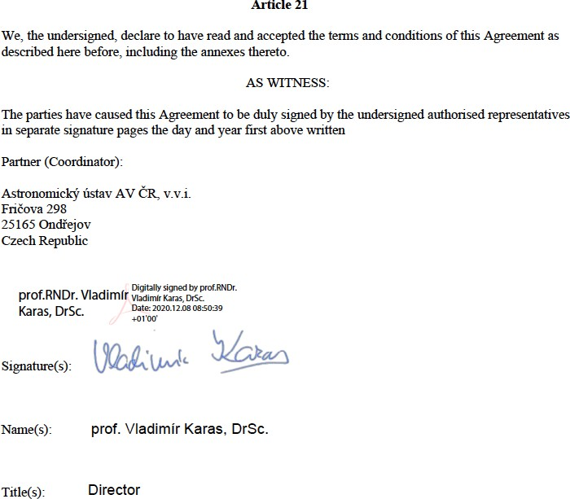

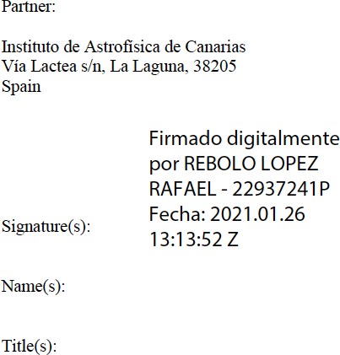

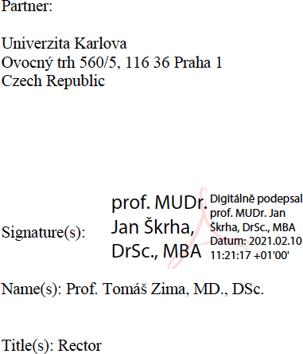

Partner:

Masarykova Univerzita
Faculty of Science, Kotlářská 2, 611 37 Brno Czech Republic

Signature(s): Name(s):
Title(s):

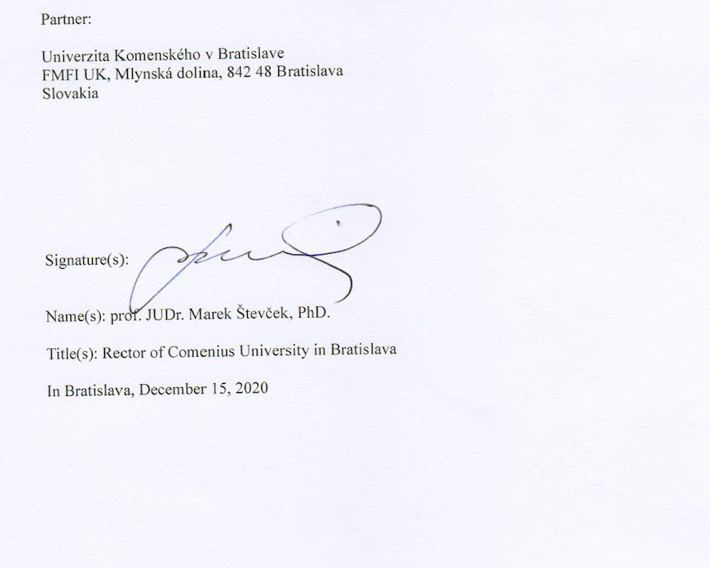

Datum: 26.3.2021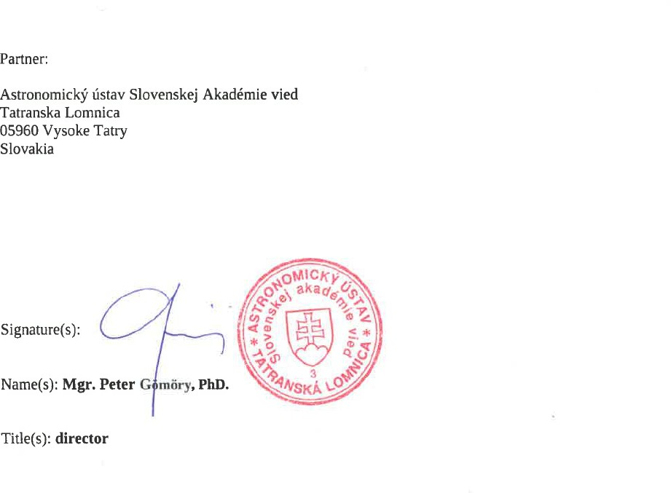

Budget/Expenditure breakdown for the 1st payment (coordinator AI ASCR)

- BUDGET ITEMS

  - MANAGEMENT BUDGET 500EURx36months=18000 EUR

  - TRANSNATIONAL MEETING
N/A

  - INTELLECTUAL OUTPUT (FTEs) 20 000 EUR

  - MOBILITY COST
N/A

DISSEMINATION EVENTS

N/A

AMOUNT RETAINED FOR DISTRIBUTION AFTER MOBILITY CALL EVALUATION 14234 EUR

TOTAL AMOUNT OF 1st payment = 38000 EUR + 14234 EUR (RETAINED)

Further payments in accordance with Annex V (Cumulative budget) will be agreed on once the call for long term mobility is closed and applications are under review. This Annex I will be adjusted accordingly if necessary.

This Annex can be adjusted any time by mutual agreement of the partners. In such case, adjusted values are provided in the Annex I amendment and signed by each partners main responsible (IAC – David Jones, AI SAS – Marián Jakubík, UK Bratislava – Juraj Toth, UTFA MU – Jan Janik, UK Prague – Josef Hanuš )

Budget/Expenditure breakdown for the 1st payment (PARTNER IAC)

- BUDGET ITEMS:

  - MANAGEMENT BUDGET
250 EURx36 months = 9000 EUR

  - MOBILITY COST
N/A

DISSEMINATION EVENTS

N/A

INTELLECTUAL OUTPUT (FTEs) 20000 EUR

TOTAL AMOUNT OF 1st payment = 29000 EUR

Further payments in accordance with Annex V (Cumulative budget) will be agreed on once the call for long term mobility is closed and applications are under review. This Annex I will be adjusted accordingly if necessary.

This Annex can be adjusted any time by mutual agreement of the partners. In such case, adjusted values are provided in the Annex I amendment and signed by each partners main responsible (IAC – David Jones, AI SAS – Marián Jakubík, UK Bratislava – Juraj Toth, UTFA MU – Jan Janik, UK Prague – Josef Hanuš)

DISSEMINATION EVENTS

N/A

INTELLECTUAL OUTPUT (FTEs)

N/A

TOTAL AMOUNT OF 1st payment = 9000 EUR

Further payments in accordance with Annex V (Cumulative budget) will be agreed on once the call for long term mobility is closed and applications are under review. This Annex I will be adjusted accordingly if necessary.

This Annex can be adjusted any time by mutual agreement of the partners. In such case, adjusted values are provided in the Annex I amendment and signed by each partners main responsible (IAC – David Jones, AI SAS – Marián Jakubík, UK Bratislava – Juraj Toth, UTFA MU – Jan Janik, UK Prague – Josef Hanuš )

DISSEMINATION EVENTS

N/A

INTELLECTUAL OUTPUT (FTEs)

N/A

TOTAL AMOUNT OF 1st payment = 9000 EUR

Further budget will be agreed on once the call for long term mobility is closed and applications are under review. Annex I will be adjusted accordingly if necessary.

This Annex can be adjusted any time by mutual agreement of the partners. In such case, adjusted values are provided in the Annex I amendment and signed by each partners main responsible (IAC – David Jones, AI SAS – Marián Jakubík, UK Bratislava – Juraj Toth, UTFA MU – Jan Janik, UK Prague – Josef Hanuš )

Partnership Agreement – 2020-1-CZ01-KA203-078200 VERSION 08: 20 JANUARY 2021

ANNEX I

Budget/Expenditure breakdown for the 1st payment (PARTNER UK Bratislava)

- BUDGET ITEMS:

  - MANAGEMENT BUDGET
250 EURx36 months = 9000 EUR

  - MOBILITY COST
N/A

DISSEMINATION EVENTS

N/A

INTELLECTUAL OUTPUT (FTEs)

N/A

TRANSNATIONAL MEETING

N/A

TOTAL AMOUNT OF 1st payment = 9000 EUR

Further budget will be agreed on once the call for long term mobility is closed and applications are under review. Annex I will be adjusted accordingly if necessary.

This Annex can be adjusted any time by mutual agreement of the partners. In such case, adjusted values are provided in the Annex I amendment and signed by each partners main responsible (IAC – David Jones, AI SAS – Marián Jakubík, UK Bratislava – Juraj Toth, UTFA MU – Jan Janik, UK Prague – Josef Hanuš )

ANNEX I

Budget/Expenditure breakdown for the 1st payment (PARTNER AI SAS)

- BUDGET ITEMS:

  - MANAGEMENT BUDGET
250 EURx36 months = 9000 EUR

  - MOBILITY COST
N/A

DISSEMINATION EVENTS

N/A

INTELLECTUAL OUTPUT (FTEs) 10000 EUR

TOTAL AMOUNT OF 1st payment = 19000 EUR

Further budget will be agreed on once the call for long term mobility is closed and applications are under review. Annex I will be adjusted accordingly if necessary.

This Annex can be adjusted any time by mutual agreement of the partners. In such case, adjusted values are provided in the Annex I amendment and signed by each partners main responsible (IAC – David Jones, AI SAS – Marián Jakubík, UK Bratislava – Juraj Toth, UTFA MU – Jan Janik, UK Prague – Josef Hanuš )

The partnership should create an individual annex for each beneficiary with their bank account details and signed by the legal representative:

PARTNER IAC

Name of Bank: BANCO BILBAO VIZCAYA ARGENTARIA
Address of branch: CL OBISPO REY REDONDO, 25 SAN CRISTOBAL DE LA LAGUNA, 38201, SPAIN
Name and address of account holder:
INSTITUTO DE ASTROFISICA DE CANARIAS VÍA LACTEA, S/N
SAN CRISTOBAL DE LA LAGUNA 38200, SPAIN
IBAN: ES50 0182 0772 4802 0156 4101

PARTNER AI SAS

Name of Bank: Štátna pokladnica
Address of branch: Radlinského 32, 810 05 BRATISLAVA 15
Name and address of account holder: Astronomický ústav Slovenskej akadémie vied Tatranská Lomnica, P.O. BOX 18, 059 60 Vysoké Tatry
Account number: 7000612957/8180 IBAN: SK39 8180 0000 0070 0061 2957

PARTNER UK Bratislava

Name of Bank: Štátna pokladnica
Address of branch: Radlinského 32, 810 05 Bratislava, Slovakia
Name and address of account holder: Univerzita Komenského v Bratislave
Full account number (including bank codes): 7000138546/8180, SPSRSKBAXXX IBAN: SK92 8180 0000 0070 0013 8546

Partner AI ASCR (Coordinator)

Name of Bank: Komerční banka.
Address of branch: Komerční banka, a.s., Na Příkopě 33, Praha 1 PSČ 114 07.
Name and address of account holder: Astronomickýústav AV ČR, v.v.i., Fričova 298, 251 65 Ondřejov Czech Republic
Full account number (including bank codes): 35-5478700287/0100 IBAN: CZ69 0100 0000 3554 7870 0287

Partner MU BRNO

Name of Bank: Komerční banka
Address of branch: Komerční banka, pobočka Brno město Name and address of account holder: Masarykova Univerzita Full account number (including bank codes): 85636621/0100, IBAN: CZ43 0100 0000 0000 8563 6621

28

