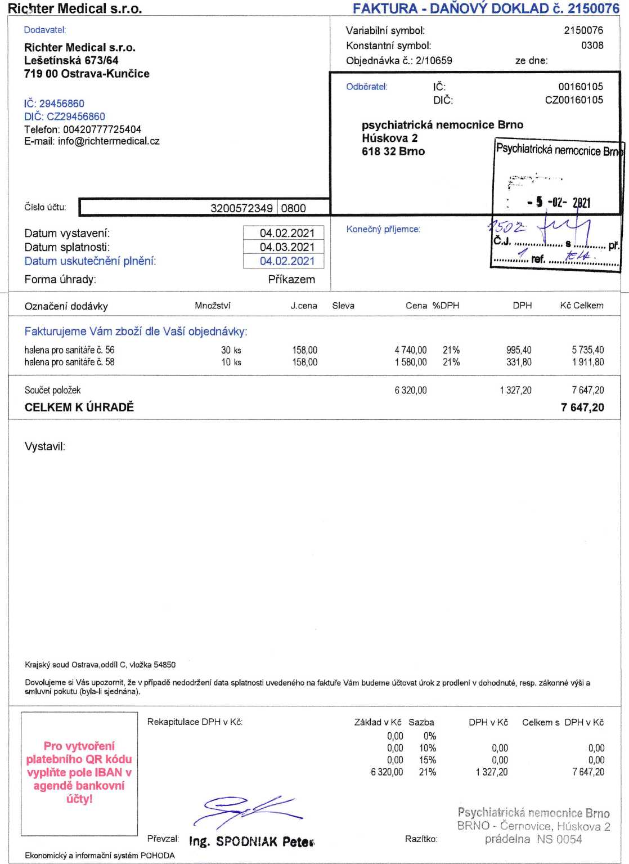
xxxxxxxxxxxxxxxxxxxxxxxxxx

Xxxxxxxxxxx xxxxxxx
Xxxxxxxxxxxxxxxxxxx
xxxxxxxxxxxxxx
vvvvvvvvvy
xxxxxxxxx
Xxxxxxxxxxxxxx
Xxxxxxxxxxxxxx
xxxxxxxxxxxxxx

Xxxxxxxxxxxxxxxxxxxxxxxx
Xxxxxxxxxxxxxxxxxx

xxxxxxxxxxxxxxxxxxxxxxxxx

Xxxxxxxxxxxxxxxxxxxxxxxxxxxxxxxxxxxxxxxxx
xxxxxxxxxxxxxxxxxxxx

