CzechGlobe

ANNEX 2 TO THE CONTRACT ON CONSORCIUM FOR PROJECT IMPLEMENTATION

Elaboration of Legal and Institutional Framework for Multihazard Early
Warning System and Climate Information, UNDPJ Gruzie

DEKONTA, a.s.

Seated
ID
Dřetovice 109, 273 42 Stehelčeves
25006096 DIČ CZ25006096

Registered V Obchodním rejstříku vedeném u Městského soudu v Praze, odd. B, sp. zn. 12280
Represented lng. Alešem Pražákem, MBA, member of board

and

Association Regional-Rural Development for Future Georgia
Seated 4, Gabriellsakadze Street, 0160 Tbilisi, Georgia
ID 404882980
Registered v gruzinském registru nevládních organizací pod číslem B18046163
Represented !vane Grigolashvili; Head of Disaster Risk Reduction Center

(hereafter “RDFG")

and

Výzkumný ústav vodohospodářský TGM, v. v. i.
Seated Podbabska 2582/30, 198 00 Praha 6
ID 00020711 DIC CZ00020711
Registered v Rejstriku verejnych vyzkumnych institucí
Represented lng. Tomášem Urbanem, chairman

(hereafter “VUV")

and

Ústav výzkumu globální změny AV CR, V. V. i.
Seated Belidla 986/4a, 603 00 Brno
ID 86652079 DIC CZ86652079
Registered v Rejstrii ku verejnych vyzkumnych instituci
Represented prof. RNDr. lng. Michalem V. Markem, DrSc., dr. h. c., charged with managing the institution

(hereafter, “CzechGlobe")

conclude the annex with the following text:

Strana 1 (celkem 3)

I. CONTRACT

1. On 30 August 2019, the aforementioned contracting parties concluded a contract for the performance of the project Elaboration of Legal and Institutional Framework for Multihazard Early Warning System and Climate Information, UNDP, Gruzie and the Annex I to it on March 24, 2020.

11. C 0 M P LE Tl N G T H E C 0 N T RA C T

1 . The Contracting Parties agree that Amendment no. 1 to the Contract between the United Nations Development Program ("UNDP") and the Institute of Global Change Research of the ASCR, vvi, UVGZ AV CR, vvi (CzechGlobe) concluded on 2 October 2020 between UNDP and CzechGlobe, which is Appendix no. 1 of this Annex. The Terms of Reference of Elaboration of Legal and Institutional Framework for Multi-hazard Early Warning System and Climate Information, which is a part of the concluded Amendment from 2 October 2020, is an Appendix no. 2 of this Annex. Appendix no. 3 is an updated budget of the Financial Offer, which stipulates the share of individual contracting parties of the consortium in the performance of the contract.

2. Other provisions of the contract and related documents (e.g. Work Plan, Technical Proposal) shall apply reasonably in accordance with the updates and changes made in the above-mentioned appendices.

Ill. COMMON AND FINAL PROVISIONS

1. This annex may only be amended in writing, in the form of a sequential numbered amendment to the contract.

2. This Appendix is drawn up in four counterparts, of which each Contracting Party shall each have one counterpart.
3. The contracting parties acknowledge and agree that this annex fulfils the requirements specified in Act No. 340/2015 Col. and is subject to the obligation to publish it in the register of contracts. CzechGlobe undertakes to enter the annex to the Register of Contracts within the statutory period, and to send a confirmation of the publication of this annex the other Contracting Parties.

4. An integral part of this Annex are:

a) Appendix 1: Amendment No. 1 to the Contract between the United Nations Development Program ("UNDP") and the Institute of Global Change Research of the ASCR, vvi, UVGZ AV CR, vvi (CzechGlobe)

b) Appendix 2: Terms of Reference of Elaboration of Legal and Institutional Framework for Multi­
hazard Early Warning System and Climate Information c) Appendix 3: Updated budget of the Financial Offer
5. This annex becomes effective upon its entry in the contract register.

·<? • -"..>..

In Dřetovice, on

lng. Aleš Pražák, MBA

member of board
DEKONTA, a.s. -

In Tbillisi, on

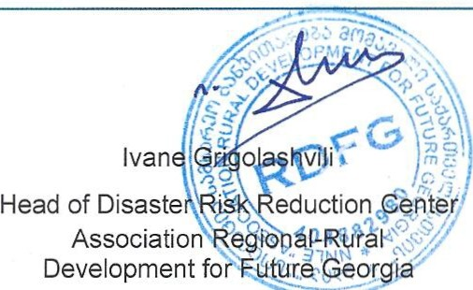
In Prague, on

In Brno, on

lng. Tomas Urban chairmen
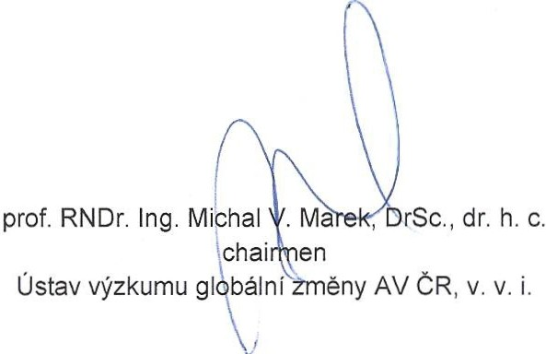
Výzkumný ústav vodohospodářský TGM, v. v. i.

Revised budget

Partner | CZK | USD
Phase 3 (Last payment) |  | 23 550
DEKONTA | 175 000 | 7 608
VUVTGM | 119 000 | 5 173
RDFG | 115 000 | 5 000
(including 3000 USD Phase 2)
CzechGlobe | 132 687 | 5 769
Exchange course rate: 23CZK/USD
Payments in total
DEKONTA | 558 923 | 25 406
VUVTGM | 494 647 | 22 484
RDFG | 354 899 | 16132
CzechGlobe | 115 7742 | 52 625
Exchange course rate: 22CZK/USD*
*it is estimation. The final rate will be based on the official exchange rate in the date of payment.

