Confidentiality Level |  | BL - Restricted for internal use | TC ID / Revision | 00277394/C
Document Status |  | Document Released | Document No. | N/A
WBS code |  | 4.3 – Beam Transport
PBS code |  | SE.BDS.BT.BTL3.S1.C016.VCH
Project branch |  | Engineering & Scientific documents (E&S)
Document Type |  | Specification (SP)
[RSD product category C]

L3BT-L4c Node Chamber with lid manipulation tools for L3 PW Beam
TP20_118
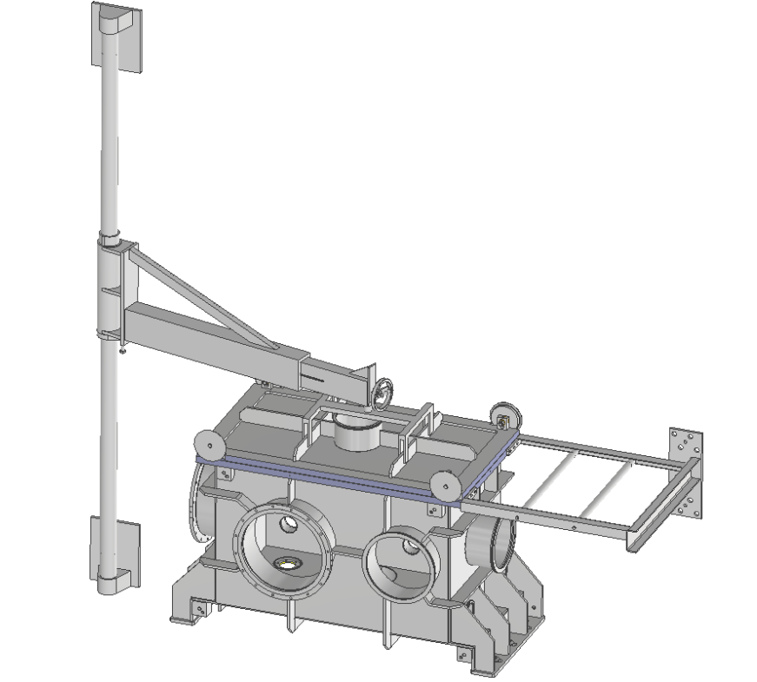
Keywords
N/A

 | Position |  |  |  | Name
Responsible person | Scientific Coordinator of Laser Technology (RP1) |  |  |  | Bedřich Rus
Prepared by | Scientific Coordinator of Laser Technology (RP1)  Senior Optomechanical Designer  Senior Technology Expert |  |  |  | Bedřich Rus  Jean Claude Lagron  Mike Griffiths

RSS TC ID/revision | RSS - Date of Creation | RSS - Date of Last Modification | Systems Engineer
021810/A.001 | 15.09.2020 | 15.09.2020 | D. Hanusková
Reviewed By
Name (Reviewer) | Position | Date | Signature
Pavel Bakule | Deputy RP1 Leader, L3BT Manager | N O T I C E
Lukáš Brabec | Group Leader of Vacuum and Cryogenics | N O T I C E
Radek Toman | Lawyer | N O T I C E
Martin Laub | Chief Engineer | N O T I C E
Daniel Kramer | Senior Vacuum Cleanliness Expert | N O T I C E
Ladislav Půst | Manager installation of technology | N O T I C E
Jakub Janďourek | Infrastructure technology coordinator | N O T I C E
Roman Kuřátko | Facility Manager | N O T I C E
Veronika Olšovcová | Safety Coordinator | N O T I C E
Viktor Fedosov | SE & Planning group leader;  Quality Manager | N O T I C E

Approved by
Name (Approver) | Position | Date | Signature
Bedřich Rus | RP1 Laser Team Lead | Via e-mail

Revision History / Change Log
Change No. | Made by | Date | Change description, Pages, Chapters | TC rev.
1 | B. Rus / M. Griffiths | 21.10.2019 | RSD draft creation | A
2 | B. Rus/D. Hanusková | 15.09.2020 | Completed RSD version for review | B
3 | D. Hanusková | 17.09.2020 | Final version for procurement | C

Table of Content

1. Introduction 4
1.1. Purpose 4
1.2. Scope of Work 4
1.3. Vacuum Flange Schedule 5
1.4. Terms, Definitions and Abbreviations 8
1.5. Reference Documents 8
1.6. References to standards 8
2. Functional, design, material, manufacture and test requirements 9
3. Cleaning, testing and packaging requirements 10
4. Transportation and Installation Requirements 11
5. Safety Requirements 12
6. Quality requirements 12
6.1. Documentation and data control 12
6.2. Nonconformity control system 12
7. Verification requirements for the Supplier 13
7.1. General requirements 13
7.2. Verification documentation 13
7.2.1. General requirements 13
7.2.2. Verification reports (VRs) 14
7.2.3. Verification Control Document (VCD) 14
7.3. Phasing of the delivery 14
7.3.1. Qualification of Design 15
7.3.2. Manufacturing 15
7.3.3. Transportation 15
7.3.4. Acceptance 16
8. ANNEX: Drawings 17
8.1. L3BT- L4c Node Vacuum Chamber (Drawing No 00277401) 17
8.2. Wall-Mounted Side Jib Crane for Manipulating the Top Lid (Drawing No 00277402) 18
8.3. Handling Frame for Sliding the Top Lid (Drawing No 00277403) 19
8.4. Vacuum Chamber Support Bracket (Drawing No 00277404) – existing structure 20

Introduction

Purpose
This Requirements Specification Document (RSD) lists the technical requirements and constraints on a product related to the RA1 programme of the ELI Beamlines project. This can lead to the identification of product interfaces with the ELI Beamlines science-based technology and ELI Beamlines building facility. This RSD also acts as the parent document for technical requirements that are addressed in lower level design description documents (see section 1.4).

The RSD contains all the technical requirements: functional and manufacturing design, manufacture, cleaning, packaging and transportation, as well as safety and quality, requirements for the following product (tender number: TP20_118): L3BT-L4c Node Chamber with lid manipulation tools (“Chamber” in further text).

This RSD states and describes the technical requirements for fabrication of the Chamber which will serve as an interconnecting segment for L3 beam transport between the L4c laser hall and the E3 experimental hall of ELI Beamlines. The Chamber is registered in the PBS database under the following PBS code: SE.BDS.BT.BTL3.S1.C016.VCH.

Scope of Work
The scope of work includes detailed design, manufacture, testing and transport to ELI-Beamlines of the stainless steel vacuum chamber and lid handling mechanisms, plus all blank flanges and fittings required to seal the chamber. Installation of the chamber and of its components is not part of the supply.

The Chamber will be installed on an existing structural steel frame in the L4c hall. Details of the support frame (brackets) are given in the drawing in Section 8.

Figure 1: Assembly of the vacuum Chamber indicating in light blue the supporting structure which is existing and not part of the supply. The lid handling frame and wall-mounted jib crane which form part of the supply are also shown.

The Chamber, see Figure 1, is designed as an externally ribbed structure in the shape of a rectangular box with overall outer dimensions 1640 (L) x 954 (W) x 966 (H) mm (see drawing in Section 8). There are one or more circular flanged penetrations on each face.

The top lid of the chamber is provided with a mechanism to allow the lid to be slightly raised and then manually moved to one side on rollers, to provide access to the internals. The lid will be aligned by locating pins providing a guide for closing. The Supplier may modify the design of this lid developed by FZU, provided it can achieve the same functions. Detail will be discussed with the Supplier during the early phase of this contract. The lid will also be equipped with lifting features (e.g. bosses for screw-in lifting eyes) to enable its handling during installation by overhead crane.

The top lid can also be manipulated by the side arm arranged as wall-mounted jib crane. The jib crane is attached to concrete wall of the L4c laser hall and its mounting plates have to be carefully shaped in order to avoid the adjacent elements of laser beam transport and other systems located in L4c.
The Chamber and all its structures (i.e. the lid handling frame and the wall-mounted jib crane) shall be made from stainless steel class 1.4301 (AISI 304). The nominal wall thickness of the vacuum chamber in the preliminary FZU design is 10 mm for the lid and 20 mm and 12 mm for longer and shorter sides of the chamber, respectively, based on FEM optimization carried out by FZU. However the Supplier is allowed, based on optimisation of the ribs structure and on results of FEM simulations, to adjust these thicknesses. The design must provide structural stability resulting in deformations of walls less than 1 mm when the Chamber is pumped down from atmospheric pressure.

Vacuum Flange Schedule
All circular flanges in the list below are dimensioned according to the ISO-K or ISO-F standard and will be sealed by simple fluoroelastomer (e.g. Viton or equivalent) O-rings. The Top Lid will be sealed by double fluoroelastomer (e.g. Viton or equivalent) O-rings.
The table below describes the intent for using these ports. For works testing by the supplier all flanges except that used for pumping are required to be blanked by corresponding ISO blank flanges. For delivery of the chamber to ELI-Beamlines all flanges will be blanked.
The alignment of the flanges on the body of the chamber is in some places critical and elsewhere not critical. Table 1 gives the permitted tolerance for individual tolerance grades applicable to all circular flanges specified in Table 2.

Flange Tolerance Grade | Tolerance Specification
A | Co-axial tolerance of ±1 mm or better and angular tolerance of ±0.5 degrees or better with respect to their ideal axis
B | Co-axial tolerance of ±3 mm or better and angular tolerance of ±2.0 degrees or better with respect to their ideal axis
C | Normal manufacturing tolerance

Table 1: Circular Flange Tolerance Grade.

Location of the flanges on the Chamber body is shown in Figure 2.
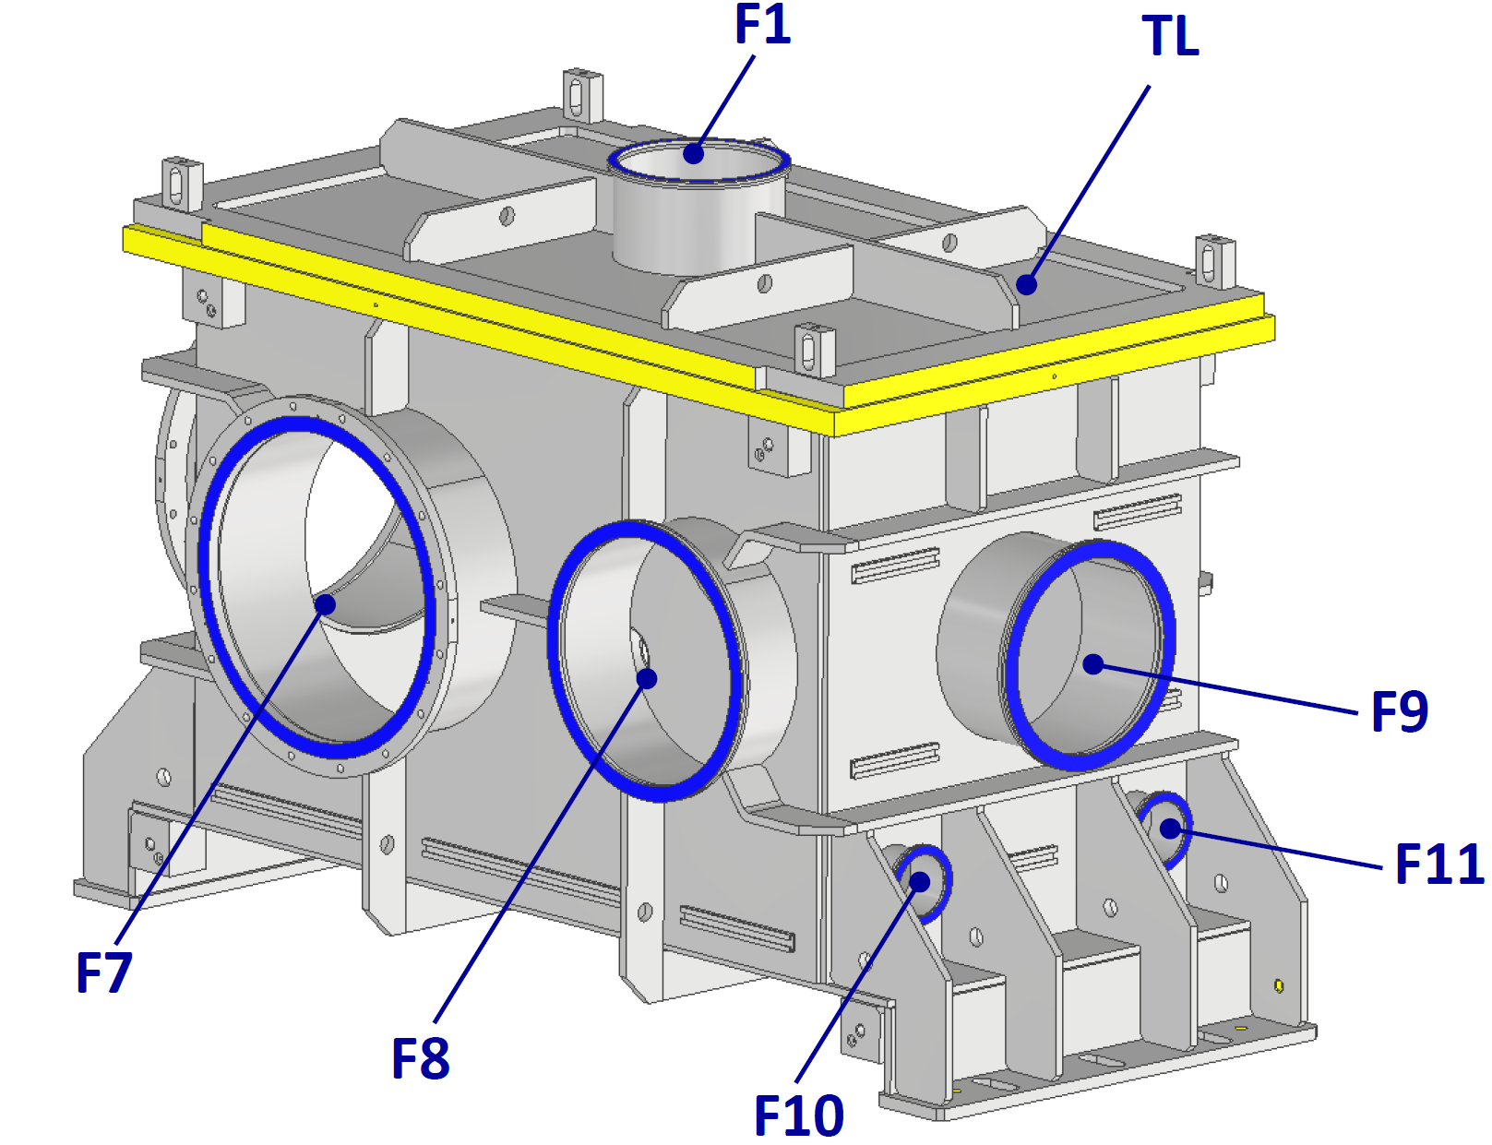

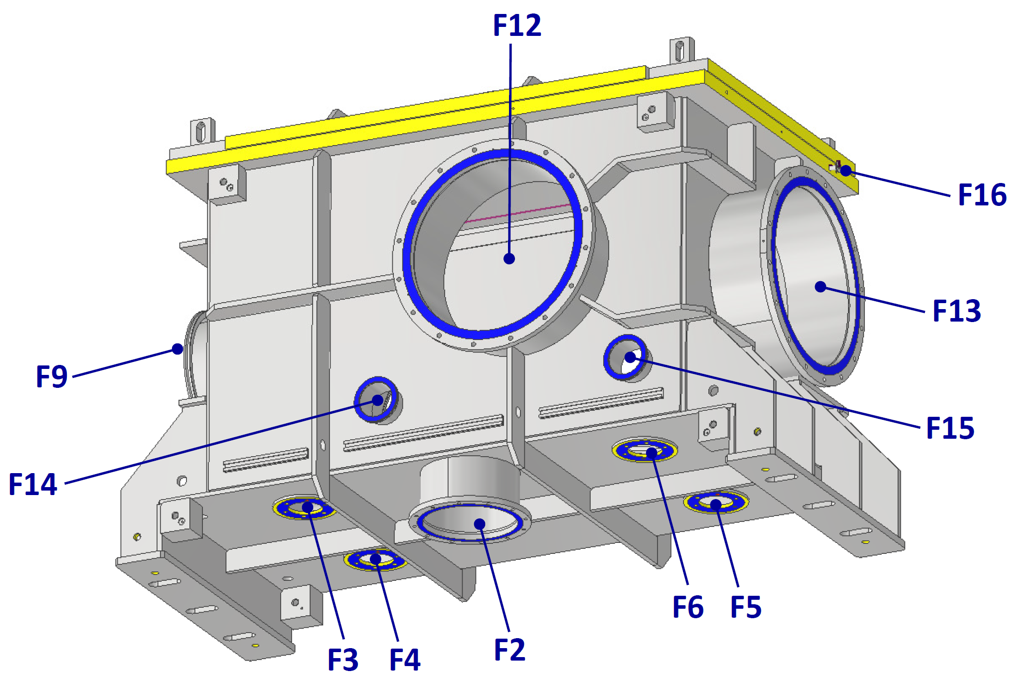
Figure 2 Top Lid and circular ISO flanges on the Chamber: view from North-East (above) and from West showing the chamber underside (below).

Flange | Size | Position / Purpose | Note | Tolerance
TL | Rectangular flange for Top Lid, overall size 1640 x 954 mm.  Flange thickness 40 mm. | Top Lid for access to Chamber interior | Top Lid thickness 10mm with reinforcing ribs to prevent its displacement at pump down.  Double O-ring seal arrangement. | N.A.
F1 | DN 250 ISO-K | Circular flange in centre of Top Lid | Will be blanked | B
F2 | DN 250 ISO-F | On Chamber underside, for possible Turbomolecular Pump | Initially closed by blank flange | B
F3 | 98-mm-diam custom flange | On underside of Chamber for connection of bellows isolation of the internal optical table | Fixing bolts inside the vacuum, see Drawing Package.  Initially closed by blank flange. | A
F4 | 98-mm-diam custom flange | Idem F3 | Idem F3 | A
F5 | 98-mm-diam custom flange | Idem F3 | Idem F3 | A
F6 | 98-mm-diam custom flange | Idem F3 | Idem F3 | A
F7 | DN 500 ISO-F | On the East side of Chamber, for beam transport to E4 | Initially closed by blank flange | A
F8 | DN 400 ISO-K | On the East side of Chamber, for access to Chamber interior | Will be blanked | C
F9 | DN 320 ISO-K | On the North side of Chamber, for access to Chamber interior | Will be blanked | C
F10 | DN 100 ISO-K | On the North side of Chamber, for cable feedthroughs | Initially closed by blank flange.  Will be equipped with vacuum electrical feedthroughs | C
F11 | DN 100 ISO-K | Idem F10 | Idem F10 | C
F12 | DN500 ISO-F | On the West side of Chamber, for beam transport from E3 | Initially closed by blank flange | A
F13 | DN 500 ISO-F | On the South side of Chamber, for beam transport to E5. | Initially closed by blank flange | A
F14 | DN 100 ISO-K | On the West side of Chamber, for cable feedthroughs. | Initially closed by blank flange.  Will be equipped with vacuum electrical feedthroughs | C
F15 | DN 100 ISO-K | On the West side of Chamber, for cable feedthroughs. | Idem F15 | C
F16 | DN 10 ISO-KK | On the South side of Chamber, for pumping of O-rings interspace of the top lid. | Initially closed by blank flange | C

Table 2 Positions and specifications of Chamber vacuum flanges.

Sections 2 to 7 of this specification provide a summary of the contractual requirements. The total scope of the contract also comprises all the requirements stated or implied in the foregoing text, whether or not included in the summaries.

Terms, Definitions and Abbreviations
For the purpose of this document, the following abbreviated terms are applied:

Abbreviation | Meaning
A | Analysis (as a verification method)
CA | Contracting Authority (Institute of Physics AV CR, v. v. i.)
DN | Diameter Nominal
ELI | Extreme Light Infrastructure
FEM | Finite Element Method
FTR | Factory Test Report
I | Inspection (as a verification method)
L4c | Identification code of hall
NCR | Nonconformity Report
RA1 | Research activity 1
RSD | Requirements Specification Document
SIR | on-Site Inspection Report
T | Test (as a verification method)
TMP | Turbomolecular Pump
VCD | Verification Control Document
VR | Verification Report

Reference Documents

Number of document | Title of Document/ File
RD-01 | Drawing package L3BT-L4c Node Chamber with lid manipulation tools

Detailed list of documentation included within RD-01 archive:

Drawing No | Filename | File format
00277401 | RD-01_A_ L3BT-L4c_Node_Vacuum_Chamber | PDF
00277402 | RD-01_B_ Wall-Mounted Side Jib Crane for Manipulating Top Lid | PDF
00277403 | RD-01_C_ Handling Frame for Sliding the Top Lid | PDF
00277404 | RD-01_D_ Vacuum Chamber Support Bracket | PDF

An overview of the RD-01 reference drawing related to the L3BT-L4c Node Chamber is shown in section 8.

References to standards
If this document includes references to standards or standardized/ standardizing technical documents the CA allows/permits also another equal solution to be offered. If a supplier offers another equal solution the CA shall not reject its bid, once the supplier by appropriate means in the bid proves that the offered supplies, services or works meet in an equivalent manner all the contractual requirements including references to standards or technical documents.

Functional, design, material, manufacture and test requirements

REQ-030858/A R2-01
The Chamber shall be detail designed and manufactured according to the requirements described herein and RD-01 assembly drawings (see Section 1.4).
Verification method: R - Review of design, T – Test, I – Inspection
REQ-030859/A R2-02
The Chamber detailed design shall make all necessary allowance for transport of the chamber to its working location. This shall include provision of designated lifting points and jacking points and positions to support the chamber on rollers for lateral movement. The lid shall also be equipped with lifting features (e.g. bosses for screw-in lifting eyes) to enable its handling by overhead crane.
Verification method: R - Review of design, I – Inspection
REQ-030860/A R2-03
The detailed design of the jib crane shall include bearings for swivelling the horizontal arm and mechanism for smooth adjusting length of this arm by means of a winch wheel, as schematically indicated in the drawings. The detailed design of the jib crane including the wall mounting plates shall be coordinated with CA in order to adapt it to the neighbouring laser beam transport systems located in L4c.
Verification method: R - Review of design, I - Inspection
REQ-030861/A R2-04
The outer side of the Chamber shall be equipped by welded sections of C-profiles as indicated in the drawings. The C-profiles will later serve for affixing electrical cables and utility piping to the Chamber.
Verification method: R - Review of design, I - Inspection
REQ-030862/A R2-05
All inner vacuum surfaces shall have roughness Ra=0.8 µm or better (i.e. smaller). If grinding is used to achieve this finish, the following rules shall apply:
- prior the grinding the cleaning procedure involving degreasing, rinsing and drying, described in REQ-0308671/A R3-01, shall be used;
- the grinding process shall not involve any abrasive paste or abrasive medium that can embed into the surface.
NOTE: the cleaning procedure described in REQ-0308671/A R3-01 can be complemented, before grinding, by laser cleaning. Details must be approved in writing by the CA before such procedure is applied.
Verification method: R - Review of design, I - Inspection
REQ-030863/A R2-06
The Chamber shall be designed and manufactured for vacuum level of 10⁻⁷ mbar or better.
Verification method: R – Review of design, T – Test
REQ-030864/A R2-07
The Supplier shall complete FEM analysis of the Chamber to demonstrate structural stability resulting in deformations of walls less than 1 mm when the Chamber is pumped down from atmospheric pressure.
Verification method: R – Review of design, A – Analysis
REQ-030865/A R2-08
The outer faces of the flanges F7 and F12 (DN500 ISO-F) shall be coaxial within a tolerance of ±0.5 mm and parallel within a tolerance of ±0.5 degrees.
Verification method: R - Review of design, I – Inspection

REQ-030866/A R2-09
The outer face of the flange F13 (DN500 ISO-F) shall have coaxial tolerance of ±0.5 mm or better with respect to its ideal axis and shall be perpendicular within a tolerance of ±0.5 degrees to common axis of the flanges F7 and F12.
Verification method: R - Review of design, I - Inspection
REQ-030867/A R2-10
The outer surface of the Chamber shall be glass bead blasted.
Verification method: R – Review of design, I - Inspection
REQ-030868/A R2-11
The Supplier shall check all major dimensions of the manufactured Chamber, as defined in the manufacturing drawings approved by the CA (see also REQ-0308696/A). The result shall be provided in the form of the Factory Test Report (see REQ-0308691/A R7-07).
Verification method: R – Review, T – Test
REQ-030869/A R2-12
After final cleaning (see R3-01) the Supplier shall assemble the Chamber in ISO7 (or better cleanliness class) cleanroom and shall vacuum test the assembled Chamber with blank flanges, bolting and O-rings which shall be part of the supply. The leak rate shall be no higher than 1x10⁻⁷ mbar·l/s. The result shall be provided in the form of the Factory Test Report (see REQ-0308691/A R7-07).
Verification method: R – Review, T – Test
REQ-0308670/A R2-13
The Supplier shall test the evacuated Chamber for deformations due to the atmospheric pressure differential. The measured deformations of the Chamber shall not exceed 1 mm at any location. The result shall be provided in the form of the Factory Test Report (see REQ-0308691/A R7-07).
Verification method: R – Review, T – Test

Cleaning and packaging requirements

REQ-0308671/A R3-01
All finished parts of the Chamber shall be degreased by thorough cleaning with high-pressure (>100 bar) water washer, using appropriate high-performance detergent (e.g. 4% solution of Brulin AquaVantage® 1990 GD or equivalent) at a temperature of at least 75°C, for no less than 3 minutes. Subsequently, the parts shall be immediately, without letting the surface to dry, rinsed in demineralised water.
The previous step, i.e. thorough cleaning with high-pressure water with appropriate high-performance detergent (e.g. 4% solution of Brulin AquaVantage® 1990 GD or equivalent), followed by rinsing in demineralised water without letting the surface to dry, shall be repeated.
Subsequently, the parts shall be dried by clean pressure gas (e.g. nitrogen) in a way not leaving traces of residues from water drops.
Using wipes wet by isopropanol or acetone as final step of the cleaning procedure of vacuum surfaces is not allowed.
Spraying or pouring of parts of vacuum surfaces by ultraclean acetone is allowed, provided it does not come into contact with any plastic parts including squirt bottles or O-rings.
Dry wiping of smooth surfaces with polyester wipes to minimize particle contamination is allowed.
NOTE: Use of specific degreasing solution must be approved in writing by CA. The CA also permits another equivalent cleaning procedure to be offered, however this must be approved in writing by the CA (see also REQ-0308696/A R7-12).
Verification method: R – Review

REQ-0308672/A R3-02
All O-rings shall be vacuum baked at temperature of 120°C for 24 hours prior to use.
Verification method: I - Inspection
REQ-0308673/A R3-03
The Chamber shall be prepared for transport with the top lid fitted and all circular flanges sealed by metal blanks cleaned to the same standard as the chamber itself.
Verification method: I - Inspection
REQ-0308674/A R3-04
The cleaned parts of the Chamber shall be wrapped in two layers of ultra-low outgassing polyethylene film (as sheet or bags) with thickness of at least 150 µm, of a type specifically for use in contamination-controlled areas. The clean conditions wrapping shall be further enclosed in robust outer packaging and transport crates as necessary for protection and handling during shipping to the ELI-Beamlines site.
Verification method: R – Review, I - Inspection
REQ-0308675/A R3-05
The vacuum chamber, the lid sliding mechanism and the jib crane shall be packed separately for transport.
Verification method: I – Inspection

Transportation Requirements
REQ-0308676/A R4-01
The supplier shall transport the completed and tested Chamber to the ELI Beamlines site
NOTE: The bid price will be considered by the CA as the final price, including transportation costs.
Verification method: R – Review, I - Inspection
REQ-0308677/A R4-02
The transportation procedure shall be reviewed and agreed by the CA.
Verification method: R - Review
REQ-0308678/A R4-03
The Supplier shall allow supervision by the CA of the activities related to the transportation.
NOTE: Any acts of supervision shall not mean that the CA assumes additional liability of any kind exceeding its liabilities according to the contract.
Verification method: R - Review
REQ-0308679/A R4-04
The flanges of the chamber shall remain sealed during transport.
Verification method: R - Review, I – Inspection

Safety Requirements

REQ-0308680/A R5-01
The Supplier shall supply a Declaration of Conformity or other equivalent document legally recognized and accepted in the Czech Republic for each product type if the appropriate legislation determines the Supplier's obligation to have a Declaration of Conformity (or the equivalent document) for the purposes of a Product sale in the Czech Republic to fulfil the requirements of 2001/95/EC directive or applicable Czech law.
Verification method: I - Inspection

Quality requirements

Documentation and data control
REQ-0308681/A R6-01
The Supplier shall supply the following relevant manufacturing documents:
- all manufacturing drawings, 3D model (see REQ-0308696/A R7-12) and design supporting documentation approved by the CA (see REQ-0308695/A R7-11 and REQ-0308696/A R7-12);
- full technical documentation on the delivered Product (e.g. storage, installation, safe operation and maintenance instructions);
- all “requests for deviation/waiver from requirements described herein” approved by the CA (see REQ-0308684/A R6-04).
NOTE: The scope of the technical documentation will be agreed with the CA during the design phase (see REQ-0308695/A).
Verification method: R – Review, I - Inspection
REQ-0308682/A R6-02
The Supplier shall use following data formats:
- *.JPG, *.PNG, *.TIFF, *.PDF/A, *.HTML
- CAD 2D: *.dwg
- CAD 3D: *.stp; *.ste; *.step or other 3D CAD formats agreed with the CA
- text processors *.doc, *.docx, OpenDocument Format
- spreadsheet processors *.xls, *.xlsx, OpenDocument Format
- presentations *.ppt, *.pptx; OpenDocument Format
Verification method: Not To Be Tracked within VCD
REQ-0308683/A R6-03
Documentation shall be supplied in the following formats: hardcopy and PDF.
Verification method: Not To Be Tracked within VCD

Nonconformity control system
REQ-0308684/A R6-04
The Supplier shall establish and maintain a nonconformity control system compatible with ČSN EN ISO 9001 (or equivalent, e.g. EN ISO 9001).
Verification method: Not To Be Tracked within VCD

Verification requirements for the Supplier
The verification process will be performed by the Supplier to demonstrate that the Chamber meets the specified requirements of the CA.

General requirements
REQ-0308685/A R7-01
The Supplier shall assign clear responsibility for the implementation of the verification process including the following activities:
- Verification planning (via VCD, see section 7.2.3);
- Verification execution and reporting (see sections 7.2.2 and 7.3);
- Verification control and close-out (see section 7.3).
Verification method: R - Review
REQ-0308686/A R7-02
The verification process shall be accomplished by the Supplier through one or more of the following verification methods:
- Review; Verification via Review (R) shall consist of using approved records (examples of such approved records are design documents and reports, technical descriptions, and engineering drawings, manuals and accompanying operation documentation) or evidence that unambiguously shows that the requirement is met.
- Inspection; Verification via Inspection (I) shall consist of a visual examination of the manufactured and/or assembled product, i.e. its physical characteristics proving that the specific requirements have been met.
- Test (including functional demonstration); Verification via Test (T) shall consist of measuring product performance and functions under realistic operating conditions. When the test objectives include the demonstration of qualitative operational performance (functional demonstration), the execution shall be observed and results recorded.
- Analysis; Verification via Analysis (A) shall consist of performing theoretical or empirical evaluations (e.g. mathematical models, calculations etc.).
Verification method: Not To Be Tracked within VCD

Verification documentation

General requirements
REQ-0308687/A R7-03
The Supplier shall establish and maintain the system of verification process documentation (see REQ-0308688/A R7-04 and REQ-0308689/A R7-05).
Verification method: Not To Be Tracked within VCD
REQ-0308688/A R7-04
Verification documentation shall consist of following basic types of documents:
- Verification reports (see section 7.2.2);
- VCD, Verification Control Document (see section 7.2.3).
Verification method: Not To Be Tracked within VCD
REQ-0308689/A R7-05
The verification reports shall be submitted to the CA for review as agreed with the CA after corresponding verification activity completion, within the time frame agreed with the CA.
NOTE: Verification activity can be design review and analysis during the Chamber development (see section 7.3.1), test and inspection after the manufacturing and installation (see sections 7.3.2 and 7.3.3).
Verification method: Not To Be Tracked within VCD

Verification reports (VRs)
REQ-0308690/A R7-06
The results of the analysis shall be documented in the corresponding Analysis Report (e.g. FEM analysis report, see REQ-030864/A, R2-07) and tracked in the VCD (see section 7.2.3).
Verification method: R - Review
REQ-0308691/A R7-07
The results of the tests shall be documented in the appropriate Factory Test Report (further “FTR”) and on-Site Inspection Report (further “SIR”) and tracked in the VCD (see chapter 7.2.3).
Verification method: R - Review

REQ-0308692/A R7-08
The results of the review of design/documentation/reports and inspection of the Chamber shall be tracked in the VCD (see section 7.2.3).
Verification method: R – Review

Verification Control Document (VCD)

The Verification Control Document (VCD) lists the requirements to be verified with the selected methods at the defined stages. The VCD is a living document which shall be used throughout the entire Contract delivery and its phases (see section 7.3 Phasing of the delivery). The VCD provides traceability during delivery phases (Qualification of Design, Manufacturing, Acceptance, etc.) and represents a formal tool of communication between the Supplier and the CA (formal record, reporting tool).

The VCD will be provided by the CA and it can be accommodated to the Supplier’s needs.

REQ-0308693/A R7-09
The Supplier shall provide a Verification Control Document (VCD) for the reviews as agreed with the CA.
NOTE 1: Guidelines for VCD preparation will be provided by the CA.
NOTE 2: The form of VCD will be agreed between the CA and the Supplier based on the best commercial praxis used by the Supplier.
NOTE 3: The form of VCD will be agreed before completion of Qualification of Design phase (see section 7.3.1).
Verification method: R - Review
REQ-0308694/A R7-10
In the VCD the Supplier shall specify HOW and WHEN each requirement is planned to be verified.
Verification method: R - Review

Phasing of the delivery
This section is intended to briefly summarize basic milestones of the Contract delivery. These milestones represent gates (checkpoints) where the quality of the delivery is to be evaluated.
Delivery shall not proceed past these gates unless their satisfactory accomplishment is approved by the CA.

Delivery lifecycle shall contain at least the following phases (quality gates):
- Qualification of Design;
- Manufacturing, cleaning and packaging;
- Transportation to ELI-Beamlines;
- Acceptance (performed by the CA).

Qualification of Design

Summary of what is to be provided by the Supplier in terms of documentation (technical documentation including manufacturing drawings, design supporting documentation and verification reports) before starting the manufacturing. The goal is to verify the manufacturing drawings and design supporting documentation.

The output of this phase is the Final set of manufacturing drawings and agreed scope of technical documentation.

REQ-0308695/A R7-11
Before completion of the Qualification of Design phase the Supplier shall provide following information that shall be agreed by the CA:
- structure and content of the verification reports (see section 7.2.2);
- scope of full technical documentation (see REQ-0308681/A R6-01);
- structure and content of the VCD ready to be implemented (see section 7.2.3).
Verification method: R - Review
REQ-0308696/A R7-12
Before completion of the Qualification of Design phase the Supplier and the CA shall agree on:
- final manufacturing drawings and 3D model provided by the Supplier (see REQ-030858/A R2-01);
- detailed procedures related to the testing and cleaning (see REQ-0308671/A R3-01);
- common nonconformity control system (see REQ-0308684/A R6-04).
Verification method: R – Review

Manufacturing
The goal is to demonstrate that the manufactured Chamber meets the requirements specified in sections 2 and 3 and is ready to be delivered to the CA. This quality gate concerns primarily:
- Inspection of the Chamber for Manufacture Quality;
- Cleaning of the Chamber;
- Assembling and Testing at the Supplier’s site (factory testing);
The output of this phase is the Manufactured and verified Chamber.

REQ-0308697/A R7-13
The results of the Manufacturing phase of verification shall be recorded by the Supplier in the appropriate FTR (see REQ-0308691/A R7-07) and overall results (including the review of documentation/reports and inspection of the Chamber) shall be tracked in the VCD (section 7.2.3).
Verification method: R - Review

Transportation
The goal is to demonstrate that the delivered Chamber meets all requirements specified herein.
Verification of the Chamber is executed by the Supplier after completion of each sub-stage including delivery and transportation.

This quality verification concerns primarily:
- Packaging;
- Transportation to the final destination;
- Inspection of the delivered Chamber and required documentation.

The output of this phase is the Verified delivered Chamber.

REQ-0308698/A R7-14
The results of the verification of delivered Chamber shall be recorded by the Supplier in the appropriate SIR (see REQ-0308691/A R7-07) and overall results (including the review of reports and inspection of the Chamber) shall be tracked in the VCD (see chapters 7.2.3).
Verification method: R - Review
REQ-0308699/A R7-15
The final issue of the VCD shall be submitted to the CA after the approval of the last report and before starting the Acceptance phase (see chapter 7.3.4).
Verification method: R – Review

Acceptance
Acceptance will be carried out by the CA upon inspection of the Chamber after delivery (see section 7.3.3).
The basis for acceptance will be completed VCD summarizing the overall verification results together with relevant documentation supporting the verification (i.e. VRs, approved manufacturing drawings and 3D model, full technical documentation, etc.).
Following a successful acceptance phase the CA will provide the Supplier with a signed acceptance protocol. In case of unsuccessful acceptance, the CA will provide to the Supplier a Nonconformity Report (NCR) and process in accordance with REQ-0308684/A shall be followed.

REQ-030900/A R7-16
The Acceptance phase shall demonstrate the following:
- The Chamber has been successfully verified by the Supplier and the results of this process have been documented in the appropriate way through VRs (see section 7.2.2) and VCD (see section 7.2.3);
- All detected nonconformities have been solved in accordance with REQ-0308684/A R6-04;
- The Chamber is free of fabrication errors and is ready for the intended operational use.
Verification method: Not To Be Tracked within VCD

ANNEX: Drawings

[vypuštěno]

