Supplier: | Customer:
Department of Electronics and Information Technology
University of West Bohemia | Institute of Experimental and Applied Physics
Univerzitni 8 | Czech Technical University in Prague
306 14 Pilsen | Husova 240/5
Czech Republic  ID: 49777513, Tax number: CZ49777513  Contact person:  Petr Burian  Tel.:  Email: | 110 00 Prague 1  Czech Republic  Email:
Pilsen, 29th September 2020
Quotation: Katherine readout for Timepix3 (with special housing)
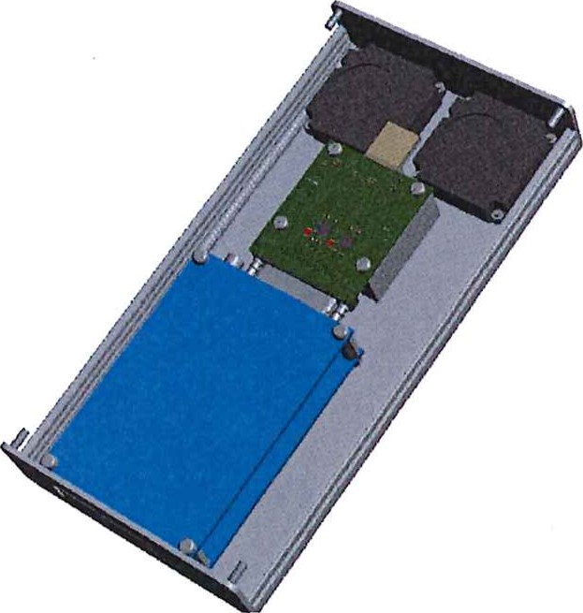
Subject of delivery:
Katherine readout for Timepix3. The item contains the readout device, the 5V power supply unit. Chipboard and Timepix3 assembly are not included. Device will be mounted in special housing covering chipboard as well. In the housing there is a pair of fans for cooling.
Subject | unit price | pcs | final price
Katherine readout for Timepix3 (with special housing) |  | 10
Delivery anf financial conditions:
The price does not include VAT. Timepix3 detectors and chipboards are not included.
Delivery costs are not included and will be invoiced separately.
Delivery time is 90 days from receipt of the order. This quotation is valid until 30th October 2020.
doc. Ing. h.D.

