Cenová kalkulace
p/n produkt ks | cena/ks | Celkem bez DPH
Acer TMP257-M-37US i3-5005U / 4GB+N / 500GB 7200ot+N / DVDRW /  NX.VBKEC.006 HD Graphics / 15.6” HD matný / BT / W7 Pro+W10 Pro / Black 5 | 12 890 | 64 450
RFS4010 Motorola RFS4010 Wired/Wireless N Ent. Router Service Controller with 3G Service 1 | 20 990 | 20 990
J9660A HP 1810-48G Smart SWITCH 1 | 11 936 | 11 936
SLM2048T-EU Cisco SG200-50, 50xGigabit, Smart, SLM2048T-EU 1 | 11876 | 11 876
SRW224G4-K9-EUCisco SF300-24, 24x10/100 +2xGig+2xComboSFP Switch 1 | 4202 | 4 202
ES-108AV3-EU010ZyXEL ES-108A v3 8-port 10/100 7 | 327 | 2 289
V11H720040 3LCD Epson EB-X31 XGA 3200 Ansi 15000:1 1 | 13640 | 13 640
0281C010 Canon LASER i-SENSYS LBP251dw - 3 roky záruka 3 | 3808 | 11 424
CZ173A#B19 HP LaserJet Pro MFP M125nw /A4,20ppm, USB,LAN,WLAN 1 | 3 233 | 3 233
Oprava PC 1 | 5 836 | 5 836
GA-H110M-S2H GIGABYTE MB Sc LGA1151 H110M-S2H, Intel H110, 2xDDR4, VGA, mATX |  | 0
BX80662I36100CPU INTEL Core i3-6100 3,7GHz 3MB L3 LGA1151, VGA - BOX  KVR21N15S8/4 DIMM DDR4 4GB 2133MHz, CL15, SR x8, KINGSTON ValueRAM |  | 0  0  0
Oprava PC, konfigurace wlan, zapojení do domény, instalace 1 | 9500 | 9 500 0  0
Cena celkem bez DPH 159 376
Cena celkem s DPH 192 845
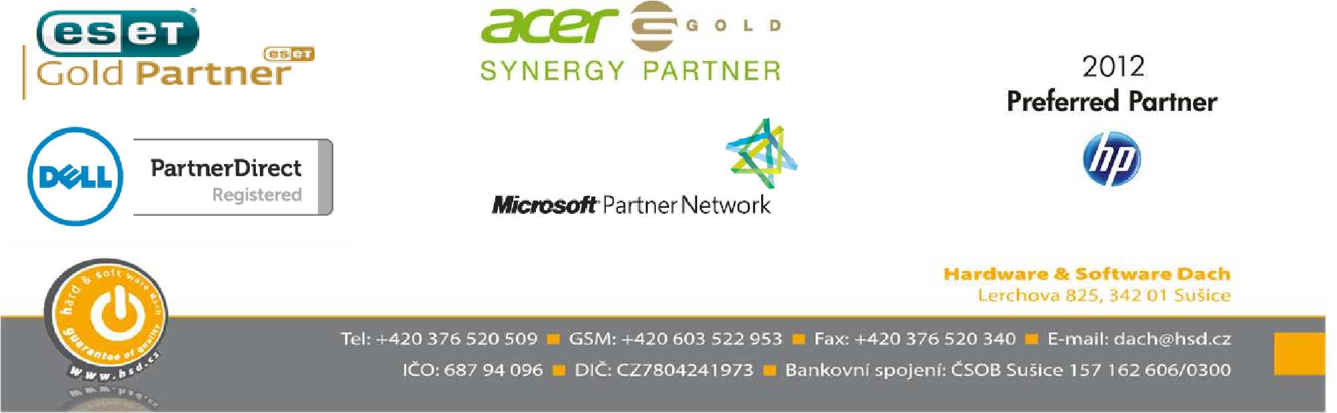
Pokud budete mít jakýkoli dotaz neváhejte mě kontaktovat. S pozdravem Bohumil Dach

