Příloha č. 2 Kupní smlouvy
Annex 2 to the Purchase Agreement

Strain-gauge data acquisition system for CTU FTS

Elsys AG Solution Description

Strain Gauge Pre-Amplifier

Position | # of Pcs | Specification
20 | 1 | Amp-BU-24-MK2  - 19 Inch Rack  - Up to 12 SGA-MK2 Rack Insert Modules (24 Channels)  - 230V Power Supply  - USB Interface for channel configuration  - Incl. Control Software
21 | 6 | SGA2-MK2 Strain Gauge Amplifier  - Gain 1, 10 , 100  - 5V / 10 V Bridge Excitation  - Quarter/ Half / Full Bridge Mode  - 7-Pol Lemo Input Connector, BNC Output  - Auto-Bridge Balancing  - High Band-Width (1.5MHz at Gain 1/10)  - https://www.elsys-instruments.com/en/products/straingaugeamplifier.php
22 | 12 | Lemo cable connector 7-pol  - FGG.1B.307.CLAD62
23 | 12 | BNC Cable SGA2-MK2 DAQ

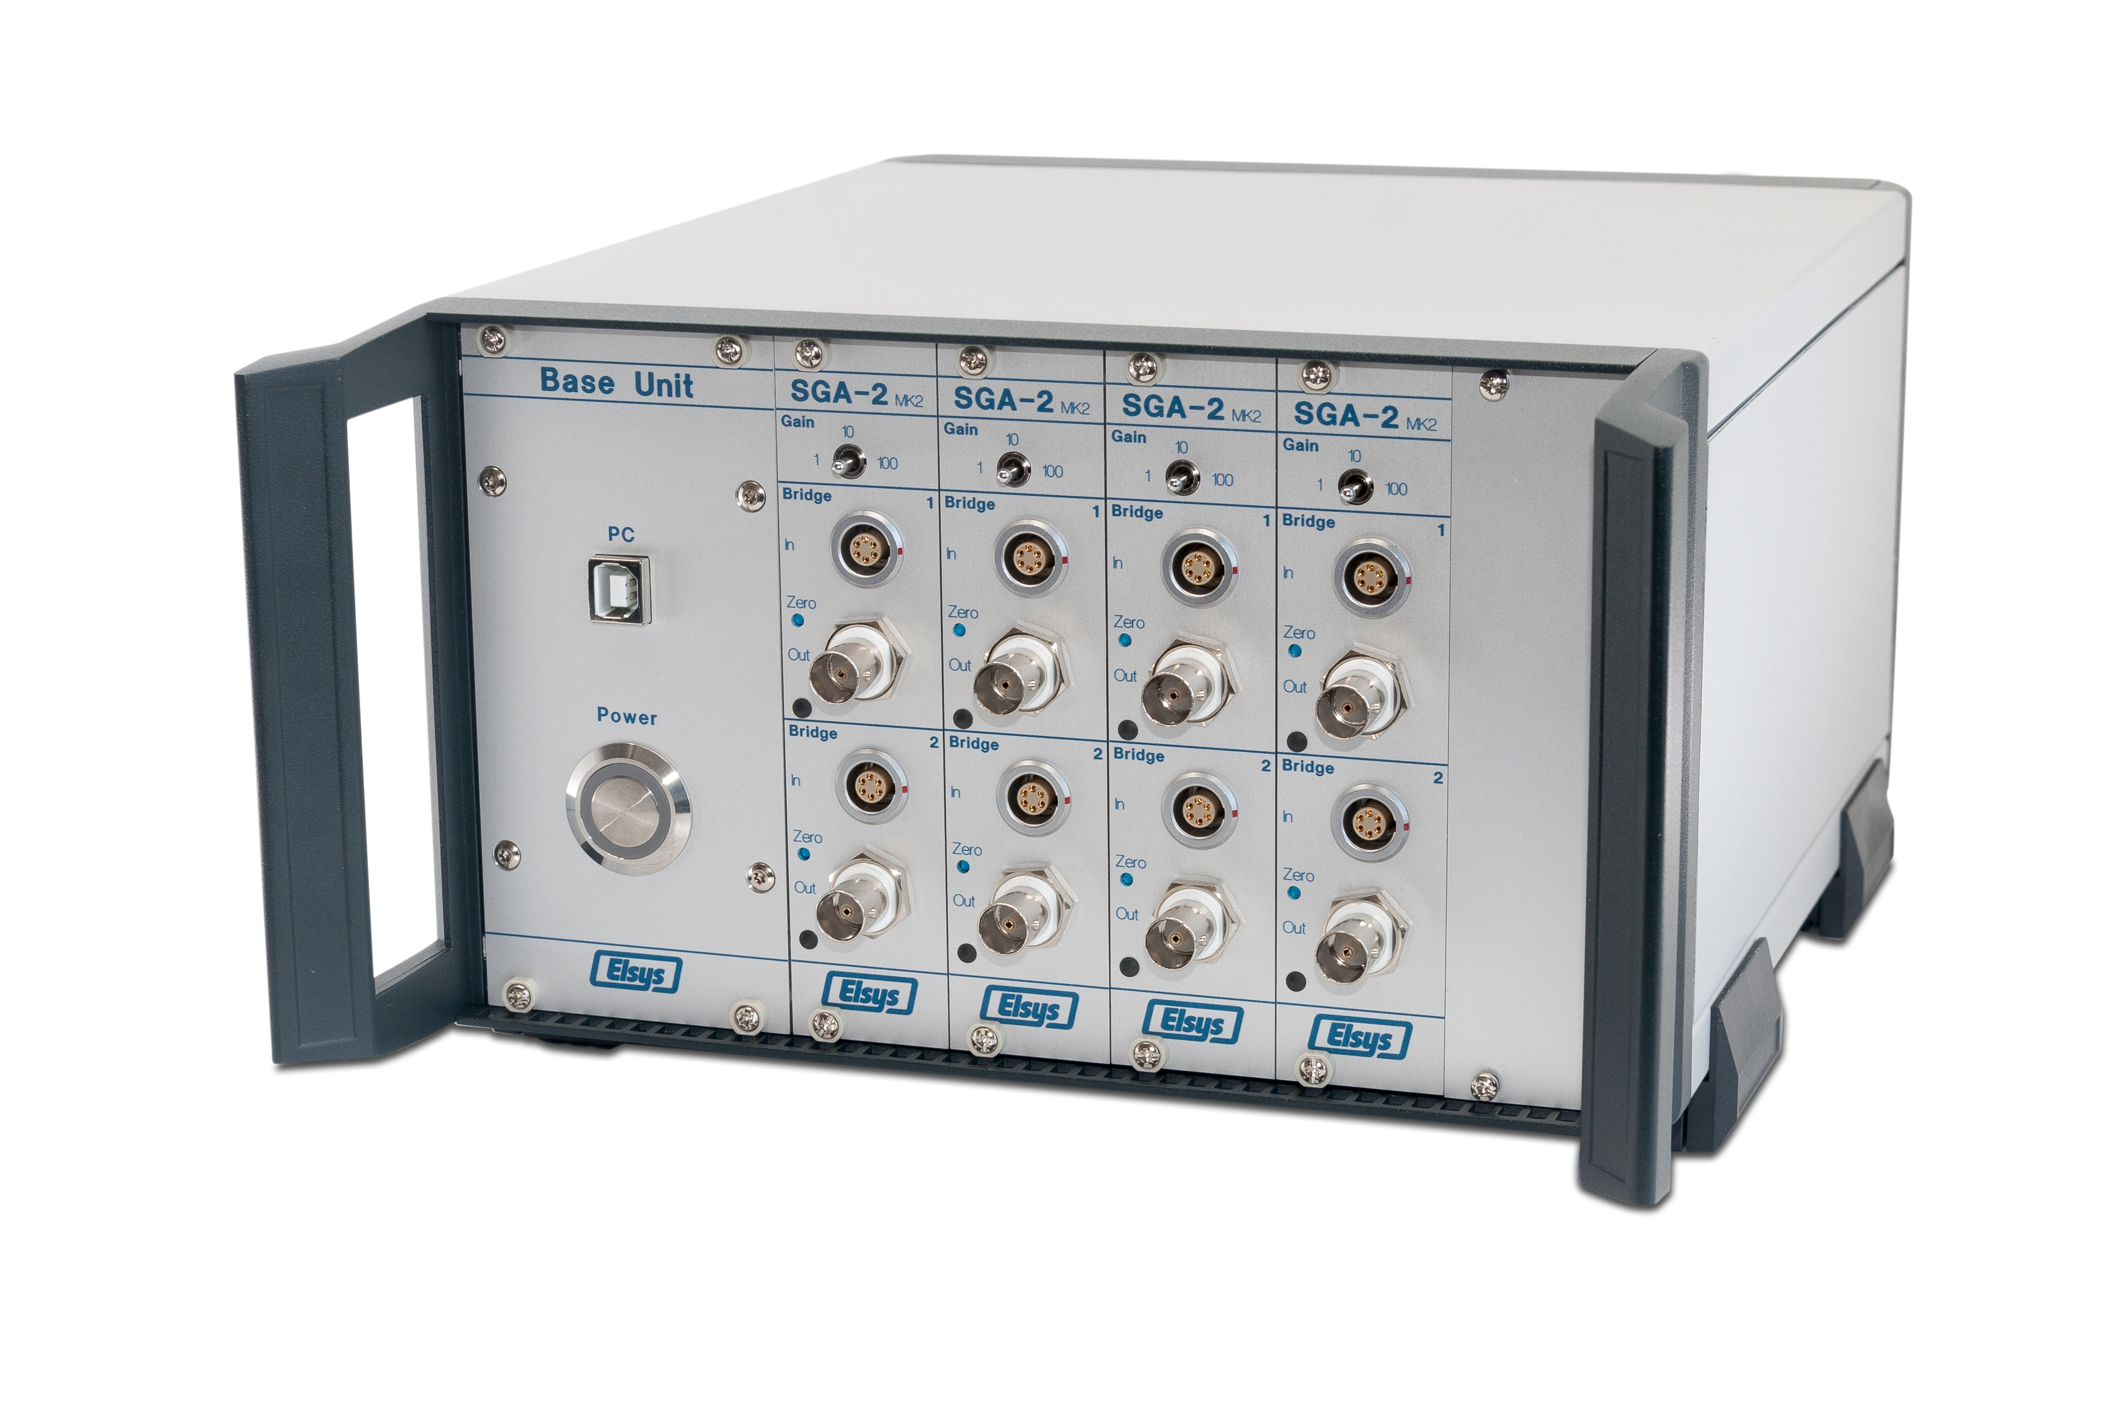
Picture as example only

Data Acquisition System

Position | # of Pcs | Specification
10 | 1 | TraNET EPC  - Industrial PC in a 19 Inch case for up to 32 channels  - Intel i5 or better CPU, 8 GB RAM, SSD System drive  - Windows 10, 64 Bit  - 1 TB Data Drive  - without Monitor  - https://www.elsys-instruments.com/en/products/data-acquisition-system-tranet-epc.php
11 | 1 | TPCE-1016-8S DAQ Module  - 8-ch Single Ended or 4-ch differential inputs  - Max Sampling rate: 5 MS/s 16 Bit, 10 MS/s 14 Bit  - On-Board Memory 8x16M  - Input Range per channel: ±50mV - ±50V  - Anti-Aliasing Filter, 200 Hz – 5 MHz cut-off frequency  - BNC Input Connector  - https://www.elsys-instruments.com/en/products/tpce_data_acquisition_card_pcie.php
12 | 1 | TPCE-1016-4D DAQ Module  - 4-ch Single Ended or 4-ch differential inputs  - Max Sampling rate: 5 MS/s 16 Bit, 10 MS/s 14 Bit  - On-Board Memory 4x32M  - Input Range per channel: ±50mV - ±50V  - Anti-Aliasing Filter, 200 Hz – 5 MHz cut-off frequency  - BNC Input Connector (+- BNC-Pair per Input Channel)  - https://www.elsys-instruments.com/en/products/tpce_data_acquisition_card_pcie.php
30 | 1 | TranAX 4 Data Acquisition Software  - https://www.elsys-instruments.com/en/products/tranax4_data_acquisition_software.php

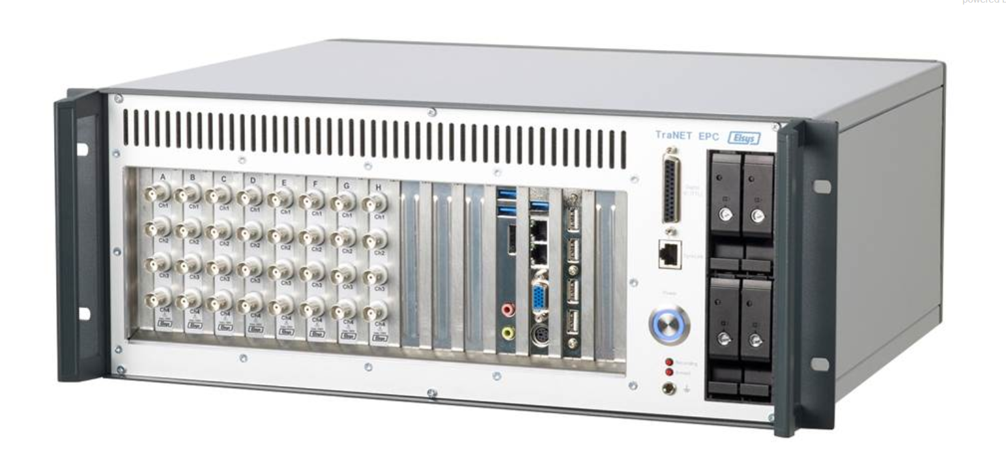
TraNET EPC – Example Image

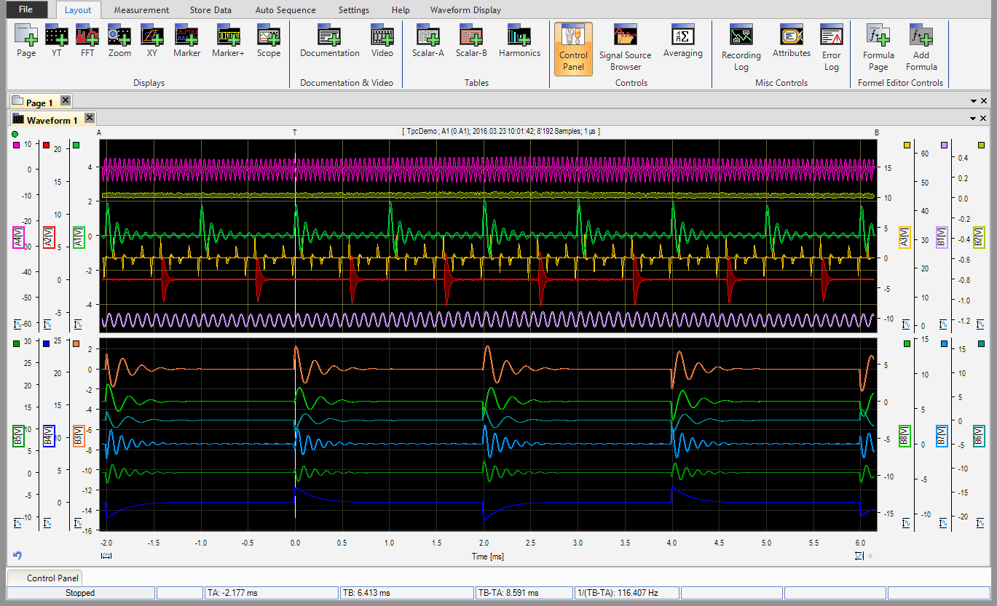
TranAX 4 DAQ Software

Additional Services included in the price

- Calibration Certificate for SGA Amplifier and DAQ Modules
- ½ Day Online Training
- Transport and Insurance
- 24 Month Warranty

Niederrohrdorf, 05.06.2020/RB

