**Concert Hall for Prague:**

**Feasibility Study Brief**

Predesign stage

Strategic planning document

**SECTION 1 – FEASIBILITY STUDY BRIEF**

**SECTION 2 – PROJECT SITE**

**SECTION 3 – OTHER MATERIALS**

**SECTION 1 – Feasibility Study Brief**

**Preamble:**

* In its Cultural Policy Concept for 2017–2021, Prague has set the goal to offer a certain level of cultural events and cultural life in the city that will “long stand up to the competition of other European cities”.
* “Although the volume of funding spent on culture in Prague is high and the city naturally enjoys a high concentration of national and other cultural institutions that are financed by the government, foundations or private sector, the quality and structure of cultural events fails to match the reputation and capabilities of the city.”
* “To achieve the goals of cultural policy, the city management will employ activate at all levels, from its own contributory organizations to investment in the infrastructure. To this day, certain areas of culture and art are not backed by institutions and technical facilities with twenty-first century standards. Prague lacks an appropriate concert hall. Its future construction is declared in the Memorandum of Cooperation and Mutual Support in the Creation of a New Concert Hall between the City of Prague and the Association for the Construction of a New Concert Hall in Prague, approved by City Council resolution no. 587 of 27. 04. 2010.”
* The above mentioned Memorandum declares: “The need to build a new concert hall in Prague as part of a modern cultural centre meeting world-class standards of the twenty-first century and also confirming Prague’s international reputation as a cultural metropolis and symbol of internationally respected Czech music tradition is made more acute by the fact that despite considerable investment from the city into culture and huge development of infrastructure services focusing on tourism, a modern concert hall has not been built in Prague in the last hundred years. Despite the indisputable importance of both historical concert halls currently being used to hold classical music concerts—the Dvořák Hall in the Rudolfinum (1885) and Smetana Hall in the Municipal Building (1914)—it must be said that neither of these halls nor the other spaces used for concerts in Prague fully meet the requirements of the twenty-first century”, and also: “... despite the turbulent development of the city and its infrastructure, with the exception of the National Technical Library, not a single public building has been built in recent decades that represents a natural centre or symbol of a newly developed or rehabilitated area.”
* The city intends to build a new concert hall in Prague as part of a contemporary music centre that meets world-class standards (in terms of acoustics, capacity, building layout, equipment, architecture and urban design) and will also confirm Prague’s international reputation as a cultural metropolis and symbol of Czech music tradition. Prague City Council Resolution number 2033 of 29. 08. 2017 recommended “Vltavská” as the site to construct the new concert hall.

**Project site and its limitations:**

* The Vltavská area is located on the south bank of the Holešovice meander on the edge of the Letná quarter and the brownfield of the former Bubny freight yard. Today, the area is mainly shaped by transport infrastructure and man-made height differences in the terrain. The river is cut off by busy roads (Nábřeží Kapitána Jaroše and on-ramps to Hlavka’s Bridge). Another barrier is formed by the north-south “magistral” highway and a railway line in the eastern part of the area.
* The complete transformation of the entire Vltavská area is envisaged for the future, including the related transformation of the Bubny area. The future appearance will be based on a land use study that has been included in this Brief for the Feasibility Study (see SECTION 2). The anticipated capacity of the area is based on the currently proposed Prague Metropolitan Plan.
* Transformation of the area will include the construction of a new railway station, Nové Bubny, which will connect directly to Václav Havel Airport.
* All land parcels concerning the construction of the new concert hall are owned by the City of Prague and government-controlled entities.

**Input parameters and project goals:**

* The main project goal is to build a contemporary concert hall in Prague that will be the starting point for transforming the entire Holešovice – Bubny – Zátory brownfield area and will become the centre of musical life in Prague. The city’s aim is to create a new, lively, open and accessible public cultural space that will be used throughout the day by all visitors to the city and Prague residents especially.
* The most important parameter of the main concert hall is its acoustics, which should be of the best possible quality at the time of construction to make it a world-class venue. The Contracting Authority assumes that the main concert hall will have natural acoustics and be used for classical, especially symphonic music performances.
* Considering the desired acoustics quality, the anticipated capacity of the main concert hall is 1800–2200 spectators.
* The main concert hall set-up must be arranged to provide a new and different music experience of music than the two current Prague halls (Dvořák and Smetana halls). The spectator must be drawn into the performance while also maintaining the intimacy of the hall. There must be balance in the relationship between spectator and performer, and between the spectators themselves.
* Another smaller hall will be located in the building, whose capacity should be determined by this study.
* Considering the importance and uniqueness of the project, the architecture must be distinctive and high quality, emphasizing synergy with the surrounding urban areas and ensuring the quality of adjacent public spaces. At the same time, this will be a building of high structural and technical standards.
* A priority concern for the urban environment is the direct connection of the new building with the river.
* A priority aspect of the proposed building’s Schedule of accommodation (use and layout of the building) is the function of the surrounding city/location and incorporation of the new building into the structure of currently existing cultural facilities (in the context of the whole of Prague and Prague 7). The building must include facilities to maximize its use by the general public without disrupting the operation of the concert hall, thereby maximizing revenue for building operations.
* A priority aspect of the decisions regarding the manner of operation and financing should depend heavily on the economic viewpoint and long-term sustainability of the project.

**Subject matter of the contract:**

* The subject matter of the contract is the preparation of a feasibility study in conjunction with the city’s plan to build a new concert hall in Prague suitable for the twenty-first century standards and needs. The site for constructing the concert hall is located near the Vltavská Metro Station in Prague 7, Holešovice.
* The study will be used to:
  + Examine in details the best possible use of the building and answer to questions of who should operate, use and finance the building, and in what manner with respect to the city’s goal to increase the quality of cultural events in the capital, making sure that the new building, whose heart will be the concert hall, is not only modern and unique to Prague and the Czech Republic, but is significant to Europe as well.
  + Support the decisions of the Prague City Council regarding further stages of the project: based on an evaluation of all potential alternatives, the Contracting Authority’s goal is to find 3–4 variants and one best possible use and layout of the building. These will be submitted to the Prague City Council to for decisions about the next phase of the project.
  + Preparation of Design Competition Brief to design a new concert hall building for Prague. The aim of the competition will be architectural design of the new building and its precise allocation within the Project Site. (see SECTION 2 – PROJECT SITE, part E).

**Purpose of the Feasibility Study (requirements for conducting the Feasibility Study):**

* The purpose of the Feasibility Study is to find the most suitable solution for the contracted work that meets the best the Contracting Authority’s requirements included in this procurement documentation.
* The Contracting Authority expects that all areas and topics addressed will be elaborated to such degree that they will be sufficiently comprehensible to the Contracting Authority and thus provide a clear basis for further decisions regarding the direction of the project. The document should be clear enough so that no further questions are raised regarding the basis of the contracted work before the Contracting Authority makes any further decisions.
* To examine and propose the manner in which the Vltavská site will be used:
  + What is the additional demand for use (excluding the main concert hall) in the Prague metropolitan region and the district of Prague 7?
  + What is the maximum possible ground surface and below-ground surface for the use of the project site? What other functions and services should the new building ensure and provide with respect to the global city’s function?

The Contracting Authority’s preference is that the proposed approach should examine the use of the site in sufficient detail (i.e. take into account demographic, socio-cultural, construction, technical, environmental and economic aspects, or possibly other select relevant aspects). The proposed solution should take into account the international, metropolitan and local context.

* To examine and propose Schedule of accommodation (use and layout) of the new building for concert hall :
* Examine additional programme and uses of the building, i.e. define everything in addition to the main concert hall that the new building should offer, to ensure that it will be an open, fully usable space at any time seven days a week with respect to attracting interest on a local, national and European scale.
* Examine what conditions must be met in order to achieve the main goal of the project set in part “Input parameters and project goals” (e.g., with respect to acoustics, interior configuration of the hall and the entire building, technology used, spatial limitations, etc.).
* Examine how the new building could be unique in the global context.
* Examine what conditions must be met to construct the new concert hall in order to create new demand from new groups of residents.
* Examine the interior layout of the building with regard to degree of variability, flexibility and adaptability of individual spaces.
* Examine the layout of the building with regard to the mutual interdependence and correlation of interior spaces and the possibility of using them at the same time for different events.
* Examine how the building could be flexible in capacity for potential growth to possible future needs and yet unknown emerging market (increased capacity, new musical directions, digital presentations, lighting etc.).
* Examine contemporary ecological trends in the construction of similar buildings.
* Examine and propose the types of the outdoor events that could be held outside of the building and recommend suitable types of performances, audience capacity, target groups and layout of this space while ensuring maximum comfort for the visitors of the building.
* Examine and propose opportunities for public education and learning spaces inside the new building. Define what conditions must be met and what the operational and economic impacts will be.
* Examine the anticipated capacity (1800–2200 spectators) of the main concert hall with respect to anticipated concert-going trends and long-term operational sustainability. The fundamental criterion for determining the capacity of the main hall must remain in achieving the best possible acoustics.
* Examine possible multi-function use, including types of events that could take place in the main hall (i.e. variants where the main hall is used for purposes other than performing classical symphonic music) with regard to permanent quality of acoustics, operational, technical and economic impacts, while ensuring sufficient quality of these events in accordance with performance requirements and the use of high end lighting and audio-visual technology.
* Determine the capacity of the smaller hall with regard to anticipated concert-going trends and long-term operational sustainability.
* Examine the multi-functionality of the small hall with respect to operational and economic impacts.
* Examine and propose whether the building should also have other halls (specifying capacity and variability of use) in addition to the main hall and the small hall with regard to anticipated concert-going trends and long-term operational sustainability.
* Examine and propose other operations and usage that would make the building more attractive to visitors and increase revenue.

The Contracting Authority’s preference is that the proposed approach and solution should examine the future use/function of the building in sufficient detail (i.e. take into account demographic, socio-cultural (city/state policy), operational (events and use, cultural role in the city and neighbourhood) and economic aspects (supply and demand, occupancy and attendance, financial sustainability) and other select relevant aspects.

The Schedule of accommodation should be based on the demand for use from the entire city and the district of Prague 7. It should also seek use that emphasizes the unique and modern character of the building with respect to usability and economic viability.

* To examine and propose the manner of operating the building.
  + Examine and propose possibilities for the ownership, administration, management and operation of the building, including an assessment of the advantages and disadvantages of these variants.
  + Consider and evaluate the following operational models: “*stagione”* (no orchestra resides at the building), philharmonic residence (the building is the residence of a select Prague or national orchestra), residence of several philharmonics (combination of Prague and national orchestras).

The Contracting Authority expects that the criteria and approach to determining the ideal building operations will be selected appropriately (i.e. they will include economic (financial sustainability, cultural policy of city/state) socio-cultural aspects (occupancy, attendance, types of use, positive impact on cultural level of society, cultural ties to the city and surroundings) and include an assessment of the advantages and disadvantages of various operational models, including the involvement of stakeholders.

* To examine construction costs and possible project financing (state, city, private sector).
* How should construction investment be financed with respect to its future operation?
* What will the efficiency and long-term sustainability of operations for the entire concert hall building be?
* What variants are there for financing the construction of the concert hall building and what are their advantages and disadvantages?

The Contracting Authority expects that the approach, method, data sources and degree of detail will be appropriately selected in order to determine the amount of construction investment and costs for subsequent building operations.

* To examine costs for building operations.
* To examine the amount of conditional investment for modifying the project site.
* To examine the approaches and processes used for similar public contracts and major foreign projects and the way these projects were managed.
* To define major project risks and how these risks can be mitigated.
* To propose a project timeline and financial schedule.
* The schedule should run up to the commencement of operations, detailed at least according to month and at most by quarters. As part of the evaluation, the tender participant will prepare a schedule for conducting the Feasibility Study.

The Contracting Authority’s preference is that the proposed approach should examine the involvement of a suitably selected range of stakeholders in sufficient detail (the choice and number of stakeholders and degree of their involvement should be appropriately selected and justified, and the proposed scheduling of actor involvement should be appropriate, logical and comprehensible). Sufficient detail should also be given to the sequence and dependence of individual proposed activities, procedures and outputs. The Contracting Authority also anticipates close cooperation with the contractor and an interim report on project progress. The Contracting Authority’s notion of the basic project approach is presented in the table below. It is assumed that the contractor will add additional details to this schedule (table) but will comply with the minimum stage performance and payment volume.

|  |  |  |
| --- | --- | --- |
| **Stage** | **Deadline** | **Price of stage** |
| **Stage 0**  The stage will include at least the following steps:   * Drafting and approving the entire project plan * Drafting and approving the Stage 1 of the project including a list of documents and source materials acquired * More detailed elaboration of Stage 1 schedule TO BE COMPLETED BY CONTRACTOR | To be completed by contractor | Payment max. 10% of total amount upon completion of stage. |
| **Stage 1**  The stage will include at least the following steps:   * Interim report from the Contractor approx. once every 14 days * Consultation with key actor (stakeholders) * Presentation of progress to the contracting authority and decision regarding further steps (narrowing down to 3–4 possible solutions, including justification) * Drafting and approving Stage 2 of the project * More detailed elaboration of Stage 2 schedule TO BE COMPLETED BY CONTRACTOR | To be completed by contractor | Payment of max. 50% of overall amount. |
| **Stage 2**  The stage will contain at least:   * Interim report from the Contractor approx.once every 14 days * Detailed examination of selected variants * Presentation to the contracting authority and selected actors (stakeholders) * Incorporation of comments from the contracting authority * Handover of a clean copy (final document)   More detailed elaboration of Stage 2 schedule TO BE COMPLETED BY CONTRACTOR | To be completed by contractor | Payment min. 40% of total amount  (after handing over the clean copy). |

**Notes:**

* The Contracting Authority expects to work closely with the selected contractor to conduct the Feasibility Study, and after signing the contract, The Contracting Authority will provide all available information and cooperation necessary. Materials the Contracting Authority possesses are contained in Section 3 of this brief.
* The Contracting Authority expects the contractor will use information and data from comparable international concert halls when conducting the Feasibility Study. The concert halls will be assessed in the study and recommendations made to the Contracting Authority (outlining both advantages and disadvantages), or certain exceptional features of a particular hall will be highlighted. The Contractor will also assess the beneficial impacts these comparable buildings have had on their surroundings.
* The Contracting Authority expects a CBA (Cost - Benefit Analysis) to be prepared as part of the Feasibility Study. A key aspect will be weighing the attractiveness of the project and benefits for society against the costs of its implementation and subsequent operation.
* As the Feasibility Study is conducted, the Contracting Authority expects to create an expert working team that will cooperate with Contractor and will be part of the Feasibility Study process.
* The Contracting Authority requires the study to include defining a vision for the entire project. The Contracting Authority will provide the Contractor full cooperation in preparing this aspect.

**Section 2 – Project Site**

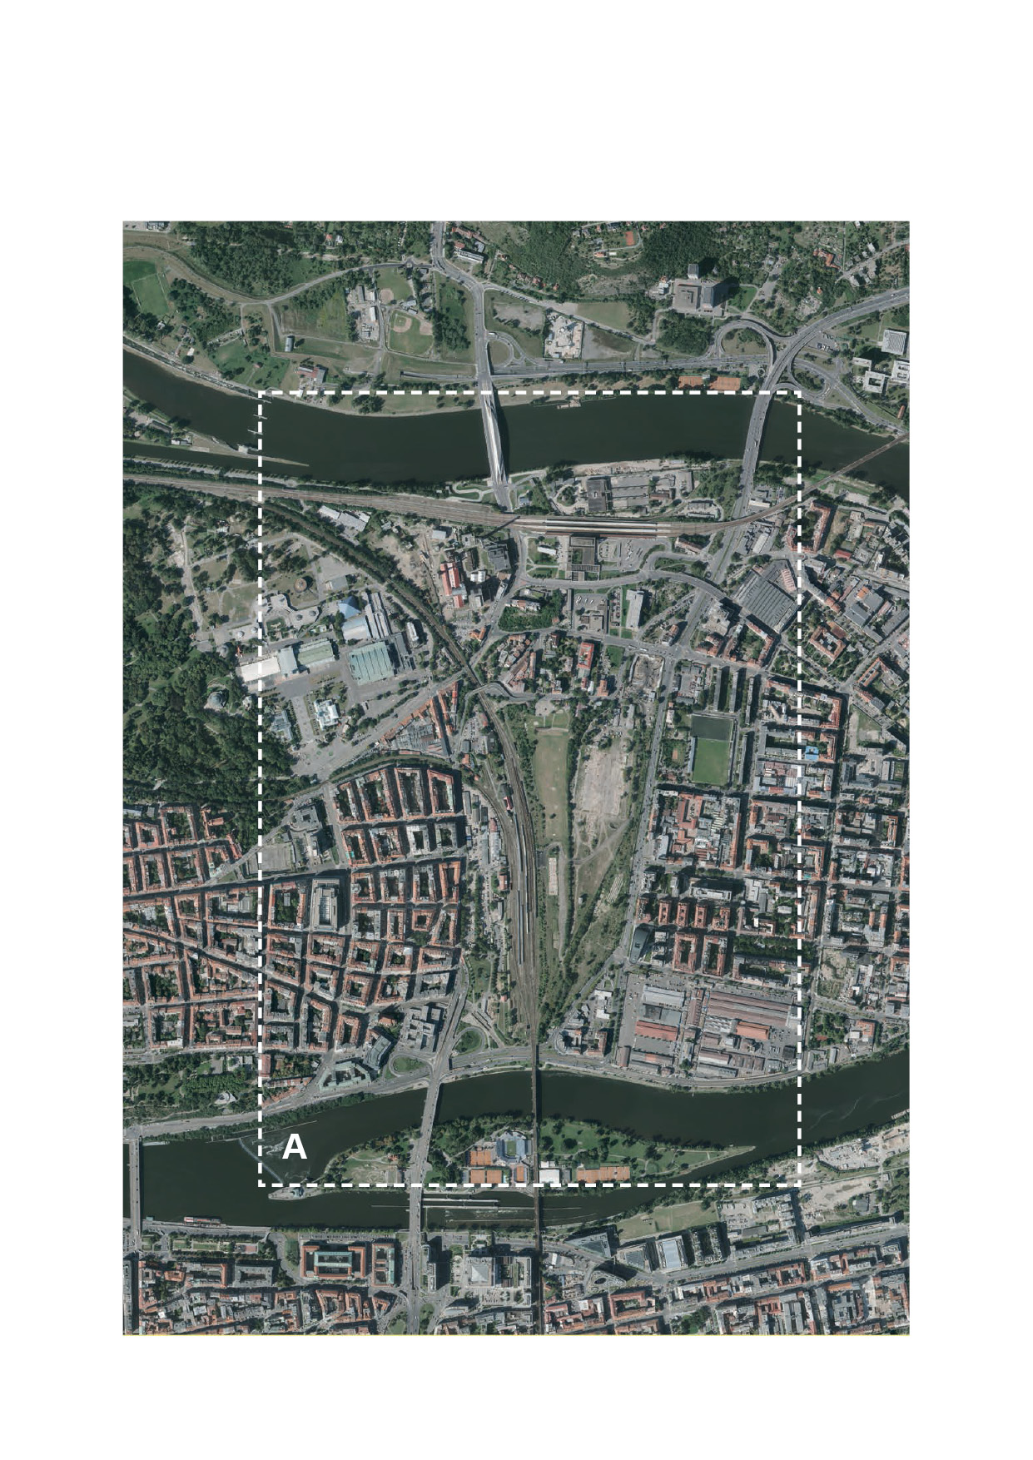**A. Broader relationships**

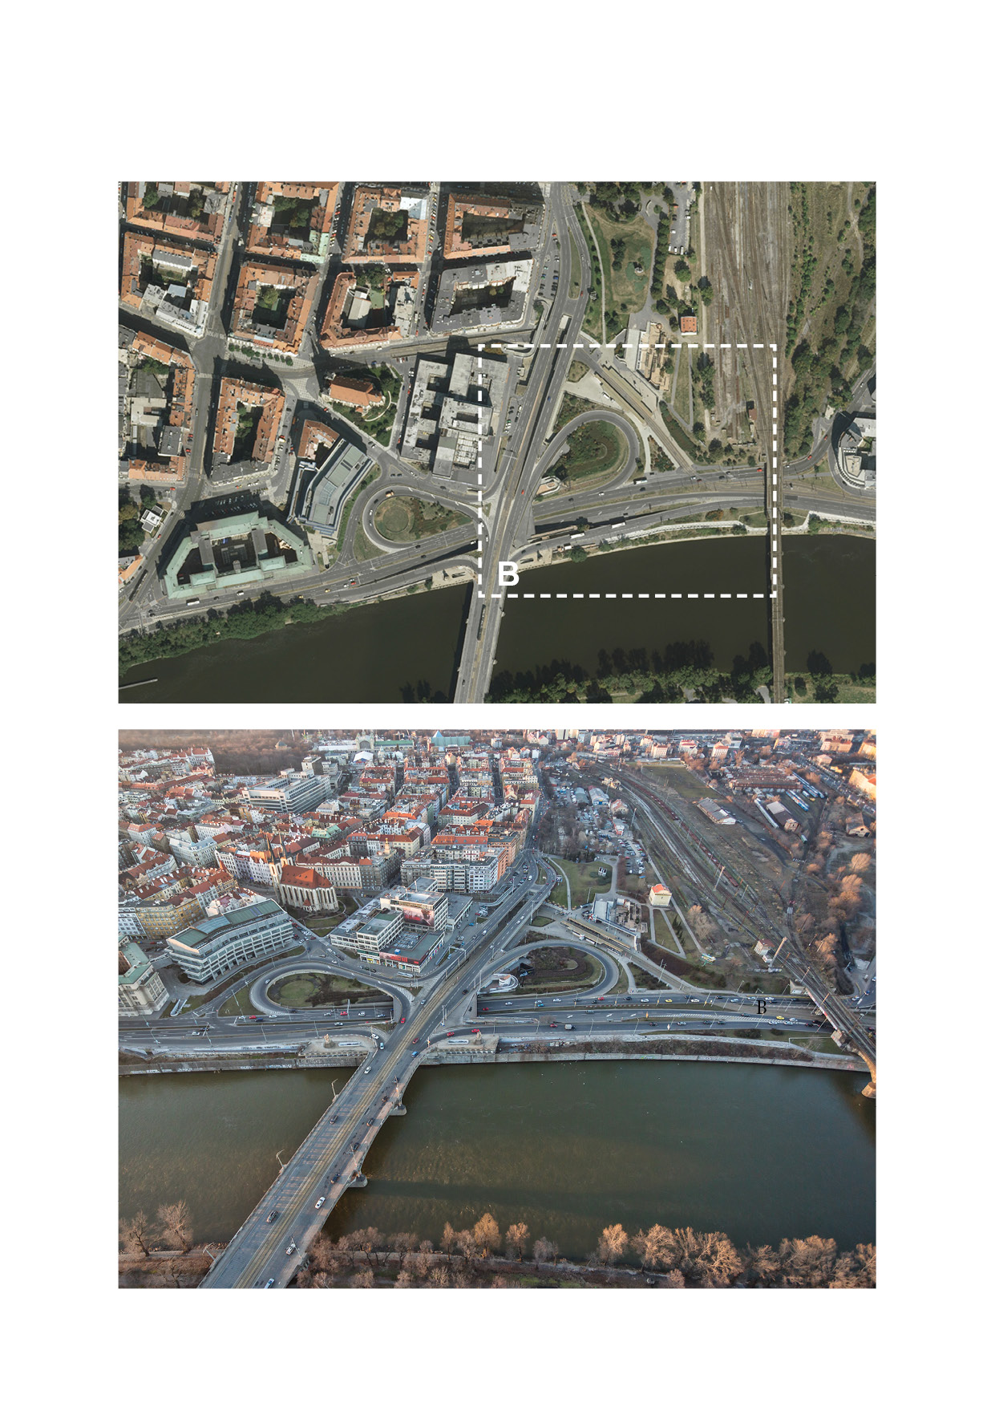**B. Plot for construction of the building for concert hall – current state**

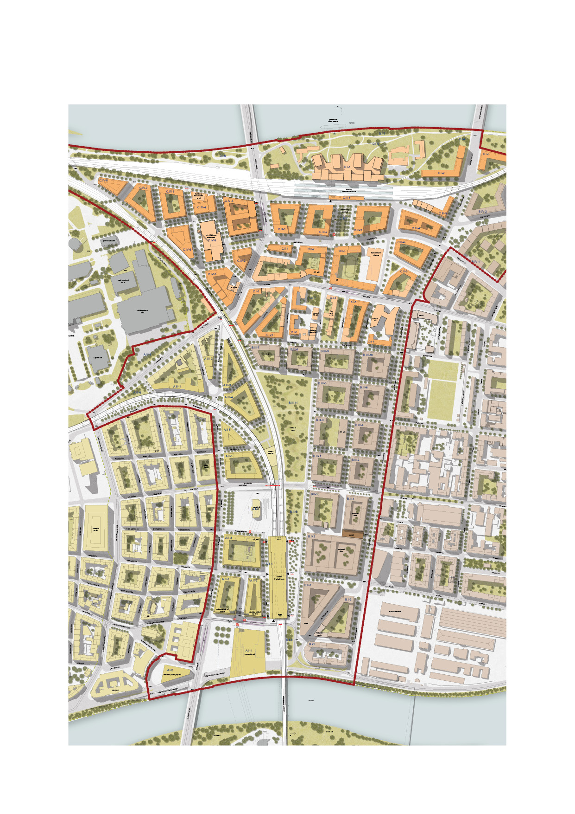**C. Broader relationships – future appearance – land use plan (illustration)**

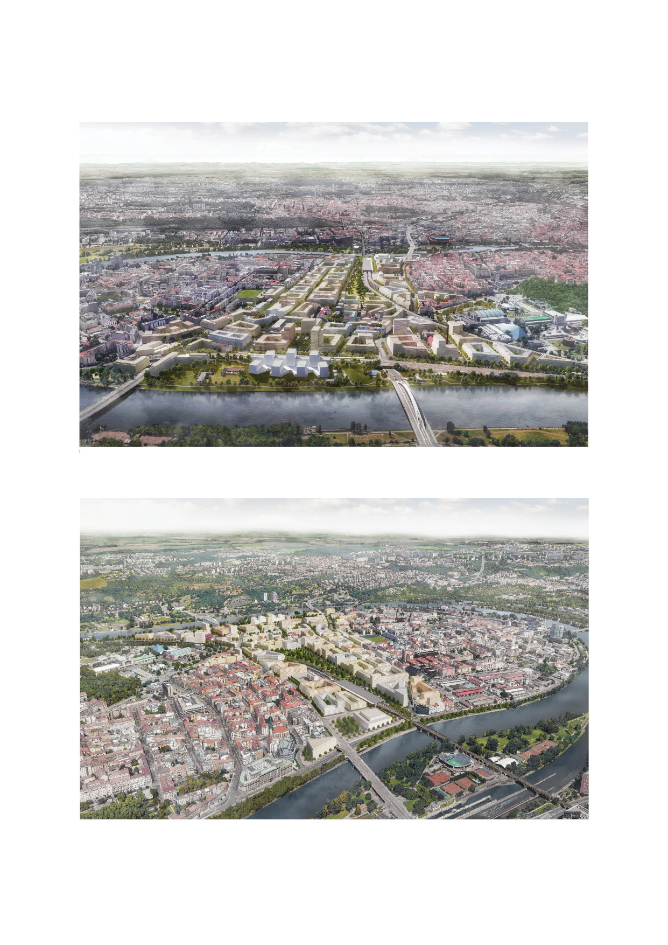**D. Site of construction for the concert hall – future appearance (illustration)**

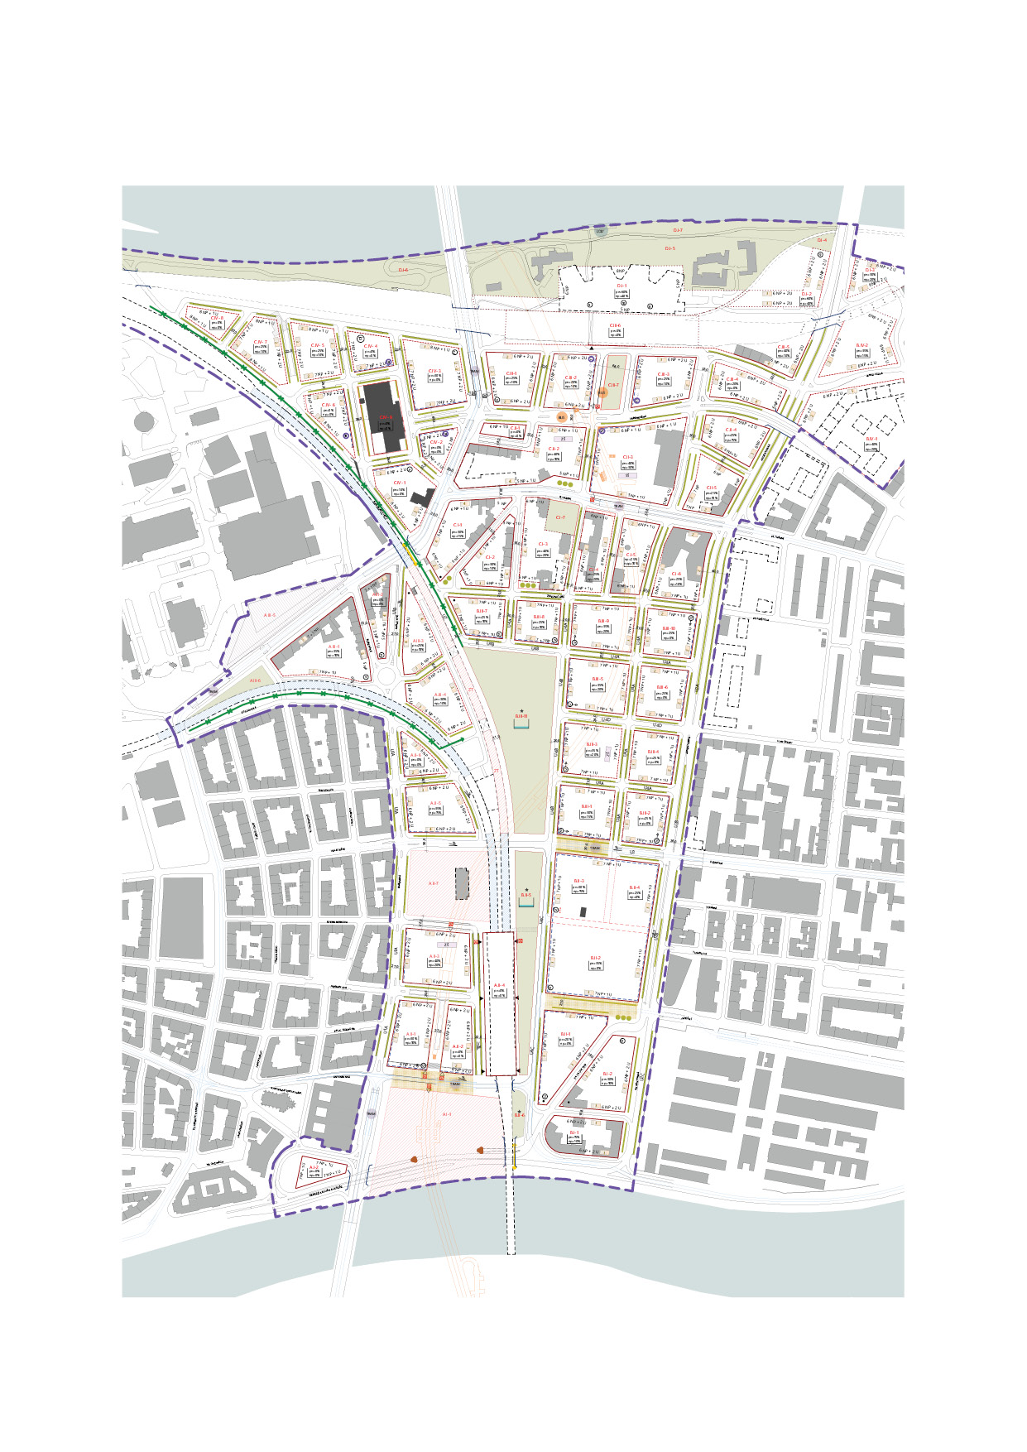**E. Site of construction for the concert hall – future appearance, regulation**

**E. Site of construction for the concert hall – future appearance, regulation (detail)**

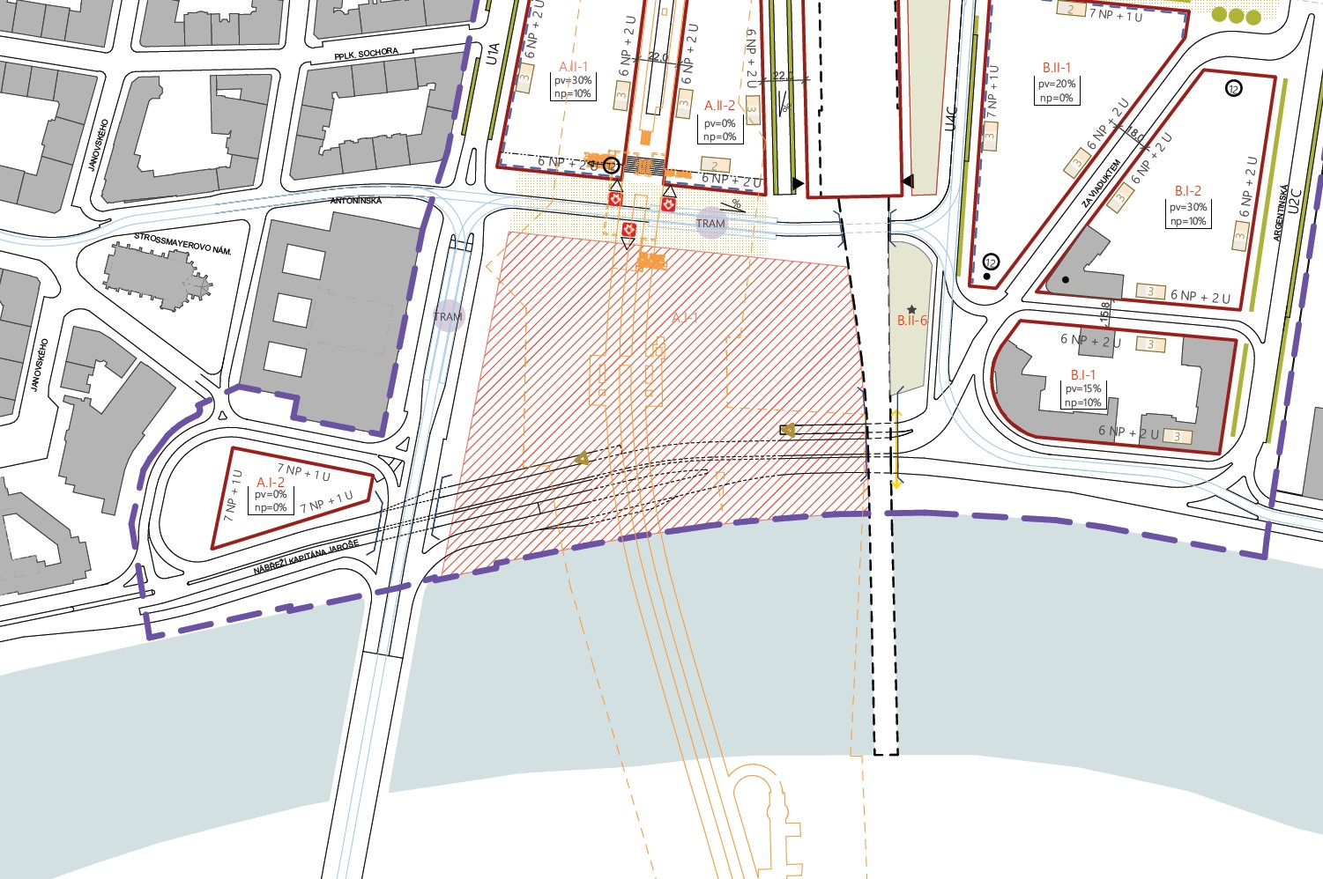

The entire land use study depicting the future appearance of the area can be downloaded under the tab *ÚS Holešovice Bubny – Zátory* from the website: <http://www.praha.eu/jnp/cz/o_meste/magistrat/odbory/odbor_uzemniho_rozvoje/uzemni_planovani/uzemni_studie/studie_porizovane/index.html>

**Section 3 – Additional materials**

Indicative list of materials that will be provided to the contractor by the contracting authority after signing of the contract:

* Catalogue of historical maps and photographs of the Vltavská area, IPR Praha.
* Concert hall designs in Prague – historical research, Atelier of Ondřej Císler (MgA. Ondřej Císler, Ph. D., Bc. Josef Holeček).