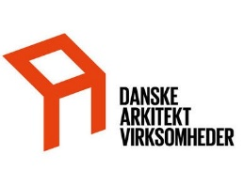

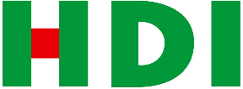**DANSKE ARK Liability Insurance Certificate of Insurance**

This is to certify that this liability insurance has been issued to the named Insured below being a member of DANSKE

ARK. This insurance is in force at this time and is subject to the policy terms and conditions.

This certificate has been issued solely as information and provides no rights to the holder. This certificate does not otherwise improve, extend or amend the coverage of the below policy.

# Insured

**Policy number** : DANSKE ARK - 209731.37561-18

**Period of Insurance** : 01-01-2020 - 31-12-2020

**Cover** : DANSKE ARK Professional & Public Liability Insurance

**Insured** : Henning Larsen Architects A/S Vesterbrogade 76, 3., 1620 København V

# Company registration no.

: 18940884

**Geographical Scope** : Worldwide, excluding USA and Canada

# Sums insured

**Professional Liability** : Damage to property and/or loss Kr. 7.500.000 per year

Bodily injury Kr. 25.000.000 per year

Deductible Kr. 75.000 per claim

**General Liability** : General Liability Kr. 10.000.000 per year

Deductible Kr. 0 per claim

**Extensions** : The total liability of HDI Danmark for damage/injury/loss is extended to

twice the insured sum per insurance year for respectively Bodily injury and damage to property and/or loss, however, maximum one sum insured per insurance event.

# Issued

**Date** : 10-02-2020

**Issued by** : HDI GLOBAL SPECIALTY SE

v. HDI Danmark, Indiakaj 6, 1.sal, 2100 København Ø Rasmus Jørgensen, Underwriting Director