Confidentiality Level |  | BL - Restricted for internal use | TC ID / Revision | 00261263/C
Document Status |  | Document Released | Document No. | N/A
WBS code |  | 4.4.
PBS code |  | SE.BDS.BT.BTL3.CSS.UTIL.AIR.CDA.E2  SE.BDS.BT.BTL3.CSS.UTIL.AIR.CDA.E5
Project branch |  | Engineering & Scientific documents (E&S)
Document Type |  | Specification (SP)
[RSD product category B]

Precision Clean Dry Air Supply Hubs
TP20_075
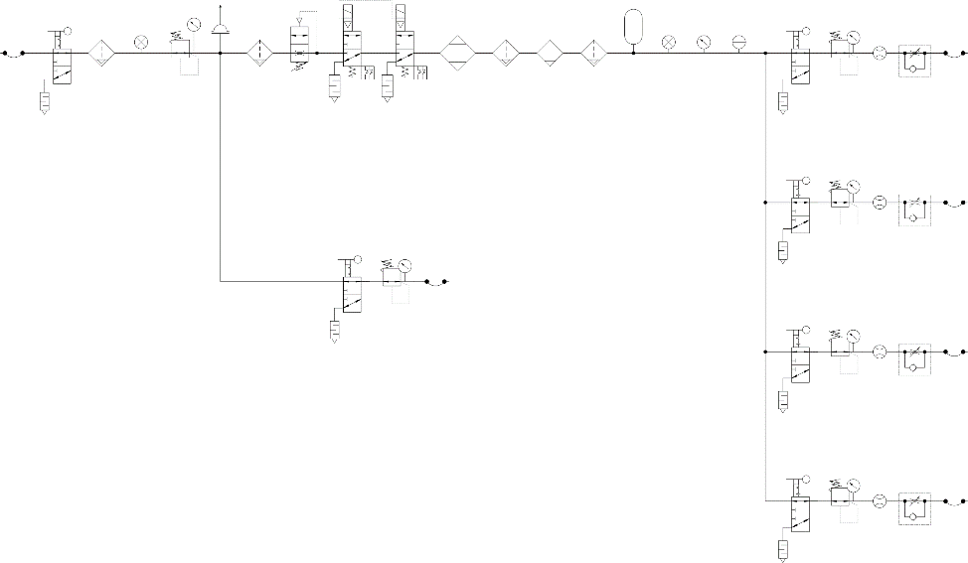

Keywords
N/a

 | Position |  |  | Name
Responsible person | Deputy RP1 Leader; Dep. 97 head |  |  | Pavel Bakule
Prepared by | Deputy RP1 Leader; Dep. 97 head |  |  | Pavel Bakule

RSS TC ID/revision | RSS - Date of Creation | RSS - Date of Last Modification | Systems Engineer
020389 /A.001 | 13.03.2020 | 13.03.2020 | Denisa Hanusková
020389 /A.002 | 16.03.2020 | 16.03.2020 | Denisa Hanusková
020389 /A.004 | 04.06.2020 | 04.06.2020 | Denisa Hanusková
Reviewed By
Name (Reviewer) | Position | Date | Signature
Daniel Kramer | Optical Designer of Laser Technology | NOTICE (RSD product category B)
Ladislav Půst | Manager installation of technology | NOTICE (RSD product category B)
Luboš Nims | Head of Electrical engineering | NOTICE (RSD product category B)
Roman Kuřátko | Facility Manager | NOTICE (RSD product category B)
Veronika Olšovcová | Safety Coordinator | NOTICE (RSD product category B)
Viktor Fedosov | SE & Planning group leader;  Quality Manager | NOTICE (RSD product category B)


Approved by
Name (Approver) | Position | Date | Signature
Georg Korn | Science and Technology Manager

Revision History / Change Log
Change No. | Made by | Date | Change description, Pages, Chapters | TC rev.
1 | P. Bakule, D. Hanusková | 13.03.2020 | RSD draft creation | A
2 | P. Bakule, D. Hanusková | 16.03.2020 | RSD update, version for internal review | B
3 | D. Hanusková, O. Bakule | 04.06.2020 | RSD update, final version for approval | C

Content

1. Introduction 4
1.1. Purpose 4
1.2. Scope 4
1.3. Terms, Definitions and Abbreviations 5
1.4. Reference documents 5
1.5. References to standards 5
1.6. Compliance diagrams 5
1.7. Key Specifications 8
1.8. Summary of Deliverables 9
2. Functional, Performance and Design Requirements 9
2.1. General Requirements 9
2.2. Specific component requirements 10
2.3. Pipe and cable management 12
2.4. High purity zone components 13
3. Environmental Requirements 13
4. Transportation and Installation Requirements 13
5. Safety Requirements 14
6. Quality requirements 14
6.1. General Quality Requirements 14
6.2. Nonconformity Control System 15
6.3. Specific Quality requirements 15
7. Verification requirements for the Supplier 16
7.1. General requirements 16
7.2. Verification documentation 17
7.2.1. General requirements 17
7.2.2. Verification reports (VRs) 17
7.2.3. Verification Control Document (VCD) 18
7.3. Phasing of the delivery 19
7.3.1. Manufacturing 19
7.3.2. Delivery and Installation 19
7.3.3. Acceptance 20

Introduction

The Contracting Authority is undertaking the ELI project with the objective of building a facility using cutting-edge laser technologies and to implement research and application projects in the field of laser-matter interaction. Part of the project realization requires the reliable generation and distribution of very high quality Clean, Dry Air for the purging of laser system enclosures and for the venting of vacuum chambers containing extremely contamination-sensitive optics. This supply is required to meet very stringent limits for particle content, dew point and hydrocarbon contamination so as to provide maximum protection of high-value and long lead-time assets, as well as having a full suite of diagnostics and controls integrated into a single standard-sized hub to provide online monitoring and fault identification.

The aim of this public contract is to procure a set of three (3) (two within basic scope and one optional – see the contract) identical CDA hubs meeting the requirements in the following sections.

Purpose

This Requirements Specification Document (RSD) lists the technical requirements and constraints for the selection of Precision Clean Dry Air Supply hubs (TP20_075). This can lead to the identification of product interfaces with the ELI Beamlines science-based technology and ELI Beamlines building facility. This RSD also acts as the parent document for the technical requirements that need to be addressed in lower level design description documents.

Scope

This RSD contains all of the technical requirements: functional, performance and design, delivery, safety and quality requirements for the following product (tender number TP20_075): Precision Clean Dry Air Supply Hubs (further “CDA hubs”).

The CDA hubs are integral parts of the standalone E2 and E5 laser systems and will be placed in the E2 and E5 laser halls at the ELI Beamlines facility. These products are registered in the PBS software under the following PBS codes: SE.BDS.BT.BTL3.CSS.UTIL.AIR.CDA.E2 and SE.BDS.BT.BTL3.CSS.UTIL.AIR.CDA.E5.

These CDA hubs are products Category B according to the ELI Beamlines RSD categories. Category B is an Off-the-shelf Product with customization (e.g., product performance). All verification activities performing by a supplier shall be executed in accordance with the supplier’s plan of outgoing inspection and tests. The verification of all specified parameters listed in this RSD will be undertaken by the supplier before delivery to the ELI Beamlines facility and the CDA hubs shall be furnished with a verification (test) reports and a declaration of conformity, to reflect their proper characteristics. Furthermore, the CDA hubs will be subject to testing and verification upon delivery to the ELI Beamlines facility. All nonconformities (if any) must be addressed by the supplier in a timely manner.

Terms, Definitions and Abbreviations
For the purpose of this document, the following abbreviated terms apply:

Abbreviation | Meaning
CA | Contracting Authority (Institute of Physics AV CR, v. v. i.)
CDA | Clean and Dry Air
DIN | Deutsches Institut für Normung
ELI | Extreme Light Infrastructure (project of the CA)
FTR | Factory Test Report
FD | Functional Demonstration (as a verification method)
GC-MS | Gas Chromatography - Mass Spectrometry
I | Inspection (as a verification method)
IP | Ingress Protection
L x H x W | Length x Height x Width
MCB | Miniature Circuit Breaker
R | Review (as a verification method)
RAL | Reichs-Ausschuß für Lieferbedingungen und Gütesicherung – European color matching standard
RD | Reference Document
RH | Relative humidity
RSD | Requirements Specification Document
T | Test (as a verification method)
VCD | Verification Control Document

Reference documents

Document number | TC ID number | Title of Document/ File
RD-01 | 00261580 | Verification control document (VCD)

References to standards
If this document includes references to standards or standardized/standardizing technical documents the CA allows/permits also another equal solution to be offered. If a supplier offers another equal solution the CA shall not reject its bid, once the supplier by appropriate means in the bid proves that the offered supplies, services or works meet in an equivalent manner the requirements including references to standards or technical documents.

Compliance diagrams

Figure 1 below shows the pneumatic function that each CDA hub shall perform. Figure 2 shows the dimensions of the cabinet that shall be used to integrate the system and the location of the DIN rail and cable trunking required.
Figure 1: CDA hub compliance diagram
[Grab your reader’s attention with a great quote from the document or use this space to emphasize a key point. To place this text box anywhere on the page, just drag it.]

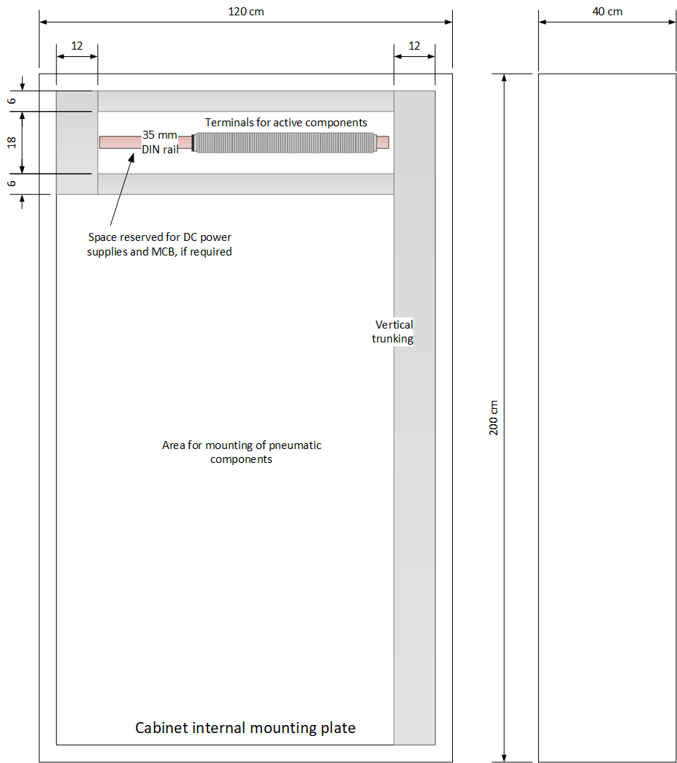
Figure 2: CDA hub cabinet layout (all dimensions in cm)

Key Specifications

Table 1 below summarizes the main specifications of each CDA hub.

Description of Specification | Required Parameter (Equal or Better) | Description of verification
Number of output lines | 5: 1x Pilot, 1x Main purge, 3x Auxiliary | Review of documentation
Combined flow output capability with all specifications satisfied (sum of all output lines) | 500 l/min with all specifications met | Test using the digital display of the built-in flow meters
Combined flow output capability with relaxed dew point specification (sum of all output lines) | 1000 l/min with air quality to 1:2:1 | Test using the digital display of the built-in flow meters
Pressure adjustment range of all outputs | 0-7 bar with individual continuous manual adjustability per output | Test using the built-in pressure gauges/sensors
Flow adjustment and measurement range of each individual output when all other outputs vented | Pilot: Not required  Main Purge: 0-1000 l/min  Auxiliary: 0-100 l/min  Individual continuous manual adjustability per output | Test using the built-in flow meters
Basic air quality of Main and Auxiliary outputs to ČSN ISO 8573-1 (equivalent to ISO 8573-1:2010) | 1:1:1, measured at the main purge and each auxiliary output | Samples submitted to  3rd party laboratory following ČSN ISO 8573-1 (equivalent to ISO 8573-1:2010) standards
Particulate content of Main and Auxiliary outputs | ISO Class 0 according to ČSN EN ISO 8573-1 (per 1000 liters:  ≤ 10 particles for 0.3-0.5 um,  ≤ 2 particles for 0.5-1 um,  zero particles above 1 um) | Particle counter fitted with high pressure diffuser provided by the Supplier or 3rd party laboratory
Volatile organic compound content of Main and Auxiliary outputs | Peaks of all detected hydrocarbon species from 16 to 300 Da shall be below 0.01 mg/m³ (i.e., even those with fewer than 6 carbon atoms). | Using purge & trap GC-MS provided by 3rd party laboratory. Spectrum shall be provided.
Enclosure | Each CDA hub shall be fully contained within a single IP55 lockable 2-door,  dimensions 1200 x 400 x 2000 mm  (W x D x H), cabinet of sheet steel ≥1.5 mm thick, power coated to RAL 7035, with 4 removable eyebolts | Review of documentation
Table 1: Key Specifications

Summary of Deliverables
Table 2 below summarizes the deliverables of the contract (including RSD) fulfilment:

 | Description | Deadline*
D1 | Detailed pneumatic diagram complete with full bill of materials, a panel layout showing placement of all components and an electrical wiring diagram showing all active components | T0 + 8 weeks
D2 | Receipt by the CA of identical completed CDA hubs at the CA site together with full Factory Acceptance Test report collating the results and supplementary materials for all Verification Tests listed in Table 1 | T0 + 10 weeks
D3 | Acceptance | T0 + 18 weeks

* T0 is defined as the date of entry into force of the contract, i.e. the contract is signed by the CA and the Supplier, or the date of activation of the option.
Table 2: Summary of Deliverables

Functional, Performance and Design Requirements

General Requirements

REQ-028815/A
Each CDA hub assembly shall conform to Figure 1. The 40 numbered components shall be provided, assembled and interconnected so as to conform to this diagram and in accordance with all other requirements and performance specifications.
NOTE 1: Additional components may be provided and connected as required.
NOTE 2: Numbered component functionality may be satisfied by combining separate individual parts, or several component functions may be merged and realized by a single multi-functional device.
NOTE 3: The precise internal pneumatic connections of each numbered component are not important as long as the implicit functionality is observed.
Verification method: I - inspection
REQ-028816/A
The Supplier shall deliver the (D1) and (D2) deliverables listed in Table 2 to the CA before the associated deadline.
Verification method: I - inspection

REQ-028817/A
The performance of each CDA hub shall meet or exceed all Key Specifications in Table 1 above. All Key Specifications shall be met simultaneously, except where noted, and in normal operation.
NOTE: The Supplier is responsible for performing all Verification Tests listed in Table 1 before delivery and for collating the Factory Acceptance Test report (D2).
Verification method: R – review, T – test

Specific component requirements
REQ-028818/A
Active components shall be provided with all necessary connectors and cables for their correct operation and complete interface to external control systems.
NOTE: Active components are the following (see figure 1 above): inlet pressure sensor (4), safe exhaust valve (9), dryer (10), manifold pressure sensor (15), dew point sensor (17), and flow sensors (28-31).
Verification method: I - inspection
REQ-028819/A
Active components of each CDA hub shall be cabled in a logical arrangement to the lower side of a row of 35 mm top-hat profile DIN rail screw terminals of nominal 4 mm² conductor cross section, located towards the top of the enclosing cabinet.
Verification method: R – review, I - inspection
REQ-028820/A
Terminals shall be labelled and numbered and a full set of wiring diagrams shall be provided ready for the CA to connect to external control systems and mains power as required.
Verification method: I - inspection
REQ-028821/A
Active components shall be powered from 24 V DC power where possible. For supplying any DC power source, the Supplier shall provide an industrial DIN-rail mount power supply mounted on DIN rail and suitable for connecting to a single phase 230 V AC mains supply after installation at the CA site.
Verification method: I - inspection

REQ-028822/A
An MCB of appropriate type and rating shall be provided on the mains inlet and the wiring diagram shall be sent to the CA for electrical safety approval as part of D1.
Verification method: R – review, I - inspection
REQ-028823/A
All active components shall be provided with a full set of documentation including the specifications of all electrical interfaces and any calibration and scaling data necessary to recover their calibrated readings from the output signal voltage, where applicable.
Verification method: I - inspection
REQ-028824/A
The component (6) of each CDA hub (see figure 1 above) shall be a simple non-resettable overpressure relief mechanism based on rupture of a metal disc with nominal rupture pressure of 10 bar.
Verification method: R – review
REQ-028825/A
The component (17) of each CDA hub (see figure 1 above) shall have a measurement range of at least -70 °C to -10 °C (-80 °C preferred) with an accuracy of better than +/- 3 °C (+/- 2 °C preferred accuracy).
Verification method: R – review
REQ-028826/A
The component (17) of each CDA hub shall have a DC voltage output in the range from 0 to 10 V.
Verification method: R – review
REQ-028827/A
The component (17) of each CDA hub shall be calibrated and the calibration certificate shall be delivered to the CA.
Verification method: I - inspection
REQ-028828/A
The component (9) of each CDA hub shall be consistent with performing the safety functions “safe exhausting” and “prevention of unexpected start” in accordance with ČSN EN ISO 13849-1 (equivalent to EN ISO 13849-1) performance level “e” category 3.
Verification method: R – review
REQ-028829/A
The component (9) of each CDA hub shall have two enabling channels (suitable for 24 V DC signals) and two feedback position channels and shall have internal (pneumatic) self-monitoring.
NOTE: The CA will provide the safety PLC, logic and external wiring connections in order to complete the full safety functionality. Responsibility for evaluating the final safety level is understood to remain under the CA.
Verification method: R – review
REQ-028830/A
The maximum peak noise level of the component (10) shall be carefully minimized by the Supplier and shall not exceed 70 dBA.
NOTE 1: The maximum permissible peak noise level is 70 dBA with the enclosure doors shut. If the CA suspects that the noise level is excessive, an additional verification measurement may be requested prior to acceptance.
NOTE 2: Measurement on the CA request – sound pressure meter located 1 m from closed enclosure door at 1 m height
Verification method: T – test
REQ-028831/A
The inlet and outlet pipe fittings for external connections to the ELI Beamlines technologies shall consist of a ČSN EN ISO 228-1 (equivalent to EN ISO 228-1) female parallel thread of either G ¾” or G ½” size, into which a removable adapter to 12 mm hose (inlet) and 8 mm hose (all outlets) is attached by the Supplier so as to permit fittings to be exchanged for other types and sizes by the CA as required.
Verification method: R – review, I - inspection

Pipe and cable management
REQ-028832/A
All pipes and cables shall be properly routed and mechanically supported at intervals of no more than 200 mm or fully enclosed in fixed cable trunking.
Verification method: I - inspection
REQ-028833/A
At least one full-height (2000 mm) section of fixed cable trunking of at least 120 mm wide x 80 mm high (see Figure 2) shall be provided to permit routing of the CA’s external connection from either the top or the plinth of the enclosure as necessary.
Verification method: I - inspection

High purity zone components
REQ-028834/A
All the components in the designated high purity zone shown in Figure 1 (downstream of the first 10 nm filter) shall be precision cleaned, internally and externally cleanroom compliant, low particulate generating (particularly valves and components with moving parts), free from oil and hydrocarbon-based grease, and shall be handled and assembled solely in the cleanroom of ISO Class 7 according to ČSN EN ISO 14644 (equivalent to EN ISO 14644) or better environment.
Verification method: R – review, I - inspection
REQ-028835/A
All the components outside of the designated zone, including the cabinet, shall be externally cleaned with clean, dry air and pure isopropanol or similar before final assembly and shall not have external particle-generating materials.
Verification method: R – review, I - inspection

Environmental Requirements
REQ-028836/A
The CDA hubs shall be designed for and capable of meeting all requirements during long term operation in a cleanroom environment of ISO class 7 according to ČSN EN ISO 14644 (equivalent to EN ISO 14644) at a temperature range of 19-21 °C with stability ±0,6 °C and humidity 40-60 % RH, and subject to a supply of compressed air of 9-11 bar and quality 4:4:4 according to ČSN ISO 8573-1 (equivalent to ISO 8573-1:2010).
Verification method: R – review

Transportation and Installation Requirements
REQ-028837/A
The transportation to the final destination at the ELI Beamlines shall be conducted by the Supplier.
NOTE: The bid price will be considered by the CA as the final price, including assembly, cleaning and transportation costs.
Verification method: I – inspection
REQ-028838/A
The final assemblies of all cleaned components of the CDA hubs shall be cleaned and packaged in clean environment of class 7 according to ČSN EN ISO 14644 (equivalent to ISO 14644) or cleaner.
Verification method: R – review, I – inspection
REQ-028857/A
The assembled CDA hubs shall be at least double wrapped in low-outgassing film before being removed from the cleanroom for palletization.
Verification method: I – inspection
REQ-028858/A
The transportation and Installation procedures shall be discussed and can be reviewed by the CA’s installation officer.
NOTE: Any acts of supervision shall not mean that the CA assumes additional liability of any kind exceeding its liabilities according to the contract.

Safety Requirements
REQ-028839/A
The Supplier shall supply a Declaration of Conformity or any other equivalent document legally recognized and accepted in the Czech Republic for each product type if the appropriate legislation determines the Supplier's obligation to have a Declaration of Conformity (or the equivalent document) for the purposes of a Device sale in the Czech Republic to fulfil the requirements of 2001/95/EC directive or applicable Czech law.
Verification method: I – inspection

Quality requirements

General Quality Requirements
REQ-028840/A
The Supplier shall provide the Product User Manual as part of the delivered system. Completeness of the Manual shall be approved by the CA. The Manual shall include the instructions and descriptions regarding the following procedures:
- transport, handling, storage;
- installation, alignment and cleaning;
- safe operation and maintenance procedures.
Verification method: R - review, I - inspection
REQ-028841/A
The Supplier shall provide information of outgoing check control of the Product. At least this information shall comprise declaration about the execution of outgoing check and declaration of conformity with technical requirements defined by the product RSD and completeness of the Product.
NOTE: Alternatively the Supplier might provide the CA the information detailed enough to prove meeting all requirements stipulated herein (e.g.: catalogue/technical datasheets, product manuals or other similar documentation).
Verification method: I - inspection
REQ-028842/A
The Supplier shall supply the following relevant manufacturing documents:
- all approved by the CA detailed pneumatic diagram complete with full bill of materials, a panel layout showing placement of all components and an electrical wiring diagram showing all active components;
- all approved by the CA “requests for deviation/waiver from requirements described herein”.
NOTE: The manufacturing documents may be supplied in electronic form in relevant data formats described in the REQ-028843/A.
Verification method: I - inspection
REQ-028843/A
The Supplier shall use following data formats:
- *.JPG, *.PNG, *.TIFF, *.PDF/A, *.HTML
- CAD 2D: *.dwg
- CAD 3D: *.stp; *.ste; *.step or other 3D CAD formats agreed with the CA
- text processors *.doc, *.docx, OpenDocument Format
- spreadsheet processors *.xls, *.xlsx, OpenDocument Format
- presentations *.ppt, *.pptx; OpenDocument Format
Verification method: Not To Be Tracked within VCD

Nonconformity Control System

REQ-028844/A
The Supplier shall establish and maintain a nonconformity control system compatible with ČSN EN ISO 9001 (equivalent to EN ISO 9001).
Verification method: Not To Be Tracked within VCD

Specific Quality requirements

REQ-028845/A
In case of a warranty repair of the CDA hubs by the Supplier, the Supplier shall redo necessary parts of the verification procedure. The results of this process shall be provided to the CA.
Verification method: Not To Be Tracked within VCD
REQ-028846/A
All the documents shall contain strictly the units which are used to define the requirements in chapters 1.7 and 2.
Verification method: R - review
REQ-028847/A
All tests of CDA hubs shall be performed with the measuring instruments with valid metrological confirmation.
NOTE: The CA can request the Supplier to provide the valid Calibration Certificates.
Verification method: Not To Be Tracked within VCD

Verification requirements for the Supplier

The verification process will be performed by the Supplier to demonstrate that the CDA hubs meet the specified requirements of the CA.

General requirements

REQ-028848/A
The Supplier shall assign clear responsibility for the implementation of the verification process including the following activities:
- Verification planning (via VCD, see chapter 7.2.3);
- Verification execution and reporting (see chapters 7.2.2 and 7.3);
- Verification control and close-out (see chapter 7.2.3, 7.3.3)
Verification method: R - review
REQ-028849/A
The verification process shall be accomplished by the Supplier through one or more of the following verification methods:
- Review; Verification via Review (R) shall consist of using approved records (examples of such approved records are design documents and reports, technical descriptions, and engineering drawings, manuals and accompanying operation documentation) or evidence that unambiguously shows that the requirement is met.
- Inspection; Verification via Inspection (I) shall consist of visual determination of physical characteristics including photographs taken by the Supplier and sent to the CA proving that the specific requirements have been met.
- Test (including functional demonstration); Verification via Test (T) shall consist of measuring product performance and functions under realistic operating conditions. When the test objectives include the demonstration of qualitative operational performance (functional demonstration), the execution shall be observed and results recorded.
Verification method: Not To Be Tracked within VCD

Verification documentation

General requirements

REQ-028851/A
The Supplier shall establish and maintain the system of verification process documentation (see REQ-028852/A and REQ-028853/A).
Verification method: Not To Be Tracked within VCD
REQ-028852/A
Verification documentation shall consist of following basic types of documents:
- Verification reports (see chapter 7.2.2);
- VCD, Verification Control Document (see chapter 7.2.3).
Verification method: Not To Be Tracked within VCD
REQ-028853/A
The verification reports shall be submitted to the CA for the review as agreed with the CA after corresponding verification activity completion, within the time frame agreed with the CA.
NOTE: Verification activity can be a review of documentation during the CDA hubs development, test and inspection after assembly of the CDA hubs.
NOTE: structure and content of the verification reports shall be agreed with the CA (see chapter 7.2.2).
Verification method: Not To Be Tracked within VCD

Verification reports (VRs)

REQ-028861/A
The results of the review of documentation and inspection of the assembled CDA hubs shall be tracked in the VCD.
Verification method: R - review
REQ-028862/A
The results of the tests shall be documented in the appropriate Factory Test Report (further “FTR”) and tracked in the VCD (see chapter 7.2.3).
Verification method: R – review

Verification Control Document (VCD)

The Verification Control Document (VCD) lists the requirements to be verified with the selected methods at the defined levels. The VCD is a living (versioned) document and provides an overview of the mutually agreed Verification methods during the contract execution and overview of the verification results at the contract end to support the acceptance of the CDA hubs. The VCD represents a formal tool of communication between the Supplier and the CA (formal record, reporting tool). The VCD will be provided by the CA and it can be accommodated to the Supplier’s needs.

REQ-028863/A
The Supplier shall provide a Verification Control Document (further “VCD”) for the reviews as agreed with the CA.
NOTE 1: Guidelines for VCD preparation see in RD-01.
NOTE 2: The form of VCD will be agreed between the CA and the Supplier based on the best commercial praxis used by the Supplier.
NOTE 3: The form of VCD will be agreed before starting of any verification activities.
Verification method: R - review
REQ-028864/A
In the VCD the Supplier shall specify HOW and WHEN each requirement is planned to be verified.
Verification method: R - review
REQ-028865/A
The verification approach shall be submitted by the Supplier in the VCD and approved by the CA prior to implementation.
Verification method: Not To Be Tracked within VCD
REQ-028866/A
The final issue of the Verification Control Document (VCD) shall be submitted to the CA after the approval of the last test report, within the time frame agreed with the CA.
Verification method: R - review
REQ-028867/A
The Supplier shall make available to the CA for consultation the VCD’s supporting documentation in addition to the reports.
Verification method: Not To Be Tracked within VCD

Phasing of the delivery
This chapter is intended to briefly summarize basic milestones of the Contract delivery. These milestones represent gates (checkpoints) where the quality of the delivery is to be evaluated.
Delivery shall not proceed past these gates unless their satisfactory accomplishment is approved by the CA.
Delivery lifecycle shall contain at least the following phases (quality gates):
- Manufacturing;
- Delivery;
- Acceptance (performed by the CA).

Manufacturing

The goal is to demonstrate that the manufactured and assembled product meets the specified technical requirements (RSD) of the CA.

This quality gate concerns primarily:
- Inspection
- Testing at the Supplier’s site (factory testing);
- Cleaning and Packaging.
Output of this phase is the Verified assembled product.

REQ-028870/A
The results of the Manufacturing verification phase shall be recorded by the Supplier in the appropriate FTR (see REQ-028862/A) and overall results (including review of documentation/reports and inspection of assembled product) shall be recorded in the VCD (see chapter 7.2.3).
Verification method: R – review

Delivery and Installation

The goal is to demonstrate that the delivered and installed final product meets all requirements specified herein.

Verification is executed by the Supplier and the CA together after completion of each stage including delivery, transportation and installation.

This quality gate concerns primarily:
- Inspection of delivered integrated product and required documentation;
- Transportation to the final destination (ELI Beamlines E5 hall);
- Inspection and on-site testing of the whole installed product.

Output of this phase is the Verified delivered and installed product.

REQ-028871/A
The results of the verification of delivered and installed Integrated System shall be recorded by the Supplier in the appropriate STR (see REQ-028862/A) and overall results shall be recorded in the VCD (see chapters 7.2.3).
Verification method: R – review
REQ-028872/A
The final issue of the VCD shall be submitted to the CA after the approval of the last report and before starting the Acceptance phase (see chapter 7.3.4).
Verification method: R - review

Acceptance

Acceptance will be carried out by the CA at ELI Beamlines premises upon delivery and final verification of the installed CDA hubs. The basis for acceptance will be completed VCD summarizing the overall verification results together with relevant documentation supporting the verification (i.e. FTR, STR, detailed pneumatic diagram complete with full bill of materials, the panel layout showing the placement of all components and an electrical wiring diagram showing all active components, Instructions for use and etc.).

The CA reserves the right to repeat any Verification Test as part of the on-Site Acceptance Test conducted at the CA’s site within 8 weeks of delivery. A failure of any parameter to reach the required specification, either during the Factory Acceptance Test or during the on-Site Acceptance Test, shall result in non-acceptance and non-fulfilment of the contract unless rectified and successfully re-tested.

In case of successful acceptance phase, the CA will provide to the Supplier signed acceptance protocol. In case of unsuccessful acceptance stage, the CA will provide to the Supplier Nonconformity Report and process in accordance with REQ-028844/A shall be applied.

REQ-028855/A
The Acceptance phase shall demonstrate the following:
- Final CDA hubs have been successfully verified by the Supplier and the results of this process have been documented in an appropriate way through FTR (see REQ-028862/A), STR (see REQ-028871/A) and VCD (see chapter 7.2.3);
- All detected nonconformities have been solved in accordance with REQ-028844/A;
- Final CDA hubs are free of fabrication errors and are ready for the intended operational use.
Verification method: Not To Be Tracked within VCD

