Dobrý den,

potvrzuji přijetí(akceptaci) spotřeby na operaci ze dne 11.06.2020, bude fakturovaná částkou 62.908,- Kč bez DPH a 72.344,20,- Kč s DPH 15%.

S pozdravem a přáním hezkého dne

xxxxxxxxxxxxxxxxx
Logistic Manager
T +420 257 286 731
F +420 222 723 568
M +420 xxx xxx xxx
Xxxxxxxxxxxxxxxxxxxxxx

Lima CZ s.r.o.
Do Zahrádek I, 157/5
155 21 Praha 5
limacorporate.com

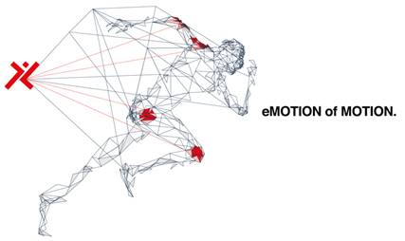

This message and its attachments are confidential and contain strictly confidential and/or privileged information. If you are not the intended recipient please notify us immediately by return and destroy all copies in whatever form they are stored. Unauthorised use of the contents and attachments of this message is a violation and prosecutable. We would like to emphasise that communications through the Internet are absolutely not secure and therefore LimaCorporate shall not be held liable for any abuse thereof by any third party whatsoever, alterations during transmission or for any damage caused by viruses or other irregularities that may occur outside its own network.
Please consider the environment before printing my email

