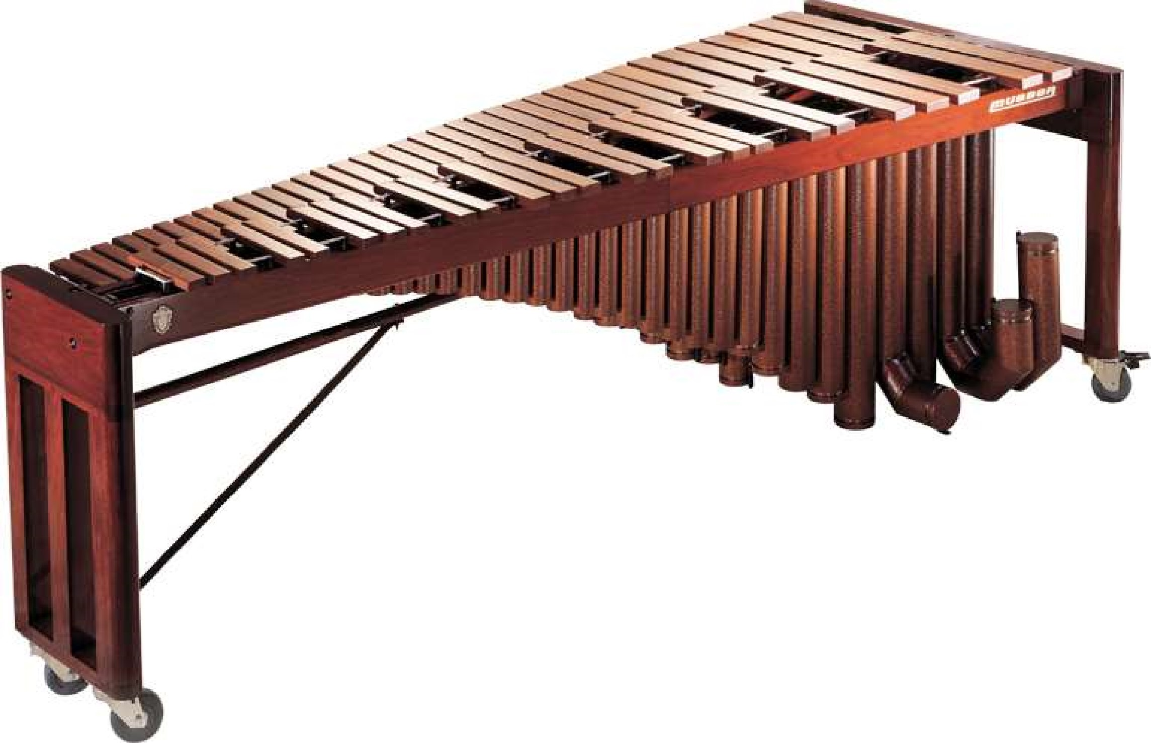

M500

Concert Grand Soloist

Musser's most technically advanced marimba creation; the M500 Concert Grand Soloist is the choice among professional recitalists for its presentation and tone. This 5-octave marimba features select hand-tuned Honduras Rosewood bars, which provide a full and rich tone. The tunable aluminum resonators allow the player to customize their sound within the limitations of acoustics, temperature and humidity. With the Musser patented resonator caps, tuning in the range of C2 to C3 is quick and accurate, even in the lowest register. Masterfully designed for the concert performer, the entire instrument disassembles for transport. The frame is height adjustable from 33.5" to 38", with durable locking casters for smooth transport and durability. Folding resonators and rails and detachable end pieces pack securely.

M500 Specifications

Octave Range 5 Octaves

Tone Range C2 – C7

Standard Tuning A=442
Bar Material | Rosewood
Bar Graduation | 1.625“ 3.25"
Resonators | Aluminum
Tunable Resonator | Yes
Resonator Shape | Straight
Resonator Finish | Copper Vein Powder Coat
Frame Style | Wood Open End
Frame Finish | Natural Wood Stain
Height Adjustable Frame | Crank Style Height Adjustment
Shallow Drop Covers | Included
Pro Padded Cover Option | N/A
Lined Dust Cover Option | N/A
Optional Cases | M51(ATA), Set of 3
Low End Width | 41“
High End Width | 16“
Length | 107“
Height | 33.5-38"
Weight 385 lbs.

