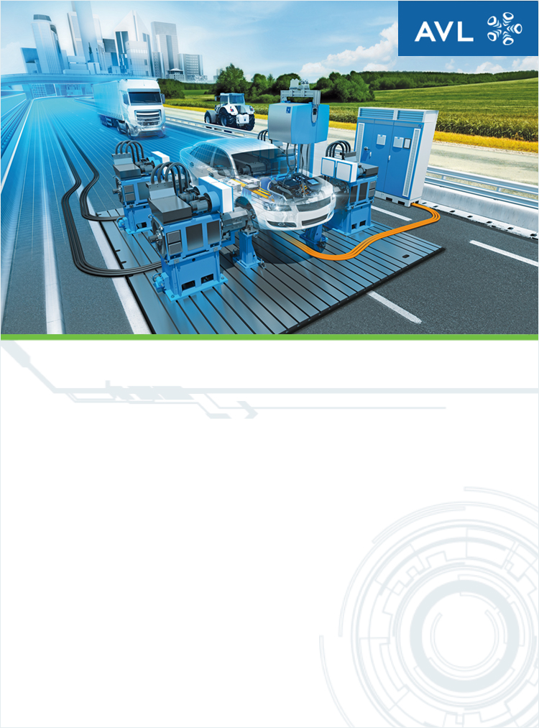

Technická universita v Liberci

Spares

AVL Proposal: 0151698-13
25. May 2020

PROPOSAL PREPARED FOR
Technická universita v Liberci
Studentská 2
Liberec, 46117

PROPOSAL PREPARED BY
XXXXXXX
XXXXXXXX
Phone No.: XXXXXXXX
Mobile: XXXXXXXXX
Fax No: XXXXXXXXX

CONTENTS
PRICING 2
TECHNICAL DESCRIPTION 4

PRICING
Pos |  | Qty |  | Item Name |  |  | Price in Kč / Unit Net | Price in Kč / Total Net* |  |  | Alternatives / Options Kč*
1 |  | 1 |  | SERVICES  T-00C.00
1.1 |  | 1 |  | Chapter  T.00
1.1.1 |  | 1 |  | AVL SPARE PARTS  TCSPARESA.00
1.1.1.1 |  | 1 |  | REMOTE CONTROL FUEL BALANCE  TM0733SFA.01 |  |  | 127.050,- | 127.050,-
1.1.1 (A1) |  | 1 |  | *Alternative: AVL SPARE PARTS  TCSPARESA.00 |  |  | 127.050,- |  |  |  | 127.050,-
 |  | 1 |  | REMOTE CONTROL SMOKE METER  TM0415SFS.02 |  |  | 127.050,- |  |  |  | 127.050,-
* options / alternatives are not included in total price.
Total Price Net without VAT |  |  |  |  | 127.050,-

University discount – 10% | -12.705,-

Total Price Discounted Net without VAT | 114.345,-

CONDITIONS
Payment Terms |  |  | within 30 days from date of invoice, net
Dispatch Terms |  |  | According to your instructions
Delivery Terms |  |  | CIP, Liberec
Delivery Time |  |  | within 4 weeks for receipt of technically and commercially clarified written order
Validity |  |  | 90 days from date of proposal
Warranty |  |  | 24 months
XXXXXXXXX
Sales Manager
XXXXXXXXXX
AVL Čechy spol. s r.o.
CZ-75301 Hranice na Moravě, Tovární 605
http://www.avl.com
http://www.avlcechy.cz
TECHNICAL DESCRIPTION
1 | SERVICES  T-00C.00

1.1 | Chapter  T.00

1.1.1 | AVL SPARE PARTS  TCSPARESA.00

After the exchange of system components original AVL spare parts guarantee that your AVL equipment continues to perform according to your expectations on reliability and quality.
A world-wide warehouse and distribution concept allows a fast delivery of parts and covers the spare part needs of all AVL instrumentation and test systems.
AVL's spare part program within the AVL eShopTM provides a comprehensive solution combining fast delivery with economic cost. Spare parts can be easy identified, ordered online via the web shop and are mostly delivered within 24 hours.

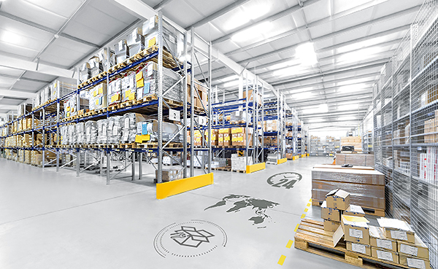

Advanced search functions, high quality images, technical details and the access to user manuals simplify the identification of spare parts.
Via the implemented Self Service Offer function you can create spare part offers easily by yourself at any time.
Should you require detailed information about the spare parts listed in this quotation please do not hesitate to register via www.avl.com/avl-eshop

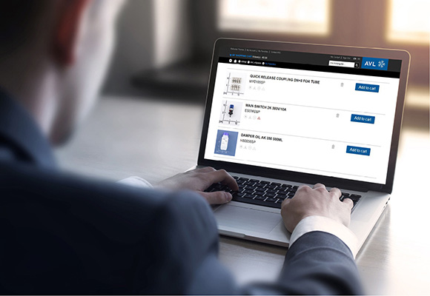

1.1.1.1 | REMOTE CONTROL FUEL BALANCE  TM0733SFA.01

For manual menu-driven operation of the Fuel Balance.

Technical Insight

Functions and displays:

- Fuel consumption values in kg/h and g
- Instantaneous consumption values
- Average consumption over preselected measurement time or preselected measurement weight
- Total/interval consumption over preselected measurement time
- Floating mean value with additional display of standard deviation and Min./Max. values
- Fully automatic accuracy check and calibration
- Error and status message display
- Maintenance interval display

Technical Data

External electric power supply: | 24 V DC +/-10%, 0,5 A

Notes

Suitable for installation in a 19" rack cabinet (see Mounting Frame for Remote Control).

Scope of Supply

Each consisting of:

1 Instrument Controller 4210A
1 Mains cable for 24 V DC connection, length 5 m
1 Operating manual

ALTERNATIVE
1.1.1 (A1) | AVL SPARE PARTS  TCSPARESA.00

For the technical description please refer to pos 1.1.1

REMOTE CONTROL SMOKE METER
TM0415SFS.02

The remote control (AVL Instrument Controller 4210) can be used to establish a connection to an AVL measuring device. The communication with the basic device takes place via the serial interface (RS-232) and a max. 20 m long cable. In addition, the functions via digital I / O and analog out are available via the external control connector.
The installed software supports the operation of an AVL Smoke Meter (only the functionalities of the 415S) and an AVL 733S fuel consumption meter. The remote display and control unit is used for displaying the measurement values, pre-selection of measuring modes and setting of measuring / instrument-specific parameters. Errors are displayed as well.

Dimensions (W x H x D) | 210 x 129 x 70 mm (without mounting frame)
Power supply | 24 VDC +/- 10 %
Power consumption | 10 W
Ambient temperature | 0 ... +50 °C
Weight | Approx. 1 kg

