91B PCB T-px ^{Q}Ò
Detector/sensor needs 2021 — Timepix3
ATLAS-TPX3 upgrade:
' 36 x 300/500 um silicon (28 for installation, 8 spare) —thickness TBD CãR(J '19 Lg L
- 18 x Timepix3 stack board (14 for installation, 4 spare)
MOEDAL-TPX3 upgrade: (søuv- svoŒq)
- TBD single layer of stack?
- 6 x 300/500/1000 urn (thickness TBD)
0 6 x Timepix3 stack or single layer PCB rg11CADO (to be defined by Bart)
0 10 x 300/500 um silicon (for the network) o ? x ? for the Nanopix upgrade
MIRAM/Space:
5 x 300 gm silicon
PAN:
0 4 x Timepix3 Quad (300 um)
• 4 x Timepix3 Quad board (2 x rad. hard)
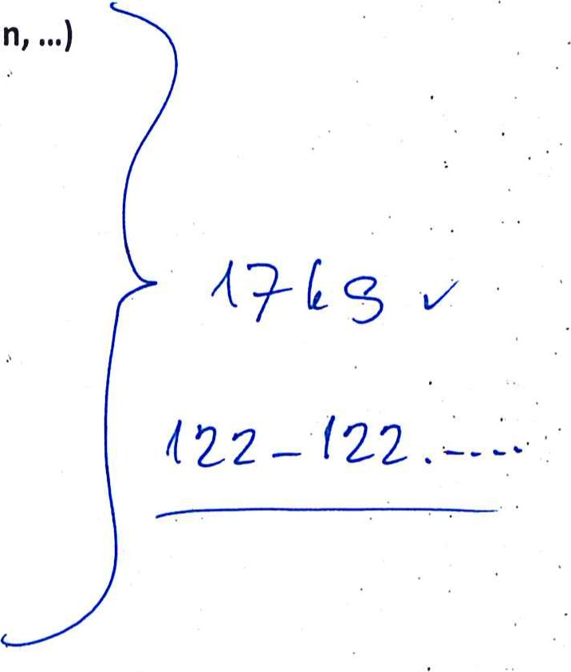
Radiation monitoring — global network (Mexico, Zugspitze, Chile, AzerbaidJan
- 8 x 300/500 um silicon (thickness depends on availability) 8 x Timepix3 stack board Stock (miscellaneous projects):
- 3 x CdTe / CZT (2 mm)
- 2 x CdTe /CZT (1 mm)
- 3 x GaAs (300 gm —1 mm)
- 3 x 3D sensors
- 5 x 300 gm silicon
5 x 500 1-1m silicon
- 2 x l mm silicon
- 23 x Timepix3 single layer PCB
Van-de-Graaff (

Pilsen, 26th February 2020

Subject of delivery:
Chipboard for Timepix3 detector: PCB, aluminum holder, plastic box, plastic sensor protection.
 | unit price | pcs | final price
Chipboard for Timepix3 |  | 50
Delivery anf financial conditions:
The price does not include VAT. Timepix3 detectors are not included.
Delivery costs are not included and will be invoiced separately.
Delivery time is 90 days from receipt of the order. This quotation is valid until 30th March 2020.
Assoc. Prof

