HIGH VOLTAGE. EXACTLY.
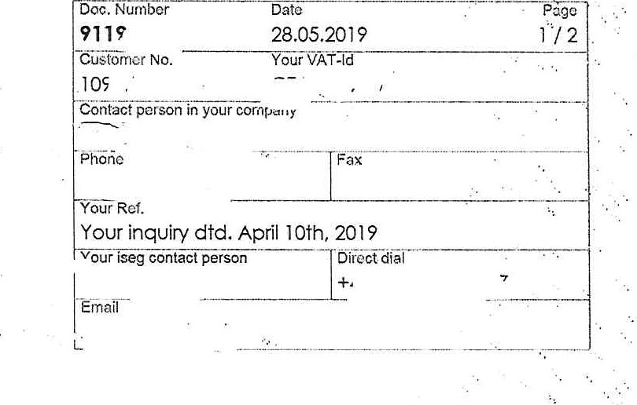
Czech Technical University in Prague
Institute of Experimental and Applied Physics
110 OO PRAGUE I
CZECH REPUBLIC

Quotation

Many thanks for your inquiry and your interest in our products. We are pleased to quote you as follows according to our general terms of business:
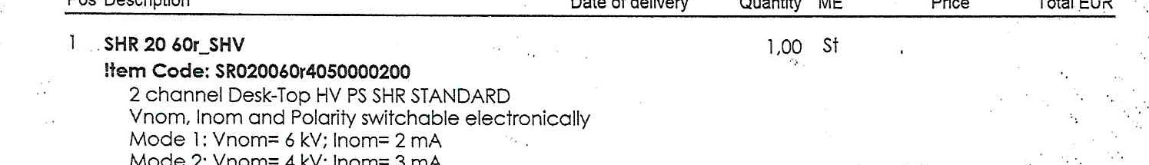Mode 2: Vnom= 4 kV; Inom= 3 rnA
Pos
•Description
Date
of
delivery
Quantity
ME
Price
Total
EUR
Mode 3: Vnom= 2 kV; Inom= 4 mA
Front panel control, 4.3" TFT, capacitive touch display

USB and Ethernet interfaces
Resolution of voltage setting/measurement: 12 mV
Resolution of current setting/measurement: 8 nA
Ripple & noise: < 10 rnV (f > 10 1-Iz) HV output: SHV connector refurbished demo unit of first series with full warranty warranty: 36 months

- HV cable with SHV connector one-sided, 5m 2,0Ô St
Item Code: SHV_C04-5.O
SHV connector assembled to HV cable HTV-30S-22-2 one-sided, other side open ends, length 5m
- Software Support Service (isegContr012, ICS) for 2 years 1.00 st
- Remote Product and Software Training via Video st
Conferencing Software 
- Packing st
Item Code: 520204 membraneous box 66cm x 62cm x56cm cc. 12kg, valid for one SHR
Transfer
HIGH EXACTLY.
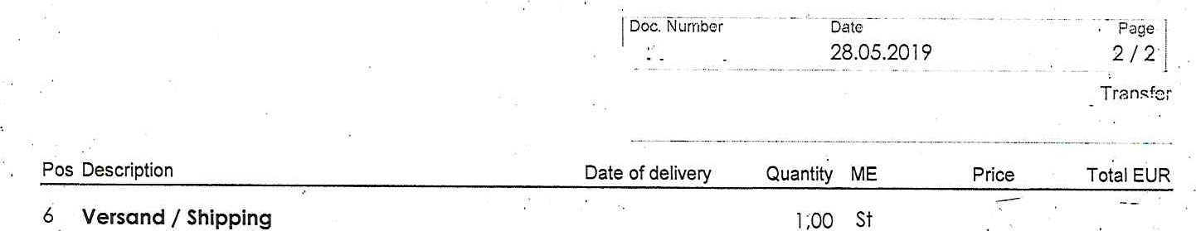6 Versand / Shipping
Item Code: Versand shipping to Prague via UPS Standard
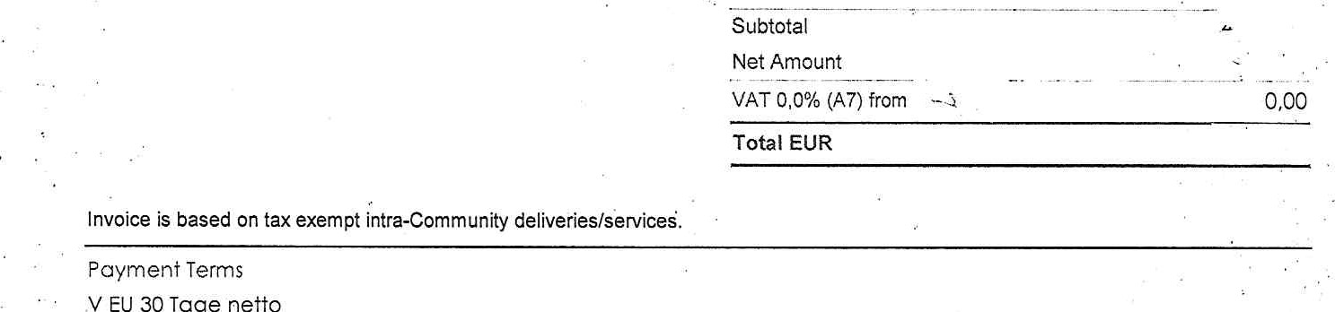
V
EU
30
Tage
netto

