ADMINISIRATIVNÍ BUDOVA BLOK č. l

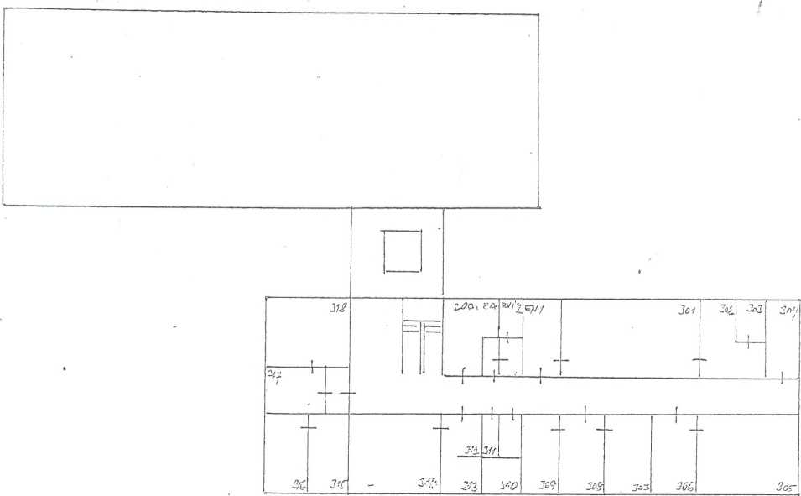

III. Etáž

|  |  |  |  |  |  |  |  |  |  |  |  |  |
| --- | --- | --- | --- | --- | --- | --- | --- | --- | --- | --- | --- | --- |
|  | |  |  | | 1 | \ | ! | ? |  | 1 | | |
|  |  |
| 1 | | T ! | | | i i « » i i  ... I I ! i - l | | | | | | —i— | i |
| —1— | 1 | I |  | |  |  | 1 | 1 | i | l | 1 |  |

|  |  |  |  |  |  |  |  |  |  |  |  |
| --- | --- | --- | --- | --- | --- | --- | --- | --- | --- | --- | --- |
|  | |  | | |  | | | | | | |
|  |  |  | — | ~ |  | I |  | 1 | 1 | I | 1 |
| 1 1 1 | | | I | | lil | ' | J 1  i i J 1 1 11 1 | | | | | | |
| 1 |  |  | i | | i  , | • T ÍL a | 1 1 | 1 | i |  | i |

II. Etáž

I.Etáž

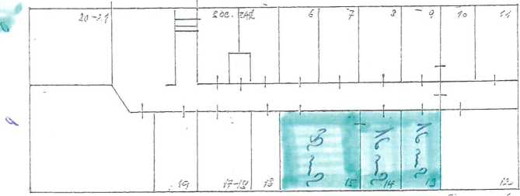

Přízemí.