Confidentiality Level |  | BL - Restricted for internal use | TC ID / Revision |  | 00230599/C
Document Status |  | Document Released | Document No. |  | N/A
WBS code |  | 3.4 – L4 System
PBS code |  | RA1.L4.CMP1.10PW.OM.LCMT
Project branch |  | Engineering & Scientific documents (E&S)Engineering & Scientific documents (E&S)
Document Type |  | Specification (SP)Specification (SP)
[RSD product category C]
Large optomechanical mirror mounts and electronic controls for L4 10 PW compressor
TP19_010

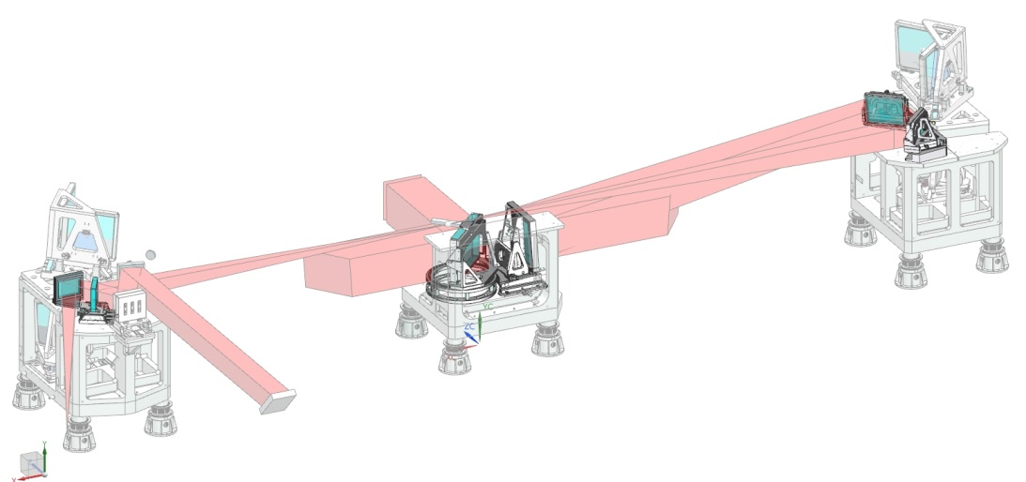

Keywords
N/A

 | Position |  |  | Name
Responsible person | Scientific Coordinator of Laser Technology (RP1) |  |  | Bedřich Rus
Prepared by | Scientific Coordinator of Laser Technology (RP1)  Senior Optomechanical Designer  Lead Laser Control and Timing Systems Specialist |  |  | Bedřich Rus  David Snopek  Jack Naylon

RSS TC ID/revision | RSS - Date of Creation | RSS - Date of Last Modification | Systems Engineer
019293/A.001 | 17.06.2019 15:35 | 17.06.2019 15:35 | Pavel Tůma
019293/A.002 | 17.06.2019 15:37 | 17.06.2019 15:37 | Pavel Tůma
019293/A.003 | 24.06.2019 08:08 | 24.06.2019 08:08 | Pavel Tůma
Reviewed By
Name (Reviewer) | Position | Date | Signature
Pavel Bakule | Deputy RP1 Leader
Daniel Kramer | Senior Laser Optical Specialist
Pavel Trojek | Senior Laser Specialist
Štěpán Vyhlídka | Short Pulse Lasers Specialist
Martin Laub | Chief Engineer
Jakub Janďourek | Infrastructure technology coordinator | NOTICE
Ladislav Půst | Manager installation of technology | NOTICE
Veronika Olšovcová | Safety Coordinator
Viktor Fedosov | SE & Planning group leader;  Quality Manager


Approved by
Name (Approver) | Position | Date | Signature
Bedřich Rus | Scientific Coordinator of Laser Technology (RP1)

Change No.
Change No. | Made by | Date | Change description, Pages, Chapters | TC rev.
1 | Bedřich Rus  David Snopek  Jack Naylon | 12.06.2019 | RSD draft creation | A
2 | Pavel Tůma | 17.06.2019 | RSD version for review | B
3 | Pavel Tůma | 24.06.2019 | RSD version for release | C

Table of Content

1. Introduction 5
1.1. Purpose 5
1.2. Scope of work 5
1.3. Terms, Definitions and Abbreviations 8
1.4. Reference Documents 9
1.5. References to standards 9
2. Technical description 10
2.1. Scope of Work 10
2.2. Optomechanical Mounts 10
2.2.1. Optomechanical mount OM7 14
2.2.2. Optomechanical mount OM7.5 15
2.2.3. Optomechanical mount OM8 15
2.2.4. Optomechanical mount OM9 16
2.2.5. Optomechanical mount SPM1 16
2.2.6. Optomechanical mount OOM1 17
2.3. Motion Control System 18
2.4. General Requirements for Manufacture, Testing, and Packaging 24
2.4.1. Cleaning Procedure 24
2.4.2. General rules for assembling 25
2.4.3. Testing and inspection 25
2.4.4. Packaging 25
3. Functional, Performance and Design requirements 26
3.1. General 26
3.2. Optomechanical mounts 26
3.3. Control system 28
3.4. Packaging and Transportation requirements 29
3.5. Testing, inspection and documentation 29
3.6. Safety Requirements 30
3.6.1. General Safety Requirements 30
3.6.2. Personal and Machine safety 30
4. Quality requirements 31
4.1. Documentation and data control 31
4.2. Nonconformity control system 31
4.3. Verification requirements for the Supplier 31
4.3.1. Recommended verification methods 32
4.3.2. Verification Control Document (VCD) 32
4.3.3. Acceptance 33
5. Reference drawings and diagrams 34
5.1. Drawing Package 34
5.2. OM7 optomechanical mount (Drawing No 00197367 Rev. 01) 35
5.3. OM7.5 optomechanical mount (Drawing No 00222423 Rev. 01) 36
5.4. OM8 optomechanical mount (Drawing No 00197941 Rev. 01) 37
5.5. OM9 optomechanical mount (Drawing No 00197387 Rev. 01) 38
5.6. SPM1 optomechanical mount (Drawing No 00212422 Rev. 01) 39
5.7. OOM1 optomechanical mount (Drawing No 00198749 Rev. 01) 40

Introduction

Purpose
This Requirements Specification Document (RSD) lists the technical requirements and constraints on a product related to the RA1 programme of the ELI Beamlines project. This can lead to identification of the product interfaces with the ELI Beamlines science-based technology and ELI Beamlines building facility. This RSD also acts as the parent document for technical requirements that are addressed in lower level design description documents (see chapter 1.4).

Scope of work
This RSD states and describes the technical requirements for the assembly of large optomechanical vacuum mirror mounts and their electronic controls, which compose the final leg of the Compressor Image relay System (CIS). This part of CIS optical beam transport is located inside the large vacuum L4 10PW compressor (In-compressor CIS, I-CIS) and is an integral part of the overall L4 laser system of ELI Beamlines. It is registered in the PBS database under the following PBS code: RA1.L4.CMP1.10PW.OM.LCMT.
This RSD contains all of the technical requirements: functional, performance and design, delivery, safety and quality requirements for the following product (tender number: TP19_010): Large Optomechanical Mirror Mounts and electronic controls for L4 10 PW Compressor (“Mounts” in further text). In addition to the requirements specified hereinafter, all parts of the Mounts shall fully comply with the drawings provided in the Reference Documents (see below RD-01, chapter 1.4).
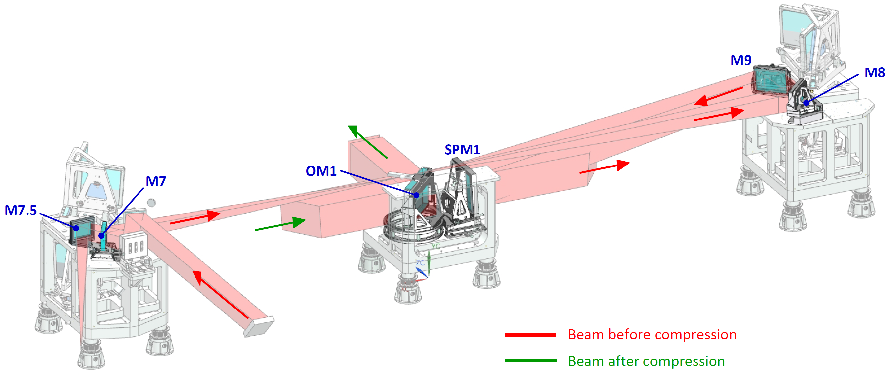
Figure 1: Overall layout of the In-Compressor Image relay System (I-CIS), showing location of all optomechanical mounts required within this contract (OM7, OM7.5, OM8, OM9, SPM1, and OOM1) and the optical path of the incoming laser beam reflected by mirrors M7-M8-M9-SPM1; mirror M7.5 serves to send the low-intensity beam transmitted through M7 to outside of the compressor. The M7, M7.5, M8 and M9 are planar mirrors; the SPM1 is a spherical mirror. A part of the required supply is also manufacture of the optomechanical mount for the compressor output mirror OM1 serving to send the compressed 10PW laser beam out of the compressor. The mounts will operate in high cleanliness vacuum environment and will be attached to the supporting chassis in each tower of the L4 compressor.

[VYPUŠTĚNO]
Figure 2: Location of the individual optomechanical mounts on the North (upper left), South (upper right), and central (bottom) chassis of the L4 vacuum compressor, indicating some spatial constraints. The mirrors M7 and M7.5 sitting on the North chassis shall have compact bases in order to fit environment of the surrounding systems. Design of the mount of mirror M9, sitting on the South chassis, shall be adapted to strongly limited height available above the local optical table on which this mount is attached. The mounts of mirrors SMP1 and OM1, both sitting on the central chassis, shall be designed with respect to close distance of these two mirrors.

Required part of the supply is manufacture of six optomechanical mounts of large laser mirrors which form the final leg of the CIS, or I-CIS, beam transport system from the L4 laser chain output to the L4 10PW compressor gratings. The overall layout of these mirrors and their mounts, sitting inside the L4 vacuum compressor, is shown in Figure 1. The mounts are located in all three compressor towers and are supported by rigid semi-monolithic chassis in each tower. The chassis are in turn mounted on monolithic isolation platforms which are mechanically de-coupled from the vacuum chamber body by means of bellow units integrated into the supporting legs.
The In-Compressor Imaging System (I-CIS) is located inside the compressor chamber and provides the following functions:
- Transports the collimated laser beam from the input of the compressor chamber in vacuum, along the required geometric path, to reach the first diffraction grating
- Expands the beam size from approximately 320x320 mm at the input of the compressor to approximately 650x650 mm on the first diffraction grating.
- Forms part of the full optical image relay system between the L4 laser chain output and the final (fourth) grating in the compressor.

All the mounts required within this supply will be operating in high-cleanliness vacuum, at nominal pressure 10⁻⁷ mbar. The detailed design of the mounts as well as choice of the material and of components of the electronic controls shall be fully compatible with operation in high-cleanliness environment. For instance, all holes made in the mounts shall be vented and, as a rule, use of lubricants is not allowed. If local application of a lubricant is unavoidable, the only permitted are Krytox™ LVP and Braycote Micronic 601EF which are UHV compatible lubricants and are known to be proven for the intended purpose in high-precision vacuum optomechanical applications. However, amounts as minimum as possible shall be used, and any specific application of the lubricant shall be approved by CA.

The following tables provide a summary of the contractual requirements. The total scope of the contract comprises all the requirements stated or implied in the foregoing text, whether or not included in this summary.

Terms, Definitions and Abbreviations

For the purpose of this document, the following abbreviated terms are applied:

Abbreviation | Meaning
API | Application Programming Interface
BiSS | Bidirectional / Serial / Synchronous
CA | Contracting Authority (Client)
CIS | Compressor Image relay System
D-SUB | Subminiature D-type connector according to specification MIL-DTL-24308
DIN | Deutsches Institut für Normung / German institute for standardisation
ELI | Extreme Light Infrastructure
EMI | ElectroMagnetic Interference
EMP | ElectroMagnetic Pulse
FEM | Finite Element Method
FLT | Fork Lift Truck
FMEA | Failure Mode and Effects Analysis
FPGA | Field Programmable Gate Array
GUI | Graphical User Interface
I-CIS | In-Compressor Image relay System
L x W x H | Length x Width x Height
L4c | Identification code of hall
MCTR | Motion Control System
MSS | Machine Safety System
NI | National Instruments
OM | Optomechanics
PLC | Programmable Logic Controller
RA1 | Research activity 1
RGA | Residual Gas Analyzer
RIO | Reconfigurable I/O
RMC | Rack Mount Controller
RS-422 | Recommended Standard for serial communication ANSI/TIA/EIA-422-B
RS-485 | Recommended Standard for serial communication ANSI/TIA/EIA-485-A
RSD | Requirements Specification Document
RTD | Resistive Temperature Detector
RTS | Real-Time Server
SCADA | Supervisory Control and Data Acquisition system
TVS | Transient Voltage suppression Diode
TC ID | Team Center IDentifier (unique identifier number)
UHV | Ultra High Vacuum
VCD | Verification Control Document

Reference Documents

Number of document | Title of Document/ File
RD-01 | 00230601/A_Drawing_package-Large optomechanical mounts for L4 10 PW compressor_TP19_010.zip

Detailed list of drawings included within RD-01 archive:

Drawing No | Filename | Sheets | File format
00197367/00 | OM7 | 1 | PDF
00222423/00 | OM7.5 | 1 | PDF
00197941/00 | OM8 | 1 | PDF
00197387/00 | OM9 | 1 | PDF
00212422/00 | SPM1 | 1 | PDF
00198749/00 | OOM1 | 1 | PDF

References to standards
If this document includes references to standards or standardized/ standardizing technical documents the CA allows/permits also another equal solution to be offered. If a supplier offers another equal solution the CA shall not reject its bid, once the supplier by appropriate means in the bid proves that the offered supplies, services or works meet in an equivalent manner the requirements including references to standards or technical documents.

Technical description

Scope of Work
Within this procurement the following scope of work is required:
A. Final production design of six large optomechanical mounts OM7, OM7.5, OM8, OM9, SPM1 and OOM1, based on the detailed conceptual design provided by CA.
The Supplier is specifically required to:
a) Develop detailed design of the individual mounts, based on the provided conceptual drawings, and perform FEM simulations of the final design to demonstrate rigidity and required vibration resonance properties
b) Identify and implement suitable actuators meeting the positioning and cleanliness requirements
c) Develop design of rigid frames in which the mirrors will be mounted and which will interface with the respective mounts; the frames shall be designed so that they do not produce any optically significant deformations to the mirrors
d) Develop design of attachment of the optomechanics to the respective optical support chassis; the solution should ideally use brackets not extending the optomechanics’ footprint on the chassis
B. Manufacture of the six optomechanical mounts OM7, OM7.5, OM8, OM9, SPM1 and OOM1.
C. Design, supply, installation and testing of the optomechanical system controller including all actuators and associated devices, according to the functional specification supplied by CA (see Section 2.3).
D. Design and supply of all cabling, cable management and vacuum feedthroughs (without vacuum flanges) for all electrical components of the mounts.
E. Final cleaning, trial assembly and functional testing of each optomechanical mount, at the supplier’s works.
F. Packaging for transport and delivery of all the mounts to the ELI-Beamlines facility.
Installation of the mounts and final integration of the controls in the L4c hall of ELI-Beamlines is not required within this nominal procurement package but may be called in as contractual option.
The supply of the mirrors is not part of the scope of supply.

Optomechanical Mounts
The outline technical requirements of all required optomechanical mounts are given in
Table 1. The mounts are fitted with actuators that allow a fine adjustment of yaw and pitch by operation of stepper motor from the external control system.
Additionally to yaw and pitch, the mirrors M7, M8, and M9 are equipped by linear translation that allows for ±12.5 mm axial translation. The SPM1 mount shall allow for ±50 mm axial translation and also ±25 mm lateral and ±25 mm vertical translation. The OOM1 mirror mount shall be equipped by a rotation stage for 95° manual rotation and not precluding future implementation of stepper motor making it possible for operation from the external control system.
The mirrors will be mounted in frames which will be installed into the supplied optomechanical mounts and shall thus interface with these mounts.
Whenever indicated the axes shall be equipped by encoders making it possible absolute position knowledge by the encoder readout. The encoders shall provide this absolute position capability even after encoder switch on, without homing of the movement.
Table 1 provides a summary of functional requirements for all the optomechanical mounts that form part of this supply. While the individual parameters in Table 1 are binding the Supplier is entitled to select appropriate type of vacuum-compatible electrical actuator for each mount /axis. If needed, CA can provide Newport VHRU and/or LTA vacuum actuators including position encoders but the Supplier shall provide full integration of these actuators into the optomechanics and into the control system.

Table 1: In-compressor L4 CIS optomechanics
(note: the individual optomechanics OMx correspond to the respective mirrors Mx).

Optomechanical mount No. | Range | Resolution ¹ | Accuracy ² | Actuator type | Encoder
OM7
Yaw | ±0.5° | 1 µrad | 2 µrad. | Stepper motor | Y
Pitch | ±0.5° | 1 µrad | 2 µrad | Stepper motor | Y
Translation | ±12.5 mm | 5 µm | 10 µm | Stepper motor | Y
OM7.5
Yaw | ±1° | N.A. | N.A. | Manual | -
Pitch | ±1° | N.A. | N.A. | Manual | -
Translation | ±12.5 mm | N.A. | N.A. | Manual | -
OM8
Yaw | ±0.5° | 1 µrad | 2 µrad. | Stepper motor | Y
Pitch | ±0.5° | 1 µrad | 2 µrad | Stepper motor | Y
Axial translation | ±12.5 mm | 5 µm | 10 µm | Stepper motor | Y
OM9
Yaw | ±1° | 1 µrad | 2 µrad | Stepper motor | Y
Pitch | ±1° | 1 µrad | 2 µrad | Stepper motor | Y
Axial translation | ±12.5 mm | 5 µm | 10 µm | Stepper motor | Y
SPM1
Yaw | ±0.5° | 1 µrad | 2 µrad | Stepper motor | Y
Pitch | ±0.5° | 1 µrad | 2 µrad | Stepper motor | Y
Axial translation | ±50 mm | 5 µm | 10 µm | Stepper + ball screw | Y
Lateral translation | ±25 mm | 5 µm | 10 µm | Stepper + ball screw | Y
Height | ±25 mm | 5 µm | 10 µm | Stepper + ball screw | Y
OM1
Pitch | ±0.5° | 1 µrad | 5 µrad | Stepper motor | Y
Yaw (fine) | ±1° | 1 µrad | N.A | 2x stepper motor | -
Rotation (flip) | ±45° | N.A. | N.A | Manual | End positions detection

¹ One incremental step of motorized actuator without microstepping; one graduation of fine adjustment scale for micrometric screw
² Absolute position knowledge by encoder readout, bidirectional repeatability for motions without encoder
³ Design of the mount should enable implementation of a stepper motor in the future

Yaw: rotation around the vertical axis
Pitch: rotation around the horizontal axis parallel to the mirror surface
Roll: rotation around the horizontal axis perpendicular to the mirror surface

All mirrors will be mounted in frames. All mirrors have a groove around the entire edge (see Figure 3 below) to allow mounting the mirrors into the frame; the width of the groove is 10 mm for the mirrors M7, M7.5, M8 and M9, and 20 mm for the mirrors SPM1 and OM1. The supplier is asked to develop a 3-point design of the mounting elements, which shall not produce any consequential optical deformations of the front surface, specifically deformation produced by the mounting across the entire surface of the mirror shall not exceed 100 nm (or lambda/10, where lambda = 1 µm). Fulfilment of this criterion shall be substantiated by detailed FEM analysis. The solution of the mounting system provided in the CA drawings is only indicative as it does not employ the edge groove.
The frames shall be inserted and attached to the optomechanical mounts. Dimensions of the individual mirrors and of their mounting frames are shown below in Table 2.
The frames will be supplied by CA according to the design developed by the supplier.

 | Substrate size |  |  | Frame size (outside dimensions)
Mirror | Width (mm) | Height (mm) | Thickness (mm) | Width (mm) | Height (mm) | Thickness (mm)
M7 | 360 | 320 | 60 | 430 | 390 | 50
M7.5 | 370 | 320 | 60 | 430 | 390 | 50
M8 | 600 | 450 | 80 | 660 | 510 | 70
M9 | 600 | 450 | 80 | 660 | 510 | 70
SPM1 | 710 | 710 | 120 | 820 | 820 | 110
OM1 | 1000 | 710 | 120 | 1100 | 800 * | 110

* Upper part of the OM1 frame consists only from central brace so as to leave maximum space for the laser beams propagating above the OOM1 mount
Table 2: Size of the in-compressor CIS mirrors and of the mounting frames (manufacture of M7.5 is not part of the nominal supply). The indicated thickness of the spherical mirror SPM1 relates to thickness at edges of this mirror.


Figure 3: Schematic indication of the mounting groove around edge of all in-compressor CIS mirrors. The width of the groove is 10 mm for mirrors M7, M7.5, M8 and M9, and 20 mm for SPM1 and OM1; the groove depth is respectively 20 mm and 30 mm.

Optomechanical mount OM7
The conceptual design of the OM7 optomechanical mount is indicated in Figure 4 and, in more detail, in the drawing package in Chapter 5. The mirror has size 360 x 320 x 60 mm. The conceptual design is based on use of flexible joints for yaw and pitch movements. The mount has also to allow linear translation of the mirror by +/-12.5 mm.
The OM7 mount and the mirror frame shall not obstruct the back side of the mirror, thus following the conceptual design provided by CA. Furthermore, the OM7 will be mounted on the North chassis in space constrained environment and therefore its size resulting from the detailed design to be developed by the Supplier shall not exceed the dimensions of the conceptual design.
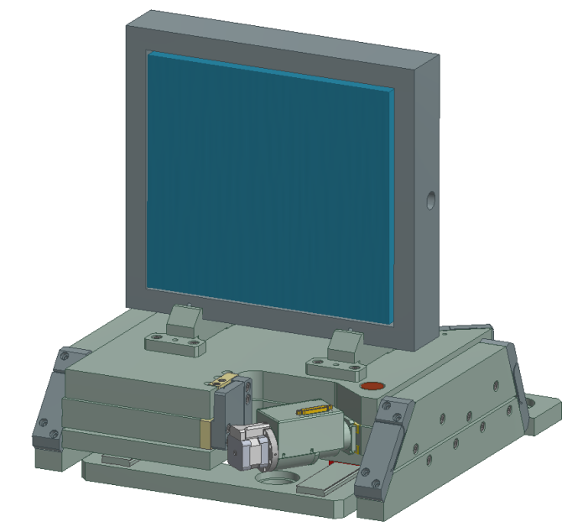
Figure 4: Conceptual design of the OM7 optomechanical mount. The mount shall allow accurate yaw and pitch alignment as well as linear motorized horizontal translation along a direction which is at 30 degrees with respect to the mirror surface.

Optomechanical mount OM7.5
The conceptual design of the OM7.5 optomechanical mount is indicated in Figure 5 and, in more detail, in the drawing package in Chapter 5. The mirror has size 360 x 320 x 60 mm. The conceptual design is based on use of flexible joints for yaw and pitch movements. The mount shall also make it possible linear horizontal movement by +/- 12.5 mm.
Manufacture of this mount OM7.5 constitutes an option of the contract.
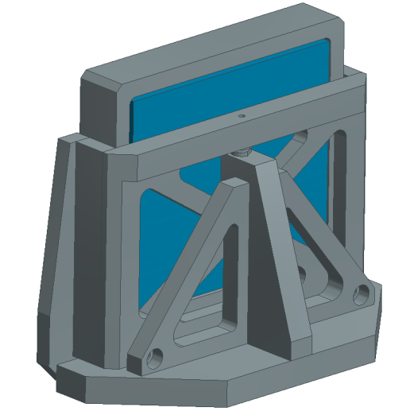
Figure 5: Conceptual design of the OM7.5 optomechanical mount. The mount shall allow accurate yaw and pitch alignment, as well as linear translation along an axis oriented at 60 degrees with respect to the mirror surface.

Optomechanical mount OM8
The conceptual design of the OM8 optomechanical mount is indicated in Figure 6 and, in more detail, in the drawing package in Chapter 5. The mirror has size 600 x 450 x 80 mm. The conceptual design is based on use of flexible joints for yaw and pitch movements. The linear movement along a horizontal direction shall allow for +/- 12.5 mm displacements.

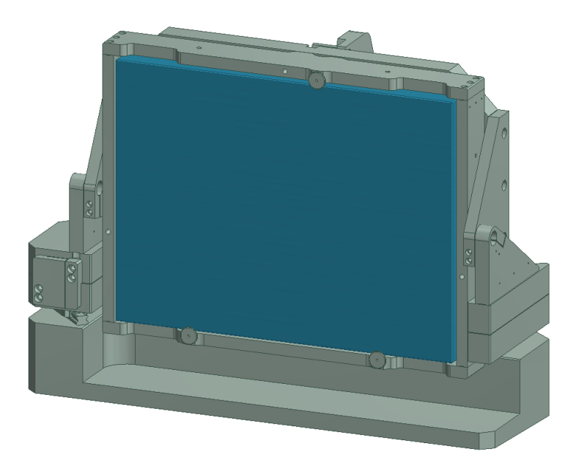
Figure 6: Conceptual design of the OM8 optomechanical mount. The mount shall allow accurate yaw and pitch alignment. The mount is also equipped by horizontal linear motorized translation along direction of approximately 45° with respect to the surface of the mirror.

Optomechanical mount OM9
The conceptual design of the OM9 optomechanical mount is indicated in Figure 7 and, in more detail, in the drawing package in Chapter 5. The mirror has size 600 x 450 x 80 mm. The conceptual design is based on use of flexible joints for yaw and pitch movements. The mount has also to make it possible linear translation of the mirror by +/- 12.5 mm.
The M9 mount shall be designed with respect to strongly restricted space between the bottom side of the mirror and the supporting optical table.

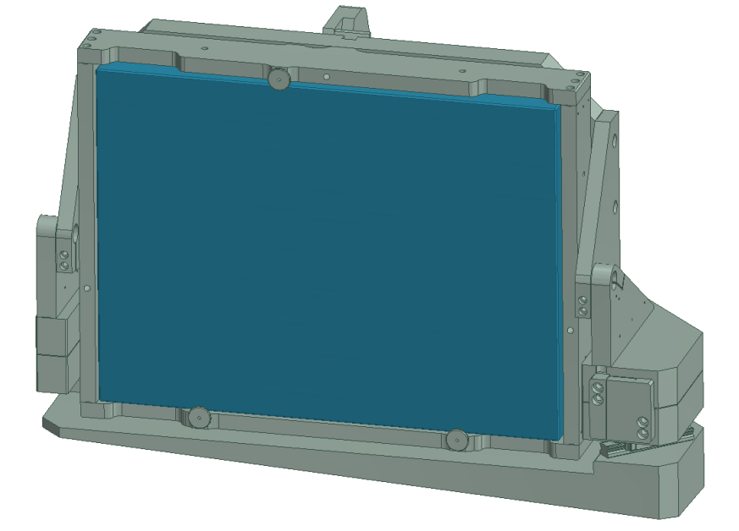
Figure 7: Conceptual design of the OM9 optomechanical mount. The mount shall allow accurate yaw and pitch alignment. The mount is also equipped by horizontal linear motorized translation along direction of approximately 45° with respect to the surface of the mirror.

Optomechanical mount SPM1
The conceptual design of the SPM1 optomechanical mount is indicated in Figure 8 and, in more detail, in the drawing package in Chapter 5. The mirror has size 710 x 710 x 120 mm. The SPM1 mount constitutes a 5-axis positioning assembly and is thus the most complex from all mounts required within this contract. The conceptual design is based on use of flexible joints for yaw and pitch movements, around a point located in the center of the front surface. The mount has also to make it possible x-y (axial and transverse direction, respectively) linear translations and also vertical translation by +/-25 mm, along an axis inclined by 3.25° with respect to vertical direction (this is due to the geometry of the optical beam path defined by the mirrors). Furthermore, the detailed design shall not exceed in dimensions the conceptual design provided by CA, as the SPM1 mount will operate in space-constrained arrangement, next to the OOM1 mount (see Figure 2).

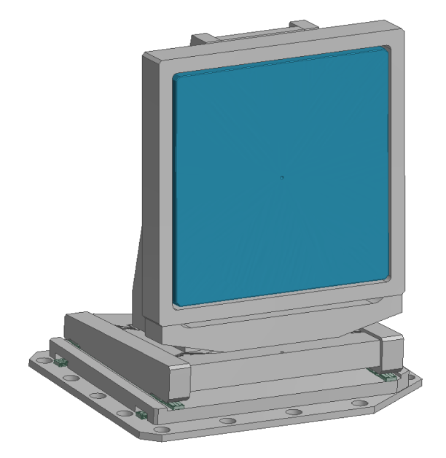
Figure 8: Conceptual design of the SPM1 optomechanical mount. The mount shall allow accurate yaw and pitch alignment around the center of the front surface. The mount shall also be equipped by motorized x-y-z linear translations where the z axis shall be inclined by 3.25° with respect to vertical direction.

Optomechanical mount OOM1
The conceptual design of the OOM1 optomechanical mount is indicated in Figure 9 and, in more detail, in the drawing package in Chapter 5. The mirror has size 1000 x 710 x 120 mm. The mount exploits flexible joints for the pitch movement. The OOM1 system shall be capable of motorized fine yaw movement but also shall allow for manually rotating (re-configuring) the mirror by 90°. This rotation is produced in the conceptual design by rotation motion guides (i.e., rails and caged ball guides).
The OOM1 mount and the mirror frame shall be designed with respect to limited space above the mirror, in order not to obstruct propagation of the laser beam in the compressor. The overall height of OOM1 thus shall not exceed that of the conceptual model supplied by CA.
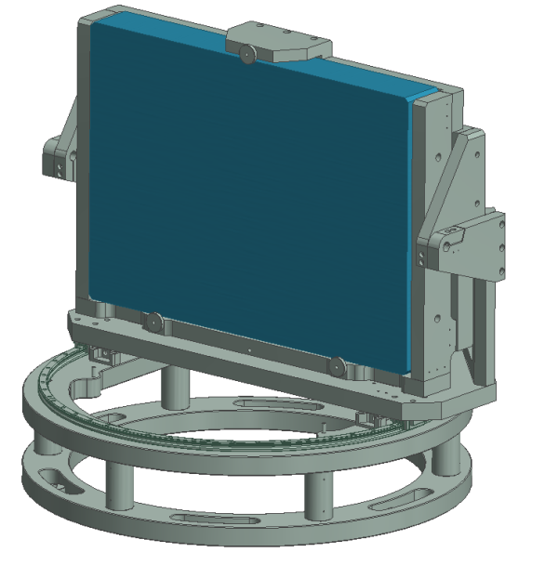
Figure 9: Conceptual design of the OOM1 optomechanical mount. Additionally to accurate yaw and pitch movements the mount shall allow rotation by 90°, to reconfigure output of the L4 compressor and to re-direct the output laser beam to the direction opposite to nominal configuration.

Motion Control System
[VYPUŠTĚNO]

[VYPUŠTĚNO]

Figure 10: State diagram for compliance of the MCTR with the concept of operations. Primary states are denoted by circles, allowed transitions by arrows and dashed lines represent permissives from safety systems.

[VYPUŠTĚNO]
Figure 11: MCTR architecture and implementation compliance diagram to be followed by the Supplier. Figure continued on the following pages

[VYPUŠTĚNO]

Table 2: Requested devices (hardware) list (motion controller)
The requested devices are those for which compatibility and operation with the existing laser equipment is proven. The necessity for a specific implementation is compatibility with the rest of the L4 laser control systems, compatibility with the control systems of other major laser equipment of ELI-Beamlines, and for maintainability assurance. Using the requested devices ensures that:
- Device has been tested by the CA and is known to be proven for its intended purpose and the requirements, thus reducing development risks and ensuring operational reliability;
- Device is already used in other parts of the L4 laser, minimizing risks of integration with the L4 laser control system and ensuring that spare parts and know-how are available at the CA;
- Device is known to be compatible with the CA’s systems and to satisfy the CA’s interface requirements, reducing the integration risks to ELI-Beamlines facility.
Device types not mentioned in this list may be freely selected by the Supplier as necessary to satisfy all other requirements.

[VYPUŠTĚNO]

General Requirements for Manufacture, Testing, and Packaging

Cleaning Procedure
- Physical pre-cleaning
  - Prior to cleaning, all components shall be examined.
  - All surfaces shall be inspected one by one and shall be free of scratches, rolling, cracks, scale, or other defects.
  - All swarf, burrs, etc. from the machined surfaces shall be physically removed. The procedures may include high pressure air blasting, water jet, scraping, swabbing etc.
  - Gross contaminations from the manufacturing process shall be removed by washing or rinsing with suitable general purpose solvent.
- Cleaning / washing
[VYPUŠTĚNO]

General rules for assembling
[VYPUŠTĚNO]

Testing and inspection
• The assembled mounts shall be tested in clean space or clean flowbox with cleanliness Class 5 according to ČSN EN ISO 14644 standard (equivalent to ISO 14644), or better.
• Prior to installation into the mounts, all actuators and components of linear translations shall be tested at works for vacuum cleanliness at vacuum pressures 1*10⁻⁷ mbar. The tests will require the quadrupole mass spectrometer (or RGA, residual gas analyzer) to prove that the residual gas mass spectrum of each actuator is free of peaks due to high-mass species beyond mass number 44 (corresponding to residual CO2 molecules).
• The mounts shall be thoroughly tested at works for functionality (resolution / range / accuracy / encoder readings / integration with the electronic controller) with mass simulators corresponding to the aggregated mass of the corresponding mirror and its frame.

Packaging
• Each movement or movable part of the optomechanical mounts shall be firmly locked before packaging to avoid damage during transport, by means of a securing bracket.
• Each mount shall be packed separately.
• A multi-layer wrapping protocol shall be applied to preserve Class 5 level of cleanliness (according to ČSN EN ISO 14644 standard (equivalent to ISO 14644), or better) during shipping.
• The interior of the package container shall be filled with clean dry air or nitrogen.
• Each mount shall be triple bagged, with two layers of polyethylene cleanroom film (e.g. UltraLOPlus™ or equivalent) and then one layer of a vapour barrier material such as foil. Seams shall be taped or heat sealed. Excess air between wrappings shall be evacuated and the bags sealed with desiccant packs inside.

Functional, Performance and Design requirements

General
REQ-027384/A
R1-00 - The detailed 3D engineering model and/or detailed drawings submitted by the Supplier shall be approved by the Client prior to proceeding to elaboration of the production (manufacture) drawings.
Verification method: R - review of related drawings and CA approval

Optomechanical mounts

REQ-027264/A
R1-01 - The optomechanical mounts shall be designed to support the respective optical components with dimensions as given in Table 2. The nominal position and orientation of the optical components in space shall be as in the 3D model. The required extent of movements shall be as in Table 1.
NOTE: The 3D model of the mounts will be provided to the Supplier after the contract signature.
Verification method: R - review of design, T – test
REQ-027265/A
R1-02 - The optomechanical mounts shall be attachable to the optical support chassis and shall be able to be pre-positioned (without engaging the actuators) with precision of ±1 mm.
NOTE: The 3D model of the chassis will be provided to the Supplier after the contract signature.
Verification method: R - review of design, T – test
REQ-027266/A
R1-03 - Each individual optomechanical mount shall provide short-term and long-term angular mechanical stability (drift) of the optical element better than 1 µrad (in a thermally stabilized environment).
Verification method: T - test
REQ-027267/A
R1-04 - FEM resonant frequency analysis of the optomechanical mounts shall be carried out by the Supplier.
Verification method: A – analysis
REQ-027268/A
R1-05 - The mounts shall not exhibit any resonant frequency below 35 Hz, and also shall not have resonant frequency close to 50 Hz.
Verification method: A – analysis
REQ-027269/A
R1-06 - The principal material of the optomechanical mounts shall be aluminium. The Supplier shall provide Certificate of Origin specifying manufacturer, composition of the alloy, for each aluminum blank used.
Verification method: R - review of material certificates
REQ-027270/A
R1-07 - The mirrors shall be mounted in frames separable from the positioning parts of the optomechanical mounts.
Verification method: R - review of design
REQ-027271/A
R1-08 - The design of the frames shall incorporate a 3-point fitting scheme for the mirrors, which shall not produce deformation across the entire surface higher than 100 nm.
Verification method: R - review of design
REQ-027272/A
R1-09 - The mounts design shall feature integration of electrical actuator including wirings for electrical actuators.
Verification method: R - review of design
REQ-027273/A
R1-10 - The detailed design of the mounts and any other components shall avoid any trapped volumes of air, e.g. the mounting holes shall not be blind tapped.
Verification method: R - review of design
REQ-027274/A
R1-11 - All actuators used in the optomechanics shall be certified for vacuum at least 1*10-8 mbar.
Verification method: R - review of documentation
REQ-027275/A
R1-12 - All outer surfaces shall be machined resulting in surface quality of Ra 0.8 µm or better.
Verification method: I – inspection, T – Test
REQ-027276/A
R1-13 - All edges of the optomechanical mounts shall be chamfered.
Verification method: R - review of design, I – inspection
REQ-027277/A
R1-14 - All cables for electrical actuators shall be organized into cable trays both inside the compressor vacuum chamber and on the chamber exterior.
NOTE 1: Layout and location of the cable trays will be specified by the CA.
NOTE 2: The 3D model of the compressor will be provided to the Supplier after the contract signature.
Verification method: R - review of design, I – inspection
REQ-027278/A
R1-15 - Cable from each electrical actuator shall be led to the exterior by no more than one electrical vacuum feedthrough.
Verification method: R - review of design, I – inspection
REQ-027279/A
R1-16 - Best practice shall be followed in the design, type choice and implementation of the vacuum electrical feedthroughs.
Verification method: R - review of design, I – inspection

Control system

REQ-027280/A
R2-01 - Actuators, encoders, sensors and other instrumentation shall be delivered with control systems, power and utilities connections as necessary for correct and safe operation of the in-compressor CIS assembly, and with full English-language documentation.
Verification method: R - review of design, I – inspection
REQ-027281/A
R2-02 - All control systems hardware (device) shall be selected from the Requested Hardware (device) List to be compatible with the hardware used for the L4 laser controls. Use of custom-made hardware or devices shall be justified by the Supplier and approved by the CA on a case-by-case basis.
NOTE: This list contains off-the-shelf control system devices that are compatible with the L4 system controls, have been verified by the CA and for which spares are maintained.
Verification method: R - review of design, I – inspection
REQ-027282/A
R2-03 - All actuators, sensors and other instrumentation which has a computer interface such as RS-485 or Ethernet shall be provided with LabVIEW drivers and/or API and a basic demonstrative graphical user interface (GUI). All drivers shall follow the National Instruments’ Instrument Driver Guidelines, and shall be verified as compatible with the National Instruments Real-Time operating system (NI ETS 2016) on the RMC-8354 real-time server computer, to ensure compatibility with the existing integration platform of the CA for the L4 laser and for other major laser equipment of ELI-Beamlines.
NOTE: The control system of the L4 laser into which the controls will be integrated is based on LabVIEW 2016 SP1.
Verification method: R - review of design, I – inspection, FD – functional demonstration
REQ-027283/A
R2-04 - All software forming part of the control system, including but not limited to drivers (see REQ-027282/A) and FPGA firmware, shall be provided fully open-source in LabVIEW, and use only National Instruments’ distributed libraries and those by 3rd parties in wide circulation via the VI Package Manager. No DLLs, .COM or .NET objects or any other mechanisms for calling closed-source external code shall be used. All software shall have full English-language documentation and comments.
Verification method: R - review of design, I – inspection, FD – functional demonstration
REQ-027284/A
R2-05 - All critical control systems software shall run on embedded real-time computing hardware chosen from the Requested Hardware (device) List (Table 3).
NOTE: Basic GUIs and non-critical software that are not essential for correct and safe operation of the CIS may run on Windows (or equivalent) or Linux (or equivalent) PCs, as necessary.
Verification method: R - review of design, FD – functional demonstration
REQ-027285/A
R2-06 - A complete set of wiring diagrams and full bill of materials shall be provided for the control system
Verification method: CA review

Packaging and Transportation requirements

REQ-027286/A
R3-01 - For the duration of its transport the individual optomechanical mounts shall be sealed under dry air or nitrogen. The initial wrapping of all parts shall be in multiple layers of ultra-low outgassing plastic film (as sheet or bags) of type specifically for use in contamination controlled areas. This clean conditions wrapping shall be further enclosed in robust outer packaging and transport crates as necessary for protection and handling during shipping to the ELI-Beamlines site.
Verification method: I – inspection
REQ-027287/A
R3-02 - The Supplier shall transport the components to the ELI-Beamlines facility and shall remain responsible (with appropriate insurance cover) up to the start of offloading at the ELI-Beamlines Facility loading ramp. Offloading of the components at the building entrance will be carried out by the CA by fork lift truck (FLT) so the packages shall be palletized to suit FLT handling.
Verification method: I – inspection
REQ-027288/A
R3-03 - In order to fit in the lift the maximum dimensions of any component transport package shall not exceed 5.5 x 5.1 x 2.95 m³.
Verification method: I – inspection

Testing, inspection and documentation

REQ-027289/A
R4-01 - All optomechanical mounts shall be cleaned and tested at the manufacturer’s works prior to acceptance for transport to ELI-Beamlines.
NOTE: CA will carry out its own spot check tests to confirm vacuum cleanliness of each of the mounts using its own test method.
Verification method: T – test
REQ-027290/A
R4-02 - Vacuum pumping tests shall prove that the actuators and the components of linear translations are compatible with a vacuum pressure 1*10⁻⁷ mbar and using the quadrupole mass spectrometer (Residual Gas Analyzer) it shall be demonstrated that partial pressure of volatile organic compounds (VOCs) and other impurities with atomic mass >44 are less than 1/80 of partial pressure of residual CO₂ molecules (atomic mass = 44) after no more than 12 hours of pumping.
Verification method: T – test
REQ-027291/A
R4-03 - The Supplier shall allow the CA supervising the activities related to the cleaning, testing, packaging and transportation.
NOTE: Any acts of supervision shall not mean that the CA assumes additional liability of any kind exceeding its liabilities according to the contract.
Verification method: N/A

REQ-027292/A
R4-04 - Only new materials and equipment with manufacturer’s full warranty shall be used for the entire scope of supply.
Verification method: I – inspection
REQ-027293/A
R4-06 - The mounts shall be delivered with fully detailed installation and operational manuals, certification and technical documentation, in English language.
Verification method: CA review of the installation and operation manual/s

Safety Requirements

General Safety Requirements

REQ-027294/A
R5-01 - The Supplier shall supply a Declaration of Conformity or any other equivalent document legally recognized and accepted in the Czech Republic for each product type if the appropriate legislation determines the Supplier's obligation to have a Declaration of Conformity (or the equivalent document) for the purposes of a Device sale in the Czech Republic to fulfil the requirements of 2001/95/EC directive or applicable Czech law.
Verification method: CA review
REQ-027295/A
R5-02 - The Declaration of Conformity shall contain at least the following regulations:
- ČSN EN 61010-1 ed. 2 Safety requirements for electrical equipment for measurement, control, and laboratory use (equivalent to EN 61010-1)
Verification method: CA review

Personal and Machine safety

REQ-027296/A
R8-03 - A risk-assessment and failure mode and effects analysis (FMEA), to agreed template, shall be conducted by the manufacturer for the control systems in their scope of supply. Hazards to persons and the environment, and failures exceeding €10k damages or requiring more than 8 hours down-time shall be identified and considered.
Verification method: CA review

Quality requirements

Documentation and data control

REQ-027297/A
The Supplier shall supply the following relevant manufacturing documents:
- all manufacturing design, 3D model and design supporting documentation approved by the CA (see REQ-027303/A);
- full technical documentation on the delivered Product (e.g. installation, safe operation and maintenance instructions);
- all “requests for deviation/waiver from requirements described herein” approved by the CA (see REQ-027300/A).
Verification method: R – review, I - inspection
REQ-027298/A
The Supplier shall use following data formats:
- *.JPG, *.PNG, *.TIFF, *.PDF/A, *.HTML
- CAD 2D: *.dwg
- CAD 3D: *.stp; *.ste; *.step or other 3D CAD formats agreed with the CA
- text processors *.doc, *.docx, OpenDocument Format
- spreadsheet processors *.xls, *.xlsx, OpenDocument Format
- presentations *.ppt, *.pptx; OpenDocument Format
Verification method: Not To Be Tracked within VCD
REQ-027299/A
Documentation (e.g. reports, protocols, certificates, instructions, manuals, etc.) shall be supplied in PDF format.
Verification method: Not To Be Tracked within VCD

Nonconformity control system
REQ-027300/A
The Supplier shall establish and maintain a nonconformity control system compatible with ČSN EN ISO 9001 (or equivalent, e.g. EN ISO 9001).
Verification method: Not To Be Tracked within VCD

Verification requirements for the Supplier
The verification process will be performed mostly by the Supplier. The VCD draft provided by CA will specify exactly what is required to be verified by whom as well as the CA proposal how.
The VCD serves for gradual recording of executed verifications by the Supplier during the Contract realization. The records usually consist of date (time) when the verification was executed, by whom, the result (OK/NOK) and usually also reference to the related document as evidence that the result of verification was OK.

Recommended verification methods
The verification process shall be accomplished by the Supplier through one or more of the following verification methods recommended by the CA:
- Test – real verification that the subject of delivery fulfills required parameters usually carried out under controlled conditions, as close as possible to real operation. The Test protocols with test results or the complete Test report usually serve as the documented evidence. (Test - T) e.g.:
  - Test at the Supplier (Factory Acceptance Test – FAT);
  - Test at the CA (Site Acceptance Test – SAT);
  - Functional Demonstration at the Supplier or at the CA but always with CA attendance (Functional Demonstration – FD);
  - Measuring – specific type of Test - physical verification that the real measured value complies with the required value in the same units and standardized measuring conditions. The measurement protocol or report can serve as the documented evidence. The CA can also ask for the calibration protocol of used gauge or similar documentation. (Measuring – M).
- Review – verification that the Documentation meet the requirements or the Documentation demonstrate the requirements fulfillment (Review – R).
- Inspection – visual check or evaluation physical characteristics of the subject whether meet the requirements (Inspection – I).
- Analysis - performing of theoretical or empirical evaluations of meeting the requirements by using defined methods (Analysis - A).

Verification Control Document (VCD)
The CA requires that the Supplier will use the VCD document provided by the CA. Supplier can extend and adapt the VCD document for better reflection to the real condition and fulfillment of the basic purpose of the VCD – to document and demonstrate the verification of fulfillment of CA requirements

REQ-027301/A
The Supplier shall gradually execute the verification as required within this RSD as well as within the VCD draft provided by CA and record the results in to the VCD.
NOTE: Phases of delivery are called Deliverables in the Purchase contract. But different mounts and the MCTR might have different time schedule of Deliverables.
Verification method: The CA will review and agree the VCD and issue Acceptance protocol for the Supplier at the acceptance of the related Phase of delivery
REQ-027302/A
Before completion of the detailed engineering documentation phase the Supplier shall provide following information that shall be agreed by the CA:
- structure and content of the Test protocols, Analysis reports, Review reports etc.;
- structure and content of the VCD if it was modified by the Supplier.
Verification method: The CA shall agree the related documentation and issue Acceptance protocol for the Supplier at the acceptance of the related Phase of delivery.

REQ-027303/A
Before completion of the detailed engineering documentation phase the Supplier and the CA shall agree on:
- final detailed engineering drawings provided by the Supplier;
- detailed procedures related to the testing, cleaning and packaging during Manufacturing phase;
- common nonconformity control system (see REQ-027300/A).
Verification method: The CA shall agree the related documentation and issue Acceptance protocol for the Supplier at the acceptance of the related Phase of delivery.

Acceptance
Acceptance will be carried out by the CA upon completion of each Phase of delivery. In case of successful acceptance phase the CA will provide to the Supplier signed acceptance protocol for each Phase of delivery. In case of unsuccessful acceptance stage the CA will provide to the Supplier Nonconformity Report (NCR) and process in accordance with REQ-027300/A shall be applied.

The final acceptance will be executed by the CA by verifying all criteria stated in REQ- 027304/A

The Acceptance phase shall demonstrate the following:
- The final product has been successfully verified and this process has been documented in an appropriate way;
- All detected nonconformities have been solved in accordance with REQ-027300/A;
- The final product is free of fabrication errors, is not damaged during transport and is ready for the intended operational use.

REQ-027304/A
The Acceptance phase shall demonstrate the following:
- All finished parts of the mirror mounts and electronic controls have been successfully verified by the Supplier and the results of this process have been documented in VCD (The completed VCD is submitted);
- All previous Phases of delivery were accepted by CA and confirmed by the related Acceptance protocol (All the Acceptance protocols are submitted);
- All detected nonconformities have been solved in accordance with REQ-027300/A;
Verification method: The CA shall verify all the related documentation and issue Final Acceptance protocol for the Supplier

Reference drawings and diagrams

The overview drawings related to this RSD and included within the RD-01 archive (see chapter 1.4) are shown below in sections 5.2 to 5.7.

TC ID No. | Title of document / File | Description
00230603/A | MCTR_Simplified_Motion_Controls_29-May-2019.pdf
00230601/A | Large optomechanical mounts for L4 10 PW compressor_TP19_010.zip | Drawing package (see below)

Drawing Package

Detailed list of drawings included within “Drawing_package-Large optomechanical mounts for L4 10 PW compressor _TP19_010.pdf” file:

No. | TC ID No. | No. of sheets | Drawing Title | Description
1 | 00197367/A | 1 | M7 | OM7 optomechanical mount
2 | 00222423/A | 1 | M7.5 | OM7.5 optomechanical mount
3 | 00197941/A | 1 | M8 | OM8 optomechanical mount
4 | 00197387/A | 1 | M9 | OM9 optomechanical mount
5 | 00212422/A | 1 | SPM1 | SPM1 optomechanical mount
6 | 00198749/A | 1 | OOM1 | OOM1 optomechanical mount

OM7 optomechanical mount (Drawing No 00197367 Rev. 01)
6
6

[VYPUŠTĚNO]

OM7.5 optomechanical mount (Drawing No 00222423 Rev. 01)

[VYPUŠTĚNO]

OM8 optomechanical mount (Drawing No 00197941 Rev. 01)

[VYPUŠTĚNO]

OM9 optomechanical mount (Drawing No 00197387 Rev. 01)

[VYPUŠTĚNO]

SPM1 optomechanical mount (Drawing No 00212422 Rev. 01)

[VYPUŠTĚNO]

OOM1 optomechanical mount (Drawing No 00198749 Rev. 01)

[VYPUŠTĚNO]

