|  |  |  |  |  |  |  |  |  |  |  |  |  |
| --- | --- | --- | --- | --- | --- | --- | --- | --- | --- | --- | --- | --- |
| JZ0qzVA?POPeq3A10d uep Odp d  o」dKueo >0 oupe「 | HdOeqzes;  AOpqeu | >Hddzaq  :n»pupa乛亠ez |  | 00、Z | 00丶 | 00' | 00 | 00丶TZ | 00、TZ | 00't | 00丶TZ | …60€Z |
|  | |  |  |  |  |  |  |  |  | … OZ> |
| n0一 e A!?oqz0一s | |  |  |  |  |  |  |  | e 96W6一 屲 | L「一96W6 屲 |
| 32 eupnn0一42)一>n»tnpud Jupoqoqo | |  |  |  |  |  |  |  |  |  |
| 0  0 | | LO€Z | ZO€Z | CO€Z | VO€Z | 90€Z | 90e8 | LO€Z | 90S8 |

68

?A0)Boupe(?AOV!qeu, …udn)f0euol!ld6T0 敻 0 pop|70T)Z KMOIWSJL.ldny€•Qet401Ud qeu0€eue-qs

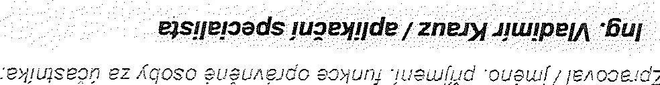

d7



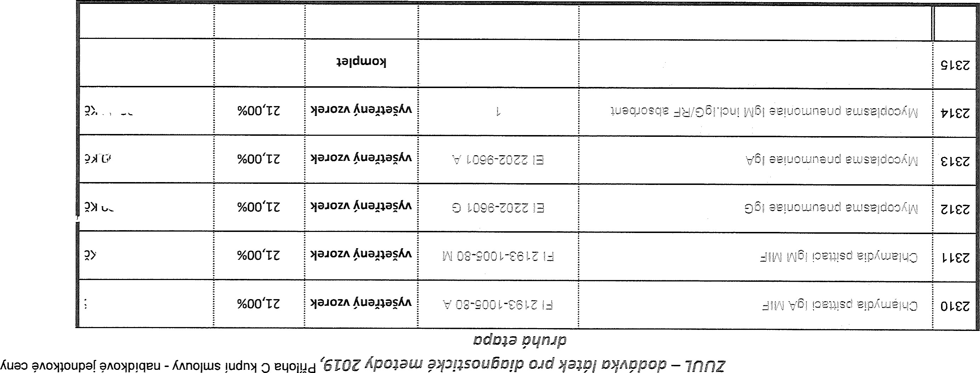

…

w

UZOd