PŮDORYS 3.NP

LEGENDA MÍSTNOSTÍ 3.NP

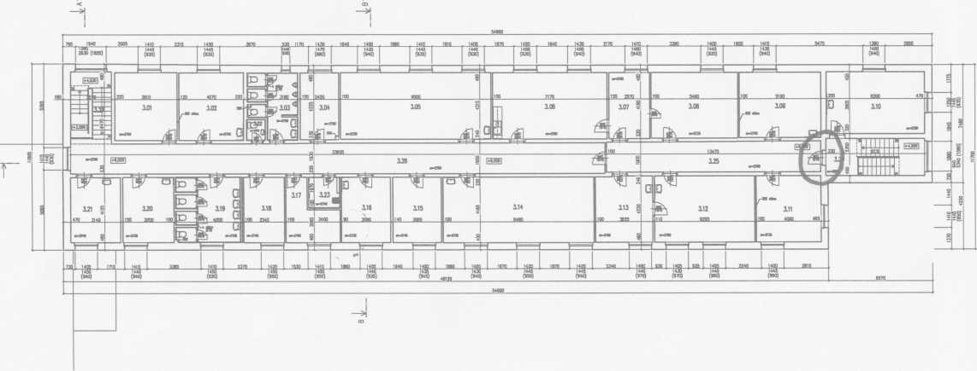

|  |  |  |  |
| --- | --- | --- | --- |
| ČJt | Oto. místnosti | PLOCHA  («) | PODLAHA |
| 101 | N201 KANCELAfi | 16,05 | PVC |
| 102 | N202 KANCELAfi | 17,52 | PVC |
| 101 | N201 K MUŽ | 11,10 | KERAHCXA DLAŽBA |
| 104 | N2Q4 KANCELAfi | 1040 | KOBEREC |
| 105 | N205 UČEBNA | 40,18 | PVC |
| 106 | N206 PROJEKTOVÁ MSTNOST | 1040 | PVC |
| 107 | N207 KANCELAfi | 10.85 | PVC |
| 108 | N208 KANCELAfi | 22.90 | PVC |
| 109 | N209 KANCELAfi | 21,24 | PVC |
| 110 | N210 KANCELAfi | 24.21 | PVC |
| 111 | N211 KANCELAfi | 17,28 | PVC |
| 112 | N212 KANCELAfi | 26,67 | KOBEREC |
| 113 | N213 KANCELAfi | 1544 | KOBEREC |
| 114 | N214 UČEBNA | 39,60 | PVC |
| 115 | N215 KANCELAfi | 1241 | PVC |
| 116 | N216 KANCELAfi | 1196 | PVC |
| 117 | N217 KANCELAfi | 10,00 | PVC |
| 118 | N218 KANCELAfi | 10,70 | PVC |
| 119 | N219 K ŽENT | 1641 | KERAIKXA DLAŽBA |
| 120 | N220 KANCELAfi | 1348 | PVC |
| 121 | N221 KANCELAfi | 1108 | PVC |
| 122 | N222 1C ZAMĚSTNANCI | 1.65 | KERAHCXA OLAŽBA |
| 121 | N2211ECHNKXA MÍSTNOST | 194 | KERAHCXA OLAŽBA |
| 124 | soraSTov? PROSTOR | 15,10 | KERAHCXA OLAŽBA |
| 125 | CHODBA | 2180 | KERAHCXA DLAŽBA |
| 126 | CHODBA | 64,62 | KERAHCXA DLAŽBA |
| 127 | scwnSTovf prostor | 11,74 | KERAHCXA DLAŽBA |

