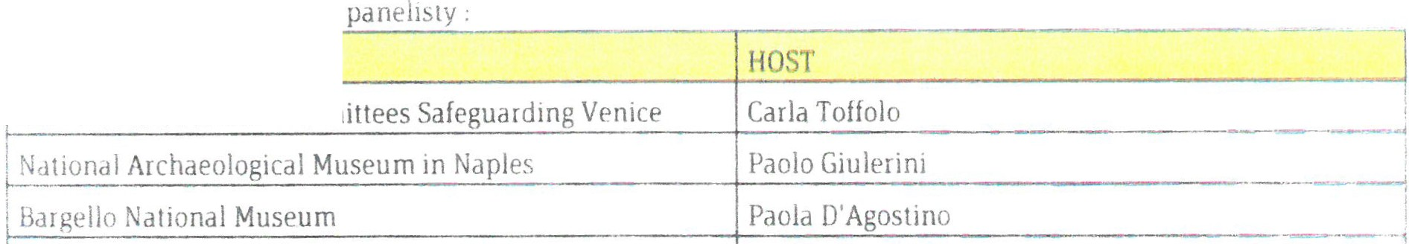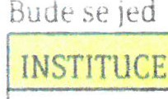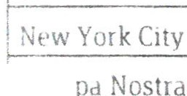ndt o ná ledupcí

Assor. ot !nt. Priva te Committees Sa

Cham ber of Architecture and Urbanism of Sao Paul o

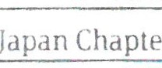Al i\
José Robeno Geraldine
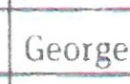Kunihir o

UNESCO lrina Bokova

Landmarks Preservation Cornmission
Kent Barwick

--· -- "l

t-L--u..r.o:._ __ -+H-ermann Parzi-"'-----------·----·-· ------

t-----------------------------·T-h-om-a-s V-o-ni-er------------------·-·-- -------·
t----------'-----'--------------Ed-uar-do-M-at-os -Mo-ct-ez-um-a ·----·---·-··-··Á

jlCU MOS

·----------------------...,fN-ě-mecko------------·---------- ·---·

I li NESCU Ernesto Ottone R

.. " \ ·,·'\I :, i-' ,,,.,,_,_ !·L.\VN PJ t-l " !/• ....... .'d-1 ;iJ r.., r ,... , \' -t p·f. l I Z- , :.1p:-.;r \ -:b· -r·d-1:- , 1 i· J t ''\J " d.=.·, ··m .1t" t : \llJ· .._ --.. . -· ,... ,l ·, ·
• ,- · i1l I 1 .':, 1 - - ') J IC:i· c 1 \t1v._. '1t-)tl: í:.. i: I ., • 11-'i.... : :f ....'·. Ci'' · ·,;L/ ' Jh:' ,f ;·lp•.dc :f.'hcl((l''i ... · j..''· tf é t:'U \.\.\'.-\·\ ;jJq:r 1- ,
;;;_...- :..·.

..I .

