- Erasmus+ Programme

Addendum to Inter-institutional agreement
2017-2019

Higher Education Student and Staff Mobility
-Mobility for learners and staff-
The institutions named below agree to cooperate for the exchange of students and/or staff in the context of the Erasmus+ programme. This Inter-institut,onal agreement will come into effect only in the event that both institutions are holders of valid Erasmus Charter for Higher Education (ECHE) for the period mentioned abcive and they commit to respect the quality requirements of ECHE in all aspects related to
. the organisation and management of the mobility. If the Erasmus� programme sets extra criteria, this Agreement will be reviewed.

Information about higher education institutions

Name of the institution Erasmus code

Technical University of Liberec CZ LIBERECOl
Contact detaíls1 (Name, E-mail, Phone) Michaela Andělová, institutional coordinator

erasmus@tul.cz; tel: +420 485 353 479 Institute of Information Technologies and Electronics, Studentská 2, 461 17 Liberec
1, Czech Republic

Bar-Ilan University, Israel RAMAT GAN

Deputy President

Mr. Daniel Schuval, Manager

International Office for Academie Affairs Ramat Gan, Israel, 52900
Tel: 972-3-738-4246
Fax: 973-3-506-4573
Email: daniel.schuval@biu.ac.il

Mobility numbers per academic year

Subject

Study

Number of staff

RAMAT GAN
area
ISCED

Subject area name
ISCED

History and archaeology

cyc/e
mobility periods Teaching Training
lxSdays XXX

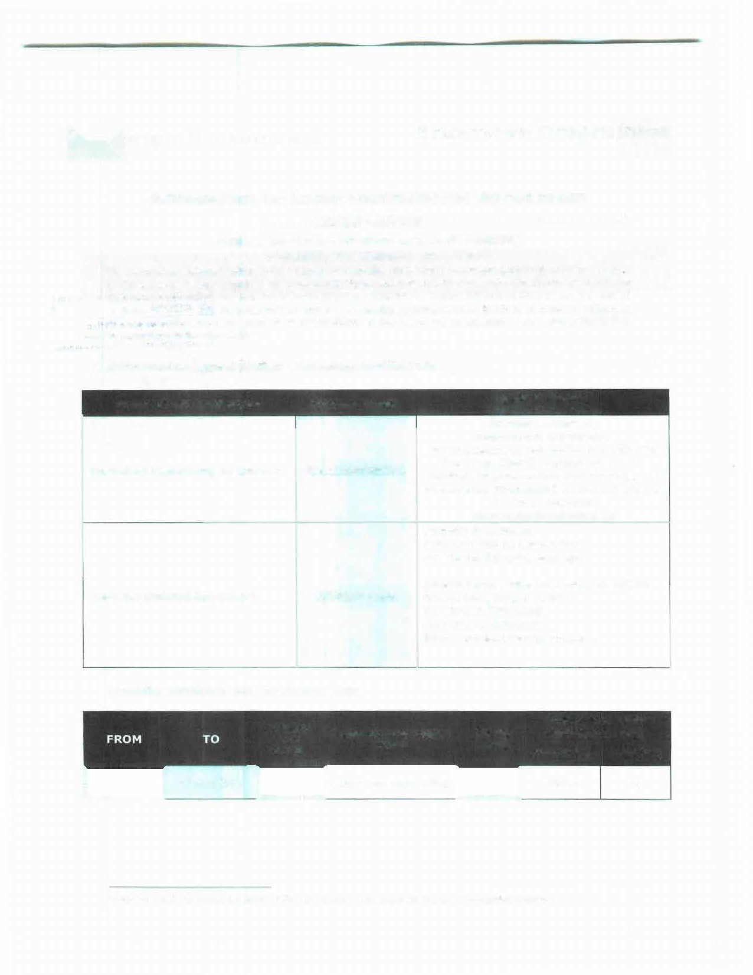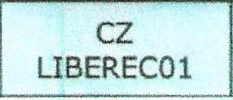

'Contact details to reach the senior officer ,n charge of this agreement and of ,ts poss,ble updates.

1

- Erasmus+ Programme

SIGNATURES OF THE INSTITUTIONS (legal representatives}

CZ LIBERECOl | Michaela Andělová, institutional coordinator | 3.6.2019
RAMATGAN | Mr. Daniel Schuval, instit ut ional coordinator | 3.6.2019

' Scann ed , s g n atur es, seals and st am ps are accepted

2

