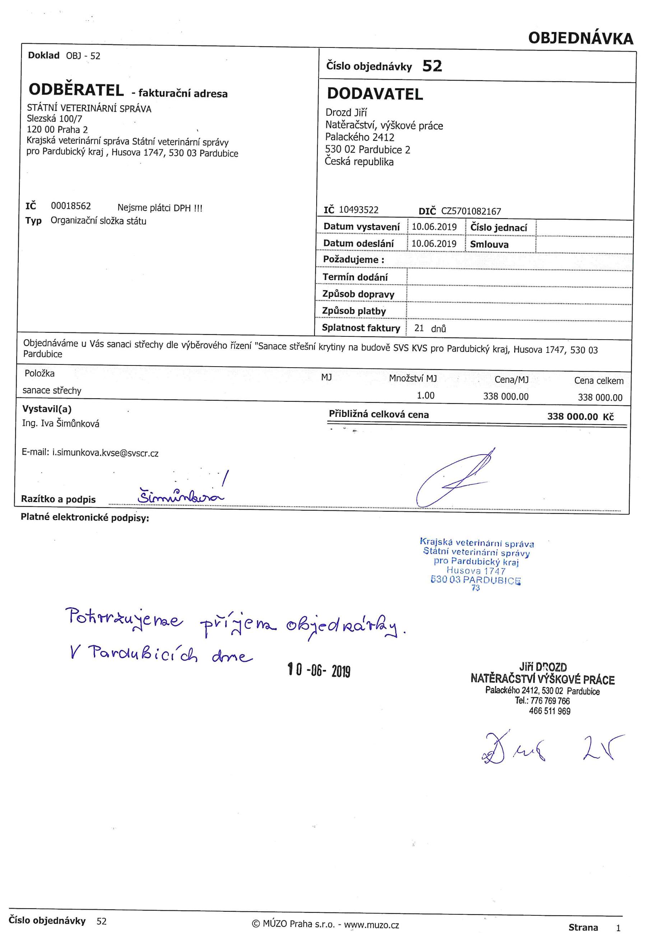

Thank you for using Apowersoft PDF Converter.
The trial version can only convert up to 5 pages.
If you want to get full version, you can open the link
below to purchase:
https://rd.apowersoft.com/7uN7f
Tip:
We offer $10 coupon for purchasing Apowersoft PDF
Converter Lifetime version,
the coupon code is apowerpdf, please copy the code to the cart or open the link below to purchase:
https://rd.apowersoft.com/7caG7

