Rev.: 56086
Last modified: 2019-03-11
P/N: 78506-0201
FLIR E85 24° + 14° + 42°
- zadavatel specifikuje, které dva ze tří objektivů požaduje
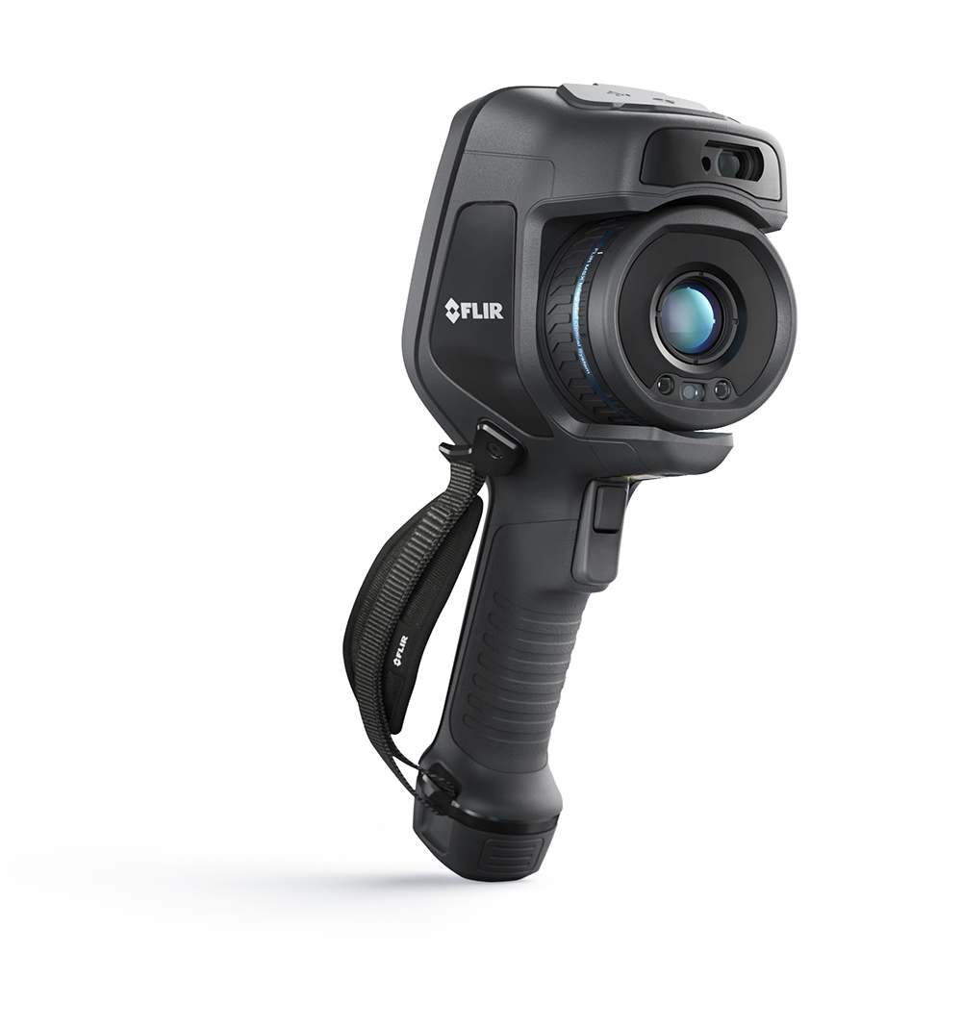

Imaging and optical data
Infrared resolution | 384 × 288 pixels
UltraMax (super-resolution) | In FLIR Tools
NETD | • <30 mK, 42° @ +30°C (+86°F)  • <40 mK, 24° @ +30°C (+86°F)  • <50 mK, 14° @ +30°C (+86°F)
Field of view | • 42° × 32°  • 24° × 18°  • 14° × 10°
Minimum focus distance | • 0.15 m (0.49 ft.), 42°  • 0.15 m (0.49 ft.), 24°  • 1.0 m (3.28 ft.), 14°
Minimum focus distance with MSX | • 0.65 m (2.13 ft.), 42°  • 0.5 m (1.64 ft.), 24°  • 1.0 m (3.28 ft.), 14°
Focal length | • 10 mm (0.39 in.), 42°  • 17 mm (0.67 in.), 24°  • 29 mm (1.41 in.), 14°
Spatial resolution (IFOV) | • 2.00 mrad/pixel, 42°  • 1.09 mrad/pixel, 24°  • 0.63 mrad/pixel, 14°
Lens identification | Automatic
f number | • 1.1, 42°  • 1.3, 24°  • 1.5, 14°
Image frequency | 30 Hz
Focus | • Continuous LDM  • One-shot LDM  • One-shot contrast  • Manual
Field of view match | Yes
Digital zoom | 1–4× continuous

Detector data
Focal plane array/spectral range | Uncooled microbolometer/7.5–14 µm
Detector pitch | 17 µm

Image presentation
Resolution | 640 × 480 pixels (VGA)
Surface brightness (cd/m2) | 400
Screen size | 4 in.
Viewing angle | 80°
Color depth (bits) | 24
Aspect ratio | 4:3
Auto-rotation | Yes
Touchscreen | Optically bonded PCAP
Display technology | IPS
Cover glass material | Dragontrail®
Programmable buttons | 1
Viewfinder | No
Image adjustment | • Automatic  • Automatic maximum  • Automatic minimum  • Manual

Image presentation modes
Infrared image | Yes
Visual image | Yes
Thermal fusion | No
MSX | Yes
Picture in Picture | Resizable and movable
Gallery | Yes

Measurement
Camera temperature range | Object temperature range | Accuracy — for ambient temperature +15 to +35°C (+59 to +95°F)
–20 to +120°C (–4 to +248°F) | –20 to +100°C (–4 to +212°F) | ±2°C (±3.6°F)
–20 to +120°C (–4 to +248°F) | +100 to +120°C (+212 to +248°F) | ±2%
0 to +650°C (+32 to +1202°F) | 0 to +100°C (+32 to +212°F) | ±2°C (±3.6°F)
0 to +650°C (+32 to +1202°F) | +100 to + 650°C (+212 to +1202°F) | ±2%
+300 to +1200°C (+572 to +2192°F) | +300 to +1200°C (+572 to +2192°F) | ±2%

Measurement analysis
Spotmeter | 3 in live mode
Area | 3 in live mode
Automatic hot/cold detection | Auto-maximum/minimum markers within area
Measurement presets | • No measurements  • Center spot  • Hot spot  • Cold spot  • User preset 1  • User preset 2
Difference temperature | Yes
Reference temperature | Yes
Emissivity correction | Yes: variable from 0.01 to 1.0 or selected from materials list
Measurement corrections | Yes
External optics/windows correction | Yes
Screening | 0.5°C (0.9°F) accuracy @ 37°C (98.6°F) with reference

Alarm
Color alarm (isotherm) | • Above  • Below  • Interval  • Condensation (moisture/humidity/dewpoint)  • Insulation
Measurement function alarm | Audible/visual alarms (above/below) on any selected measurement function

Set-up
Color palettes | • Iron  • Gray  • Rainbow  • Arctic  • Lava  • Rainbow HC
Setup commands | Local adaptation of units, language, date and time formats
Languages | 21

Service functions
Camera software update | Use PC software FLIR Tools

Storage of images
Storage media | Removable memory; SD card (8 GB)
Time lapse (periodic image storage) | No
Remote control operation | • Using FLIR Tools (using USB cable)  • FLIR Tools Mobile (over Wi-Fi)
Image file format | Standard JPEG, measurement data included. Infrared-only mode

Image annotations
Voice | 60 seconds built-in microphone and speaker (and via Bluetooth) on still images and video
Text | Text from predefined list or soft keyboard on touchscreen
Visual image annotation | Yes
Image sketch | Yes: on infrared images only
Sketch | From touchscreen
METERLiNK | Wireless connection (Bluetooth) to:  FLIR meters with METERLiNK
Compass | Yes
Laser distance meter information | Yes
Area measurement information | Yes
GPS | Yes: location data automatically added to every still image and the first frame in video from built-in GPS

Video recording in camera
Radiometric infrared-video recording | RTRR (.csq)
Non-radiometric infrared-video recording | H.264 to memory card
Visual video recording | H.264 to memory card

Video streaming
Radiometric infrared–video streaming (compressed) | Over UVC
Non-radiometric video streaming (compressed: IR, MSX, visual, Picture in Picture) | • H.264 (AVC) over RTSP (Wi-Fi)  • MPEG4 over RTSP (Wi-Fi)  • MJPEG over UVC and RTSP (Wi-Fi)
Visual video streaming | Yes

Digital camera
Resolution | 5 MP with LED light
Focus | Fixed
Field of view | 53° × 41°
Video lamp | Built-in LED light

Laser pointer
Laser alignment | Position is automatically displayed on the infrared image
Laser distance meter | Activated by a dedicated button
Laser | Class 2, 0.05–40 m (1.6–131 ft.) ±1% of measured distance

Data communication interfaces
Interfaces | USB 2.0, Bluetooth, Wi-Fi, DisplayPort
METERLiNK/Bluetooth | Communication with headset and external sensors
Wi-Fi | Peer to peer (ad hoc) or infrastructure (network)
Audio | Microphone and speaker for voice annotation of images
USB | USB Type-C: data transfer/video/power
USB standard | USB 2.0 High Speed
Video out | DisplayPort
Video connector type | DisplayPort over USB Type-C

Radio
Operating frequency | Bluetooth + EDR/LE: 2402–2480 MHz  WLAN 2.4 GHz: 2412–2462 MHz  WLAN 5 GHz: 5150–5350 MHz (DFS: only slave mode)  Note that frequency band 5150–5350 MHz is for indoor use only, see national regulations.
RF output (EIRP) | Bluetooth + EDR/LE: < 10 dBm  WLAN: < 17 dBm
Antenna | Integrated PIFA antenna (gain: maximum 1.4 dBi)

Power system
Battery type | Rechargeable Li-ion battery
Battery voltage | 3.6 V
Battery operating time | > 2.5 hours at 25°C (68°F) and typical use
Charging system | In camera (AC adapter or 12 V from a vehicle) or two-bay charger
Charging time (using two-bay charger) | 2.5 hours to 90% capacity with charging status indicated by LEDs
Charging temperature | 0°C to +‎45°C (+‎32°F to +‎113°F)‎, except for the Korean market: +10°C to +‎45°C (+‎50°F to +‎113°F)‎
External power operation | AC adapter 90–260 V AC, 50/60 Hz, or 12 V from a vehicle (cable with standard plug—optional)
Power management | Automatic shut-down and sleep mode

Environmental data
Operating temperature range | –15 to +50°C (5–122°F)
Storage temperature range | –40 to +70°C (–40 to +158°F)
Humidity (operating and storage) | IEC 60068-2-30/24 hours/95% relative humidity 25–40°C (77–104°F)/two cycles
EMC | • ETSI EN 301 489-1 (radio)  • ETSI EN 301 489-17  • EN 61000-6-2 (immunity)  • EN 61000-6-3 (emission)  • FCC 47 CFR Part 15 Class B (emission)
Radio spectrum | • ETSI EN 300 328  • FCC Part 15.249  • RSS-247 Issue 2
Encapsulation | IP 54 (IEC 60529)
Shock | 25g (IEC 60068-2-27)
Vibration | 2g (IEC 60068-2-6)
Drop | Designed for 2 m (6.6 ft.)
Safety | EN/UL/CSA/PSE 60950-1

Physical data
Weight (including battery) | 1 kg (2.2 lb.)
Size (L × W × H) | 278.4 × 116.1 × 113.1 mm (11.0 × 4.6 × 4.4 in.)
Battery weight | 140 g (4.9 oz.)
Battery size (L × W × H) | 150 × 46 × 55 mm (5.9 × 1.8 × 2.2 in.)
Tripod mounting | UNC ¼″-20
Housing material | PCABS with TPE, magnesium
Color | Black

Warranty and service
Warranty

Shipping information
Packaging, type | Cardboard box
Packaging, contents | • Extra lens, 14°‎  • Extra lens, 42°‎  • Battery (2 ea)‎  • Battery charger  • Hard transport case  • Infrared camera with lens  • Lens cap,‎ front  • Lens cap,‎ front and rear (only for extra lenses)  • Accessory Box I:  ◦ SD card (8 GB)‎  ◦ USB 2.0 A to USB Type-C cable,‎ 1.0 m  ◦ USB Type-C to HDMI adapter,‎ standard specification UH311  ◦ USB Type-C to USB Type-C cable (USB 2.0 standard)‎,‎ 1.0 m  ◦ Power supply for battery charger  ◦ Power supply,‎ 15 W/3 A  ◦ Printed documentation  • Accessory box II:  ◦ Hand strap  ◦ Lanyard strap,‎ camera  ◦ Wrist strap  ◦ Lens cap strap  ◦ Front protection  ◦ Carabiner hook  ◦ Accessory box III:  – Hand strap bracket, right  – Hand strap bracket, left  – Torx T10 wrench  – Front protection fastener  – Screws
Packaging, weight | 6.4 kg (14.1 lb.)
Packaging, size | 500 × 190 × 370 mm (19.7 × 7.5 × 14.6 in.)
EAN-13 | 4743254002791
UPC-12 | 845188014049
Country of origin | Estonia

