- Technical Specifications

Tender: „Mechanical helium cryogenic system“

Optical Cryostat with highly accurate temperature control

Manufacturer: Montana Instruments
Model: Customized system based onstandard system Cryostation C2

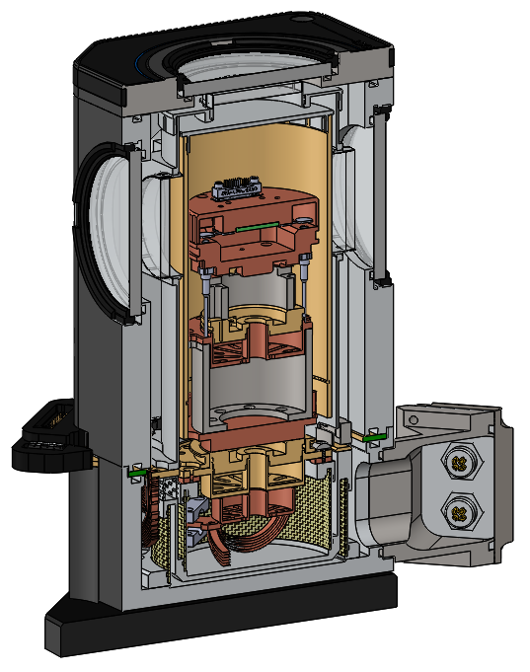

Technical Specifications
- Sample temperature range: < 4,5 K – 350 K
- Sample temperature stability at the detector mount <50 µK
- Vibration stability at the base of the sample chamber < 5 nm (peak-to-peak)
- Desk-top solution of the cryostat. Version for metric optical tables
- Sample Chamber dimensions:
  - diameter 53 mm inside the cold shield
  - height 100 mm inside the cold shield
- Cooled chamber includes two temperature sensors Cernox
- Cold head includes two temperature sensors
- Air-cooled compressor with variable speed for lowest noise. Loudness < 65 dB
- Mechanical cryo-cooler, air-cooled
- Cooling time from room temperature down to 4,5 K in 4 hours
- 4 vacuum feedthroughs and 4 radiation windows
- 28 electrical feedthroughs + 1 ground via mini pin connectors
- 16 wires vie Fisher connectors, thermally anchored at the 35 K and 4 K stages to prevent parasitic heat leaks.
- 2 compression feedthroughs for 125 µm or 250 µm fiber
- 10 m Helium hoses
- Radiations shields: 35K and 4 K inner isothermal shield for sample chamber
- Helium pressure lines galvanically isolated
- Control unit
- User interface computer with software for automated operation (licence for one computer)

