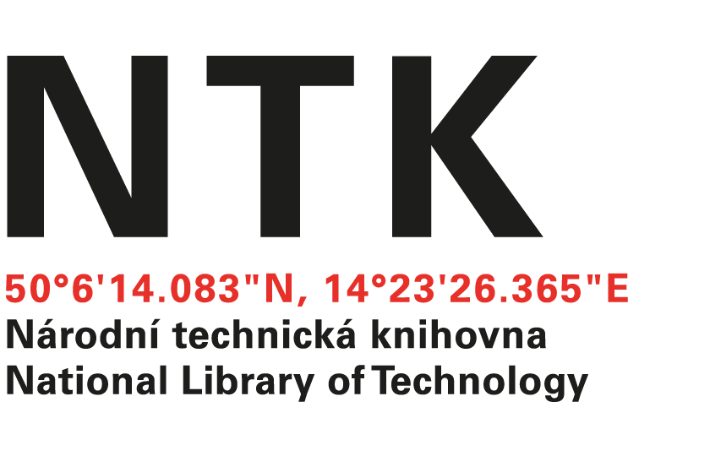
Objednávka

č. 402/10/2016

Objednatel: | Dodavatel:
Národní technická knihovna | EBSCO Information Services s.r.o.
Technická 6/2710 | Klimentská 1746/52
160 80 Praha 6 - Dejvice | 110 00 Praha 1 - Nové Město
IČ: 61387142 | IČO: 49621823
DIČ: CZ61387142 | DIČ: CZ49621823

Dobrý den,

na základě Vámi zaslané nabídky ze dne 2. 12. 2016 u Vás objednáváme předplatné následujících online časopisů na rok 2017 v celkové hodnotě 4 804 640,84 Kč s DPH.

Název | ISSN | Formát obj.
ABI Technik | 0720-6763 | online
Advanced Materials Research | 1022-6680 | online
AIAA journal | 1533-385X | online
Annales de l'I.H.P. | 0246-0203 | online
Architectural engineering and design management | 1745-2007 | online
Architectural theory review | 1326-4826 | online
Astronomy & astrophysics | 0004-6361 | online
Building services engineering research & technology | 0143-6244 | online
Canadian journal of civil engineering | 0315-1468 | online
Communications in algebra | 0092-7872 | online
Computer journal | 0010-4620 | online
Cybernetics and systems : an international journal | 0196-9722 | online
Drying Technology | 0737-3937 | online
Dynamical systems : an international journal | 1468-9367 | online
European Journal of Information Systems | 0960-085X | online
Geophysical and astrophysical fluid dynamics | 0309-1929 | online
Grey room : architecture, art, media, politics | 1526-3819 | online
Interfaces | 0092-2102 | online
International journal of construction education and research | 1557-8771 | online
International journal of cooperative information systems | 0218-8430 | online
International journal of crashworthiness | 1358-8265 | online
International journal of electrical engineering education | 2050-4578 | online
International journal of green energy | 1543-5075 | online
International journal of materials research | 1862-5282 | online
International journal of mining, reclamation and environment | 1748-0930 | online
International journal of parellel, emergent and distributed systems | 1744-5760 | online
International Journal of Protective Structures | 2041-420X | online
International journal of reliability, quality, and safety engineering | 0218-5393 | online
International journal of robotics research | 0278-3649 | online
International journal of software engineering and knowledge engineering | 0218-1940 | online
International journal on artificial intelligence tools | 0218-2130 | online
Journal of aircraft | 0021-8669 | online
Journal of architecture | 1360-2365 | online
Journal of Broadcasting & Electronic Media | 0883-8151 | online
Journal of composite materials | 0892-7057 | online
Journal of defense modeling and simulation | 1548-5129 | online
Journal of Electronic Resources Librarianship | 1941-1278 | online
Journal of energetic materials | 0737-0652 | online
Journal of Essential Oil Research | 1041-2905 | online
Journal of Geology | 1537-5269 | online
Journal of Information Technology | 0268-3962 | online
Journal of Intelligent Material Systems and Structures | 1045-389X | online
Journal of Nuclear Science and Technology | 0022-3131 | online
Journal of Optical Communications | 0173-4911 | online
Journal of plastic film & sheeting | 8756-0879 | online
Journal of Print and Media Technology Research | - | online
Journal of quality technology | 0022-4065 | online
Journal of reinforced plastics and composites | 0731-6844 | online
Journal of spacecraft and rockets | 0022-4650 | online
Journal of the Air & Waste Management Association | 1096-2247 | online
Journal of the Electrochemical Society | 1945-7111 | online
Journal of the European Mathematical Society | 1435-9863 | online
Journal of thermoplastic composite materials. | 0021-9983 | online
Libri : International journal of libraries and infomation services | 0024-2667 | online
Lighting research and technology | 1477-1535 | online
Materials at high temperatures | 0960-3409 | online
Materials science and technology | 0267-0836 | online
Materials transactions | 1345-9678 | online
Mathematical Sciences Publishers - All Journals Package | - | online
MTZ. Motortechnische Zeitschrift | 2192-8843 | online
Nanotoxicology | 1743-5390 | online
Nature | 0028-0836 | online
Nature geoscience | 1752-0894 | online
Nature chemistry | 1755-4330 | online
Nature methods : techniques for life scientists and chemists | 1548-7091 | online
Nature nanotechnology | 1748-3387 | online
Nature photonics | 1749-4885 | online
New review of hypermedia and multimedia | 1361-4568 | online
New space | 2168-0256 | online
Nuclear news | 0029-5574 | online
Operations research | 0030-364X | online
Physics of plasmas | 1070-664X | online
Physics today | 0031-9228 | online
Planning Theory | 1741-3052 | online
PNAS, Proceedings of the National Academy of Sciences | 1091-6490 | online
Polymer journal | 0032-3896 | online
Powder metallurgy | 0032-5899 | online
Quarterly of applied mathematics | 1552-4485 | online
Rangeland Ecology & Management | 1550-7424 | online
Rangelands | 0190-0528 | online
Review of scientific instruments | 0034-6748 | online
Science | 0036-8075 | online
Simulation | 0037-5497 | online
Smart structures and systems | 1738-1584 | online
Surface engineering | 0267-0844 | online
Technisches Messen | 0171-8096 | online
The Grey Journal | 1574-180X | electronic mail
Theory and practice of logic programming | 1471-0684 | online
Water environment research | 1061-4303 | online
Waves in random and complex media | 1745-5030 | online

S pozdravem

Anna Motejlková
akvizice elektronických informačních zdrojů
Objednávku přijal/a:
V Praze dne 5. 12. 2016
vyřizuje: Ing. Anna Motejlková
email: eiz@techlib.cz
telefon: +420 232 002 572

