# * ** �

* *

* *

*•*

r4Smow; wmu mou

UWOOOWA

wmrnE

**Erasmus+ Programme**

### **Key Action 1**

**- Mobility for learners and staff - Higher Education Student and Staff Mobility**

**Inter-institutional agreement 2019-2021**

### **between programme countries**

The institutions named below agree to cooperate for the exchange of students and/or staff in the context of the Erasmus+ programme. They commit to respect the quality requirements of the Erasmus Charter for Higher Education in all aspects related to the organisation and management of the mobility, in particular the recognition of the credits awarded to students by the partner institution.

### **Information about higher education institution**

|  |  |  |  |
| --- | --- | --- | --- |
| **Name of the institution** | **Erasmus** | **Contact details** | **Website** |
|  | **code** | **(email, phone)** | **(eg. of the course** |
|  |  |  | **catalogue)** |

Parístwowa Wyi.sza Szko/a PL LESZNO0l Zawodowa. im. Jana Amosa

Komerískiego w Lesznie

Jan Amos Komenski State School of Higher Education in Leszno

Technická univerzita v Liberci CZ UBERECOl Technical University of Liberec

Institutional Erasmus+ Coordinator

5 Adam Mickiewicz Street, 64-100 Leszno, Poland

Tel: +48 65 528 78 78

Fax: +48 65 528 78 78

email: [dwz@pwsz.edu.pl](mailto:dwz@pwsz.edu.pl)

Institutional Erasmus+ Coordinator

Studentská 2,

461 17, Liberec, Czech Republic.

email: [erasmus@tul.cz](mailto:erasmus@tul.cz)

www.erasmus.gwsz.edu.i;il

[www.tul.cz/en](http://www.tul.cz/en)

### **Mobility numbers per academic year**

The partners commit to amend the table below in case of changes in the mobility data by no later than the end of Januar in the recedin academic

##### FROM TO

**-l!!'IW'!llW-J!!ll!i9l!Pllli.""'..**

###### *area*

***Subject area***

***Study* Number of student mobility**

***cycle* periods**

###### *co*\**de*

***na***\****me***

###### *[short*

***cycle,***

Student Mobility for Studies

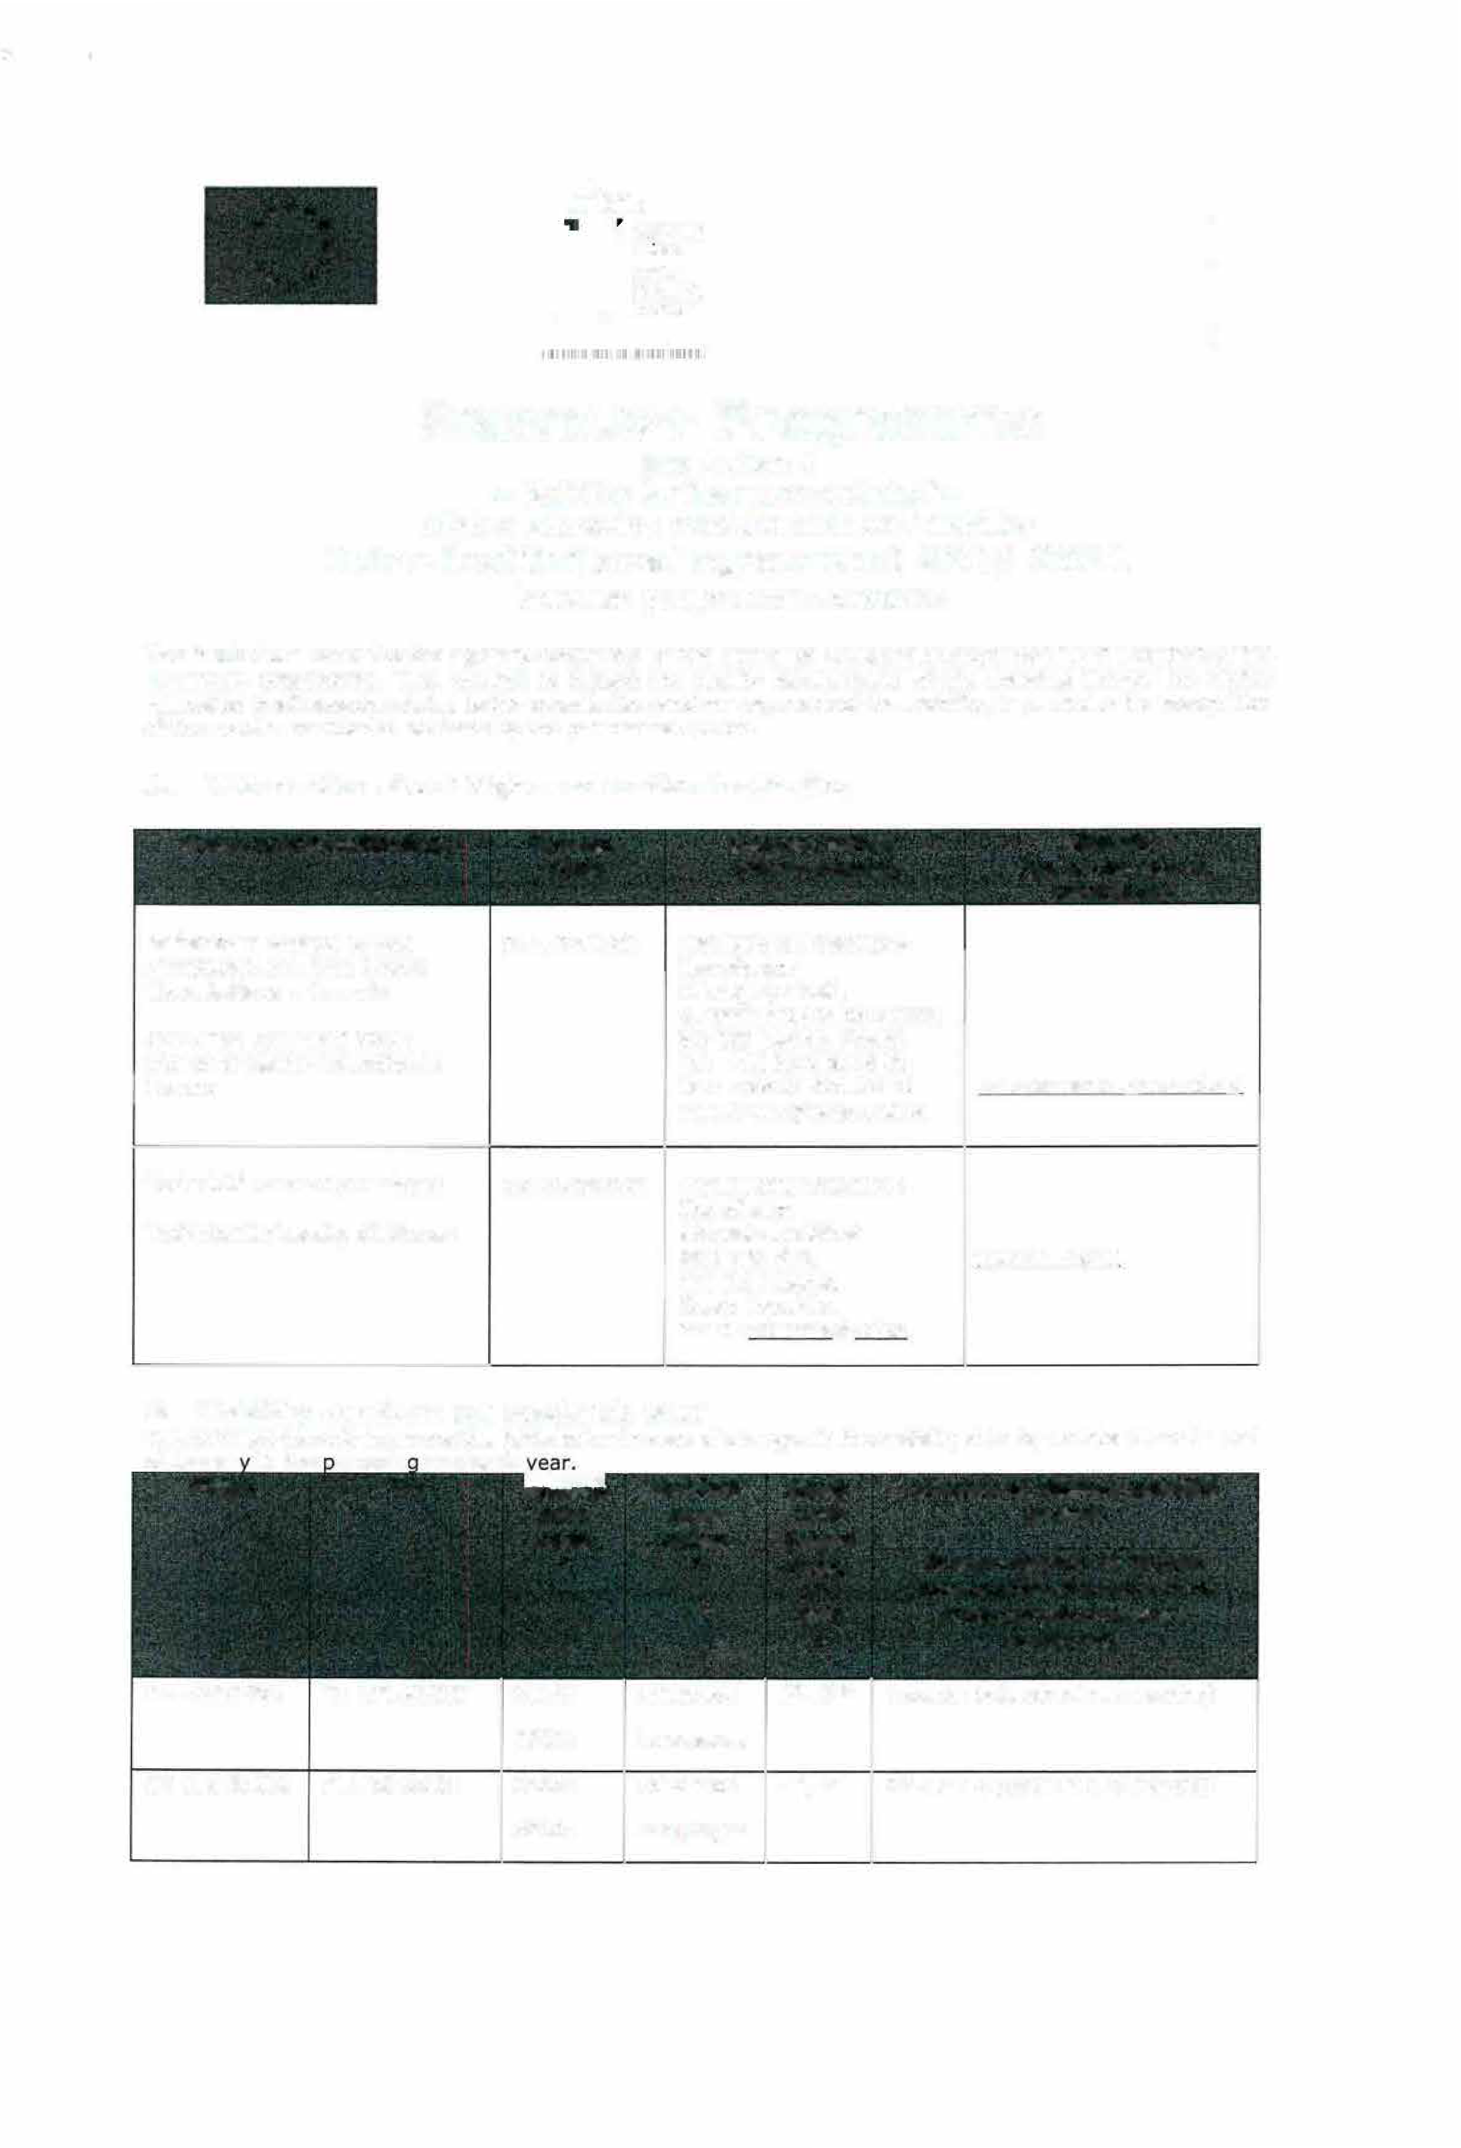

PL LESZNO0l CZ LIBEREC0l

CZ LIBEREC0l PL LESZNO0l

0110:

0230:

0110:

0230:

Education Languages Education Languages

***1••*** , *[total number of months of the*

***2nd]*** *study periods or average*

*

*duration*J*

1st , 2nd 2 students (each min. 3 months)

1st , 2nd 2 students (each min. 3 months)

|  |  |  |  |  |  |
| --- | --- | --- | --- | --- | --- |
| **FROM** | **TO** | ***Subj ect*** | ***Subject*** | ***Study*** | **Number of student mobility** |
|  |  | ***area*** | ***area*** | ***cycle*** | **periods** |
|  |  | ***code*** | ***name*** | ***[short*** |  |

* ***cycle,*** Student Mobility for Placements

*

***1st ,***

###### *2 nd]*

*

|  |  |  |  |  |  |
| --- | --- | --- | --- | --- | --- |
| PL LESZNO0l | CZ LIBEREC0l | 0110 :  0230 : | Education  Languages |  | |
|  |  |
| CZ LIBEREC0l | PL LESZNO0l | 0110:  0230: | Education  Languages | 1st , 2nd | 2 students ( each min. 2 months) |

1 Study cycle: 1'': undergraduate level (Bachelor, Diplom); 2nd: postgraduate level (Master); short cycle (short-term-programme) s and 3rd (PhD) is not available al Hochschule Darmstadt.

|  |  |  |  |  |  |  |  |
| --- | --- | --- | --- | --- | --- | --- | --- |
|  | **FROM**  **[Erasmus code of the** | **TO**  **[Erasmus code ofthe receiving**  **inst itution]** | | ***Subject area code***  *  **ISCED** | ***Subject area name*** | **Number of staff mobility periods**  Staff Mobility *Staff*  for Teaching *Mobility for* | |
| **sending**  **instit ution J** |
|  | | | | | | | |
| CZ LIBEREC0l | | | PL LESZNO0l | 0110: | Education | 2 mobilities |  |
|  | | |  | 0230: | Languages | min. 8 hours |
|  | | |  |  | Job shadowing visit |  | 2 mobilities |
|  | | |  |  | 1 week |
| PL LESZNO0l | | | CZ LIBEREC0l | 0110: | Education | 2 mobilities |  |
|  | | |  | 0230: | Languages | min. 8 hours |
|  | | |  |  | Job shadowing visit |  | 2 mobilities |
|  | | |  |  | 1 week |

*Training*

1. **Recommended language skill s**

The sending institution, following agreement with the receiving institution, is responsible for providing support to its nominated candidates so that they can have the recommended language skills at the start of the study or teachin eriod:

#### Language of instruction

*level:* 82]

**Language of instruct ion**

**Recommended language of instruction level**

Staff Mobility for Teaching

Mobility for St udies

Student

**1 2** *[Minimum recommended level: 81]*

*[Minimum recommended*

|  |  |  |  |  |
| --- | --- | --- | --- | --- |
| PL LESZNO0l | English | Polish | B1 English | B2 English |
| CZ LIBEREC0l | English | Czech | B1 English | B2 English |

## Addit ional requirem ent s

#### I nstitution Additional requirements

|  |  |
| --- | --- |
| CZ LIBEREC0l | In case of additional requirements of academic, organisational or ether aspects (e.g . students with special needs), please consult our website: [http:// www.tul. cz/en/erasm us/ incom ing](http://www.tul.cz/en/erasmus/incoming) ­  international-students or contact the Erasmus Office: [erasmus@tul.cz](mailto:erasmus@tul.cz) . |
| PL LESZNO0l | Due to the fact that PL LESZNO0 l don• t have full program in English, International Office of Technical University of Liberec is kindly request to send proposal of Learning Agreement as soon as possible to PL LESZNO0l to check is it possible to offer a full course (30 ECTS) for student. |

1. **Calendar**



1. **A** lications/information on nominated students must reach the receivin

|  |  |  |
| --- | --- | --- |
| PL LESZNO0l | | |
|  |  |  |
| CZ LIBEREC0l | 30th June (1 5th June if the student needs a Visa) | 30th November {15th  November if the student needs a Visa |

1. The receiving institution will send its decision within 6 weeks.
2. 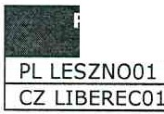Academie Calendar



- End of June

1. **A** Transc r ipt of Records will be issued by the receiving institution no later than five1 weeks after the assessment period has finished at the receiving HEL The assessment period usually last until the end of the semester.
2. The present bilateral agreement will be valid during the academic years 2018/19 - 2020/21, unless either side terminates the agreement in writi ng at the !atest by September 30th for activities taking placing during the next (n+l) academc yiear. Additional activities, cancellations or new subject areas are to be communicated by the same deadline.

## Information

##### Gradíng svstems of the institutions

|  |  |  |  |  |  |
| --- | --- | --- | --- | --- | --- |
| I | **Institution** |  |  | **Website for information** | |
| PL LESZNO0l | | PWSZ LESZNO uses the **ECTS credi t syst em .** | | | |
|  | |  |  | O/o **of** |  |
|  | | **Local Grade**  **{Scale)** | **ECTS**  **Grade** | **successful students normally achieving the**  **grade** | **Definition** |
|  | | 5,0 (90-  100% ) | **A** | 10 | **Excellent** - outstanding performance with oni minor errors |
|  | | 4,5 (80-  89,5%) | B | 25 | **Very Good** - above the average standard but some errors |
|  | | 4,0 (70-  79,5%) | C | 30 | **Good** - generally sound work with a number o notable errors |
|  | | 3,5 (60-  69,5%) | D | 25 | **Satisfactory** - fair but with significant shortcomings |
|  | | 3,0 (50-  59,5%) | E | 10 | **Sufficient** - performance meets the minimum criteria |
|  | | 2,0 (O-  49,5%) | F | - | **Fa il** - some more work required befor e the cre can be awarded |
| CZ LIBEREC0l | | *TUL uses the* ***ECTS credit system.***  *The symbols of* ***course unit duration: (Y)*** *1 fu/I year academic year and* ***(S)*** *1* semester.  *In addition to ECTS, TUL* uses *the* ***local numera/ grade*** system as *following:*  ***(1 )*** *Excel/ent,*  ***(1 - )*** *Excellent Minus,*  ***(2 )*** *Very Good,*  ***( 2 - )*** *Very Good Minus,*  ***(3 )*** *Good and*  ***( 4 )*** *Fail.*  ***( R )*** *SatisfactorvComoletion of Course* - *No Grade.* | | | |

1. **Visa**

The sending and receiving institutions will provide assistance, when required, in securing visas for incom ing and outbound mobile participants, according to the requirements of the Erasmus Charter for Higher Education .

I f ť d . t b • ' d d b th f li . • t t • · t d · f ť

##### Institution Details

|  |  |
| --- | --- |
| PL  LESZNO0l | EU Schengen zone - visa is not obligatory for EU citizens.  In case of any questions contact :  I nternat ional Off ice - Ms. Edyta Chudzicka Tel/ Fax: +48 65 528 78 78  [edyta.chudzicka@pwsz.edu.pl](mailto:edyta.chudzicka@pwsz.edu.pl) |
| cz  LIBEREC0l | Students with non-EU nat ionality should inform by e-ma il [(erasmus@tu l.cz](mailto:(erasmus@tul.cz) ) about the town where they have appl ied for the VISA in their home country . Acceptance letters in Czech and English languages will be sent to the International Office of the home univers ity .  [htt p: // www .mvcr .cz/mvcren/a rt icle/ a-v isa- for -a-stay-of -over-90 -days-lonq - te rm .aspx](http://www.mvcr.cz/mvcren/article/a-visa-for-a-stay-of-over-90-days-lonq-term.aspx) |

1. **Insurance**

The sending and receiving institutions will provide assistance in obtain ing insurance for incoming and outbou nd mobile part icipants, according to the requirements of the Erasmus Charter for Higher Education .

The receiving institution will inform mobile part icipants of cases in which insurance cover is not automat ically

* ' d d I f ť d . t b • ' d d b th f li . • t •. d. f .

##### Institution Details

|  |  |
| --- | --- |
| PL LESZNO0l | Insurance, which will provide all medical costs is obligatory. Sean of insurance must be sent  to Incoming Coordinator before the mobility. We accept EU health insurance card.  In case of any questions contact : International Office - Ms. Edyta Chudz icka Tel/Fax: +48 65 528 78 78  [edyta.chudz icka@pwsz.edu .pl](mailto:edyta.chudzicka@pwsz.edu.pl) |
| cz  LIBEREC0l | We accept EU health insurance card, students with non-EU nationality should show their insurance contract at arrival. [http :/ / www.mzcr .cz/ prevence/ uk/ uk.html](http://www.mzcr.cz/prevence/uk/uk.html) |

1. **Housing**

The receiving institution will guide incoming mobile part icipants in finding accommodation, according to th e requirements of the Erasmus Charter for Higher Educat ion.

f · d . b • .d d b th f li . • •

d. f ť

##### Institution Details

|  |  |
| --- | --- |
| PL LESZNO0l | Accommodation is booked at Komenik Residence Halls by PWSZ LESZNO Erasmus Office  upon acceptance of the student.  [htt p:// pwsz.edu. pi/ index. php/ baza-dyda kt yczna/ 100-dom-studencki-komen ik](http://pwsz.edu.pi/index.php/baza-dydaktyczna/100-dom-studencki-komenik)  There is no need to send a special application form or to register . To inform about the time of arrival: [edyta.ch udzicka@pwsz.edu .pl](mailto:edyta.chudzicka@pwsz.edu.pl) |
| cz  LIBEREC0l | Accommodation is booked at Harcov Residence Halls by TU Uberec Erasmus Office upon acceptance of the student. There is no need to send a special applicat ion form or to register. To inform about the time of arr ival: [us.koleje@ t ul.cz](mailto:us.koleje@tul.cz)  The facilit ies of the university are accessible for handicapped persons. There is also a centre for guidance and support: [htt p: // www.tu l. cz/akadem icka-poradna - a-centrum -podpory](http://www.tul.cz/akademicka-poradna-a-centrum-podpory) 82 |

1. **SIGNATURES OF THE INSTITUTIONS (legal representatives)**

##### Institution Name, function Date

PL LESZNO0l Prof. dr hab. Maciej Pietrzak, *!*; *?111'}*

Rector

##### Signature**2**

CZ LIBEREC0l PhDr. Lucie Koutková, Ph.D.

Head of the International Office

1l.i ·�{�



2 Scanned signatures are accepted

