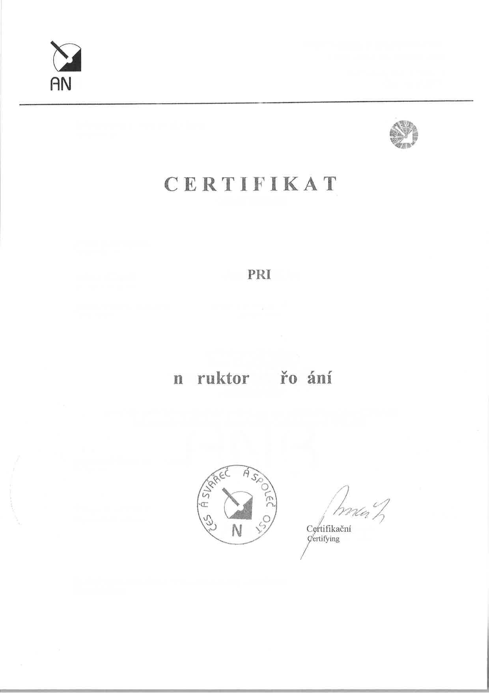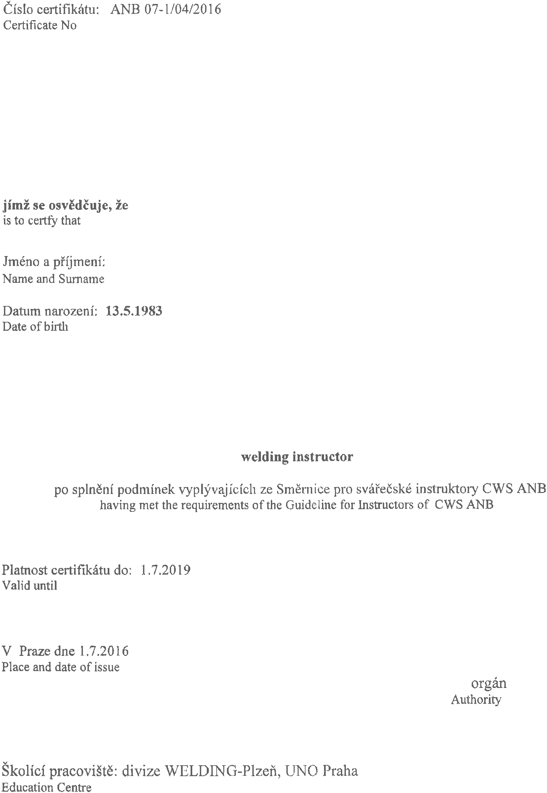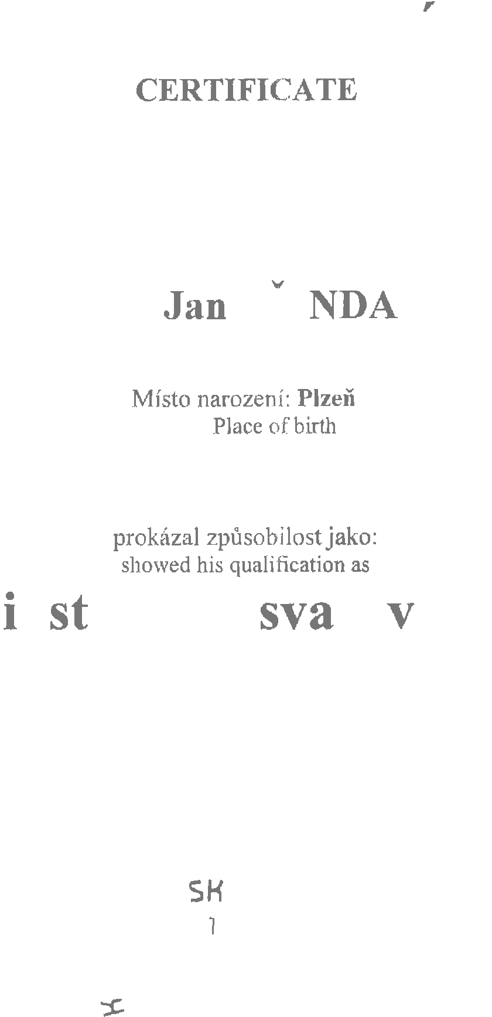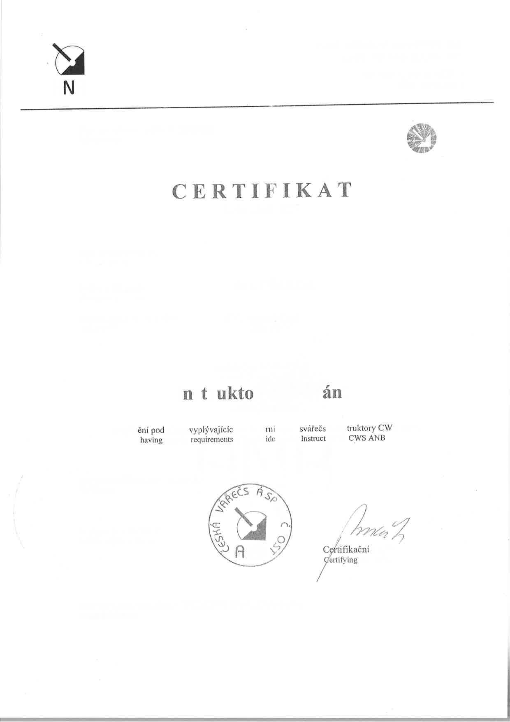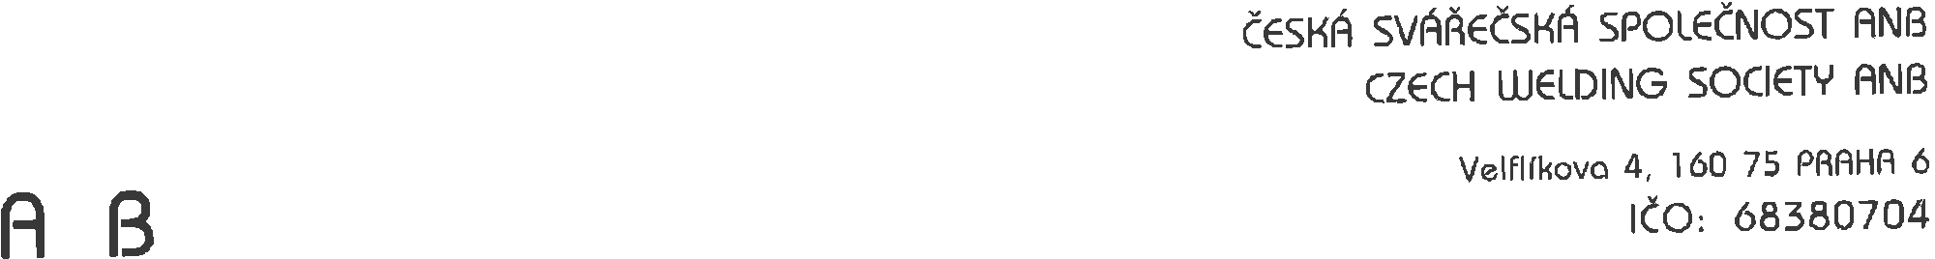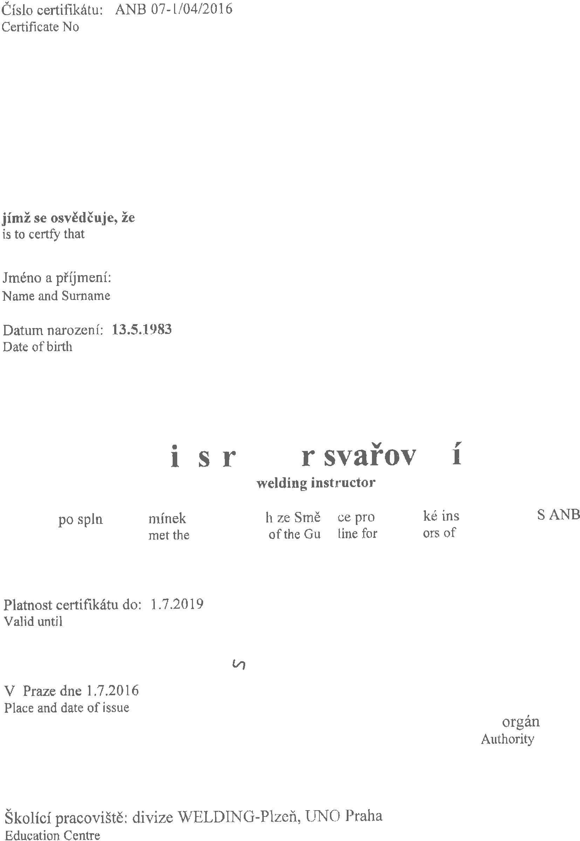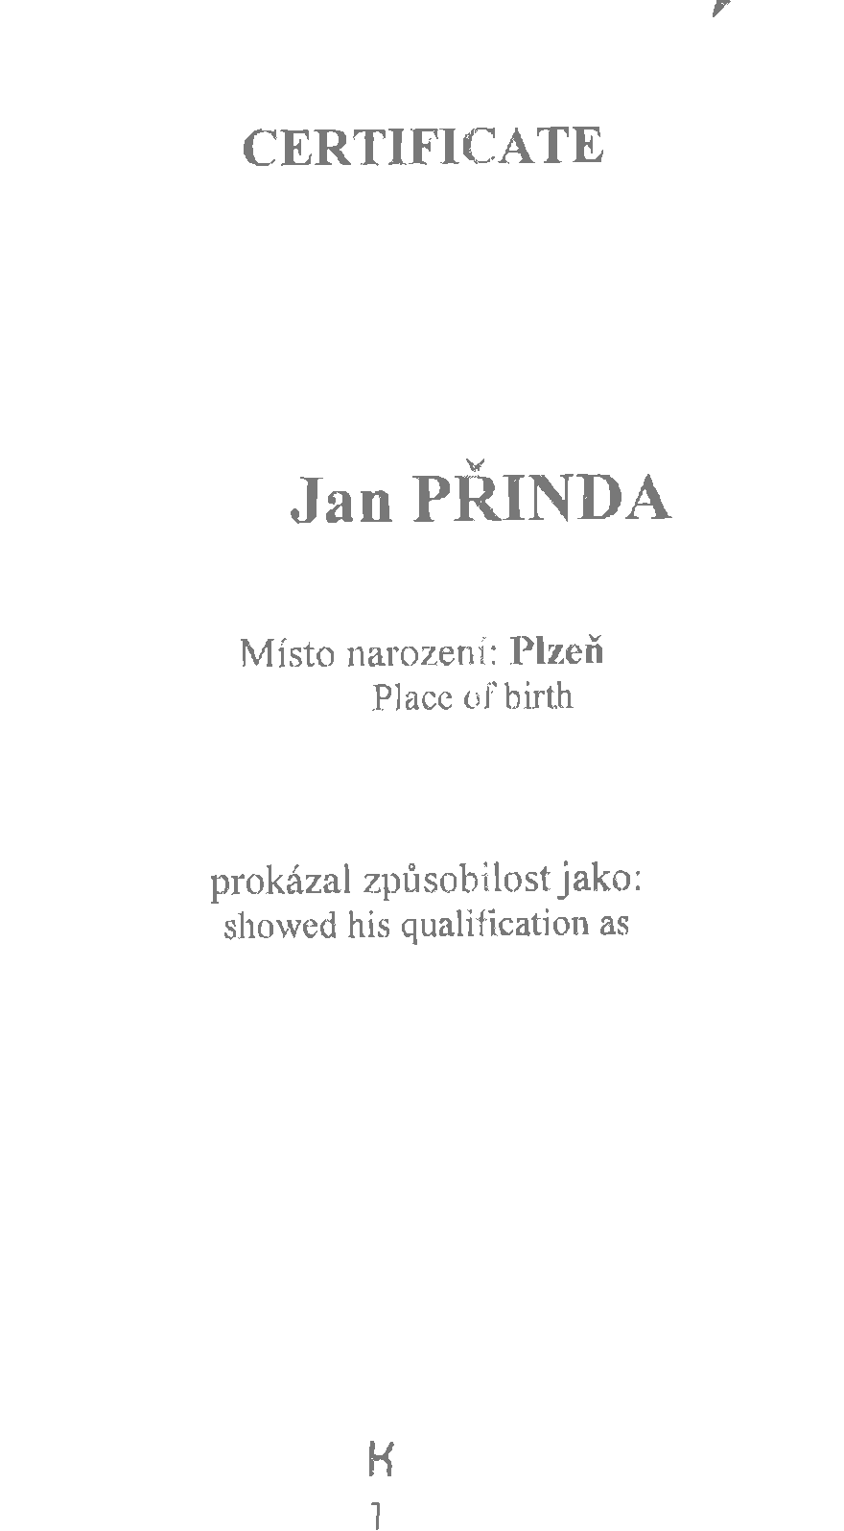

Thank you for using Apowersoft PDF Converter. The trial version can only convert up to **5** pages.

If you want to get full version, you can open the link below to purchase:

https://rd.apowersoft.com/7uN7f

Tip:

We offer $10 coupon for purchasing Apowersoft PDF Converter Lifetime version,

the coupon code is **apowerpdf**, please copy the code to the cart or open the link below to purchase:

https://rd.apowersoft.com/7caG7