Confidentiality Level |  | BL - Restricted for internal use | TC ID / Revision | 00202207/C
Document Status |  | Document Released | Document No. | N/A
WBS code |  | 3.4 – L4 system
PBS code |  | RA1.L4BT.CSS.VAC.VCH.1
Project branch |  | Engineering & Scientific documents (E&S)
Document Type |  | Specification (SP)
[RSD product category C]

L4c-E3 Halls Vacuum Interconnecting Duct for L4 10 PW Beam
[TP18_794]

Keywords
N/A

 | Position |  |  |  | Name
Responsible person | Scientific Coordinator of Laser Technology (RP1) |  |  |  | Bedřich Rus
Prepared by | Scientific Coordinator of Laser Technology (RP1)  Senior Optomechanical Designer  Senior Technology Expert |  |  |  | Bedřich Rus  Jean Claude Lagron  Mike Griffiths

RSS TC ID/revision | RSS - Date of Creation | RSS - Date of Last Modification | Systems Engineer
015453/A.001 | 06-Nov-2018 10:46 | 09-Nov-2018 16:46 | Aleksei Kuzmenko
015453/A.002 | 09-Nov-2018 21:40 | 09-Nov-2018 21:41 | Aleksei Kuzmenko
015453/A.003 | 14-Nov-2018 13:53 | 14-Nov-2018 13:53 | Aleksei Kuzmenko
Reviewed By
Name (Reviewer) | Position | Date | Signature
Daniel Kramer | Chief Laser Optical Designer  L4 BT Working Group Lead
Jakub Janďourek | Infrastructure technology coordinator | N O T I C E
Ladislav Půst | Manager installation of technology
Lukáš Brabec | Group Leader of Vacuum and Cryogenics
Martin Laub | Chief Engineer
Pavel Bakule | Deputy RP1 Leader
Roman Kuřátko | Facility Manager | N O T I C E
Stefan A. Weber | RP5/6 Group leader
Veronika Olšovcová | Safety Coordinator
Viktor Fedosov | SE & Planning group leader;  Quality Manager

Approved by
Name (Approver) | Position | Date | Signature
Bedřich Rus | Scientific Coordinator of Laser Technology (RP1)

Revision History / Change Log
Change No. | Made by | Date | Change description, Pages, Chapters | TC rev.
1 | B. Rus | 02.11.2018 | RSD draft creation | A
2 | B. Rus,  A. Kuzmenko | 09.11.2018 | RSD update, version for internal review | B
3 | B. Rus,  A. Kuzmenko | 14.11.2018 | RSD update, final version for approval | C

Table of Content

1. Introduction 4
1.1. Purpose 4
1.2. Scope of Work 4
1.3. Terms, Definitions and Abbreviations 7
1.4. Reference Documents 7
1.5. References to standards 7
2. Functional, design, material and manufacture requirements 8
3. Cleaning, testing and packaging requirements 9
4. Transportation and Installation Requirements 10
5. Safety Requirements 10
6. Quality requirements 11
6.1. Documentation and data control 11
6.2. Nonconformity control system 11
7. Verification requirements for the Supplier 12
7.1. General requirements 12
7.2. Verification documentation 12
7.2.1. General requirements 12
7.2.2. Verification reports (VRs) 13
7.2.3. Verification Control Document (VCD) 13
7.3. Phasing of the delivery 14
7.3.1. Qualification of Design 14
7.3.2. Manufacturing 14
7.3.3. Transportation and Installation 15
7.3.4. Acceptance 15
8. ANNEX – Vacuum liaison Tube L4c-E3 (Drawing No 00176521 Rev. 01) 16

Introduction

Purpose
This Requirements Specification Document (RSD) lists the technical requirements and constraints on a product related to the RA1 programme of the ELI Beamlines project. This can lead to the identification of product interfaces with the ELI Beamlines science-based technology and ELI Beamlines building facility. This RSD also acts as the parent document for technical requirements that are addressed in lower level design description documents (see section 1.4).

The RSD contains all of the technical requirements: functional and design, cleaning, packaging, transportation and installation, safety and quality requirements for the following products (tender number: TP18_794): L4c-E3 Halls Vacuum Interconnecting Duct for L4 10 PW Beam (“Duct” in further text).

This RSD states and describes the technical requirements for fabrication of the duct which will serve as an interconnecting segment for 10PW beam transport between the L4c laser hall and the E3 experimental hall of ELI Beamlines. The duct is registered in the PBS database under the following PBS code: RA1.L4BT.CSS.VAC.VCH.1.

Scope of Work
Within this procurement manufacture of stainless steel vacuum duct (tunnel) is required. The duct will be installed in the structural concrete wall penetration between the L4c and E3 halls. The size of the penetration is 1x1 m and the thickness of the structural wall is 1.2 m; in each hall L4c and E3, there is an additional technology wall, adjacent to the structural wall, with thickness 400 mm.

The design of the duct features its straightforward connectivity to ISO-F 1000 vacuum flanges on each end, i.e. in the halls L4c and E3.

The vacuum duct, see Figure 1 below, is designed as an externally ribbed structure in the shape of a rectangular box with overall outer dimensions 920 x 920 mm (see RD-01 in Section 1.4 or overview of drawing in section 8).

The duct shall be made from stainless steel class 1.4301 (AISI 304). The vacuum wall thickness in the current FZU design is 7 mm but the Supplier is allowed, based on optimisation of the ribs structure and on results of FEM simulations, to make this thickness between 6 and 8 mm.

The duct shall be terminated on both ends by circular flanges made from stainless steel class 1.4301 (AISI 304), with an outer diameter 1168 mm and thickness 35 mm (see Figure 2 below). The plate will provide a vacuum interface between the duct body and the ISO-F 1000 flanges which will be part of the vacuum lines in both L4c and E3 halls. In the side adjacent to the duct body the end circular flanges will be equipped with a trapezoidal groove to accommodate an O-ring with cross-sectional diameter 8 mm. On the outer side, the flange will have a groove to accommodate a DN1000 centering ring.

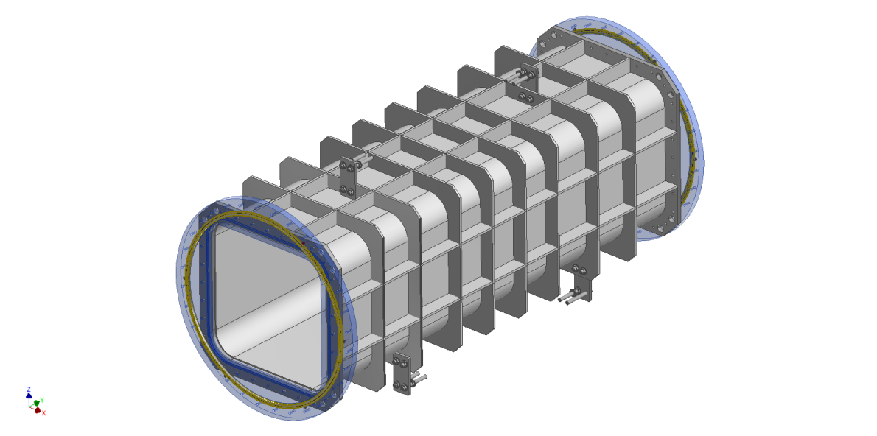

Figure 1: Assembly of the vacuum interconnecting duct consisting of the 920 x 920 mm tunnel with length 2 528 mm, which will be inserted into the wall between the L4c-and E3 halls, and circular end flanges of thickness 35 mm providing ISO-F 1000 interface to vacuum lines in both halls. The duct will be positioned in the wall symmetrically with respect to L4c and E3 halls.

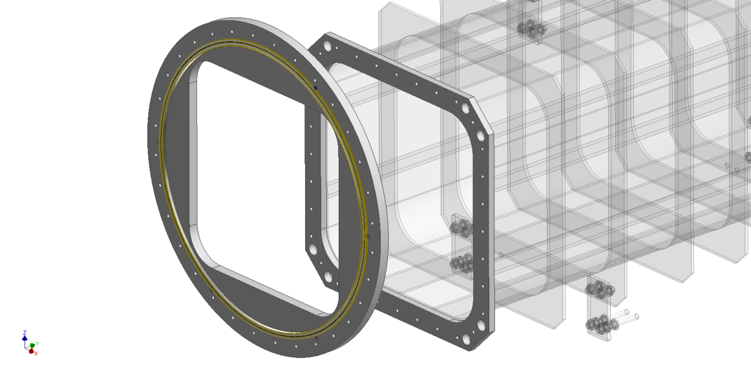
Figure 2: The circular end flange that will have vacuum sealing on both sides. As in the provided drawings, on the side interfacing with the 920 x 920 mm tunnel an O-ring will be inserted in a trapezoidal groove while on the outer side the flange will contain a recess co accommodate DN1000 centering ring that will support an O-ring according to ISO 1609 standard.

The duct will be attached to the wall by means of mounting plates, see Figure 3. The layout of these plates can be adapted from the layout indicated in the provided drawings RD-01, based on an agreement with the Contracting Authority (CA), to accommodate the final structure of the reinforcing ribs.

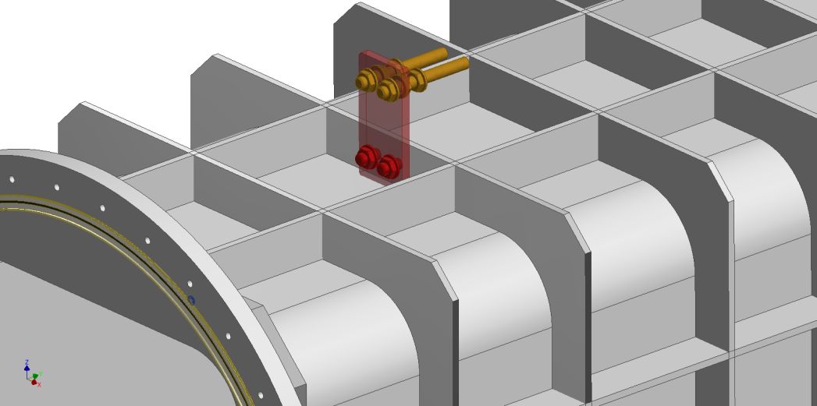

Figure 3: The mounting plates will serve to position and attach the central segment to the concrete wall between the L4c and E3 halls. On each end, there will be three mounting plates, two on the bottom and one on the top of the duct.

The duct will be mounted into the 1000 x 1000 mm wall penetration symmetrically with respect to the structural wall (1200 mm thick) between the L4c and E3 halls (see Figure 4). The total length of the duct is designed so as to provide adequate space on the outstanding part of the segment on each side making it possible to connect e.g. DN 1000 ISO-F vacuum valve.

Figure 4: The duct mounted in the L4c-E3 wall penetration. The technology walls (400 mm from the structural wall) in both halls are indicated in light yellow.

The following tables provide a summary of the contractual requirements. The total scope of the contract comprises all the requirements stated or implied in the foregoing text, whether or not included in this summary.

Terms, Definitions and Abbreviations
For the purpose of this document, the following abbreviated terms are applied:

Abbreviation | Meaning
A | Analysis (as a verification method)
CA | Contracting Authority (Institute of Physics AV CR, v. v. i.)
DN | Diameter Nominal
ELI | Extreme Light Infrastructure
FEM | Finite Element Method
FTR | Factory Test Report
I | Inspection (as a verification method)
L4c | Identification code of hall
NCR | Nonconformity Report
RA1 | Research activity 1
RD | Reference Document
RSD | Requirements Specification Document
STR | on-Site Test Report
T | Test (as a verification method)
VCD | Verification Control Document
VR | Verification Report

Reference Documents

Number of document | Title of Document/ File
RD-01 | 00202395-A_3.4_ES_DW_Drawings_package-Vacuum_Interconnecting_Duct_L4c-E3_Halls_TP18_794.rar

Detailed list of documentation included within RD-01 archive:

Drawing No | Filename | File format
00176521 Rev.01 | 00176521-01_DW-Vacuum liaison Tube L4c-E3 | PDF
00176521 Rev.01 | 00176521-01_3D-Vacuum liaison Tube L4c-E3 | JT

An overview of the RD-01 reference drawing related to the L4c-E3 Halls Vacuum Interconnecting Duct for L4 10 PW Beam is shown in section 8.

References to standards
If this document includes references to standards or standardized/ standardizing technical documents the CA allows/permits also another equal solution to be offered. If a supplier offers another equal solution the CA shall not reject its bid, once the supplier by appropriate means in the bid proves that the offered supplies, services or works meet in an equivalent manner the requirements including references to standards or technical documents.

Functional, design, material and manufacture requirements

REQ-025586/A
The duct shall be detail designed and manufactured according to the according to the requirements described herein and RD-01 assembly drawings (see Section 1.4).
Verification method: R - Review of design, T – Test, I - Inspection
REQ-025587/A
The duct and end flanges shall be manufactured from stainless steel 1.4301 (AISI 304) with certification 3.1 according to ČSN EN 10204 (or equivalent, e.g. EN 10204).
Verification method: R - Review of design
REQ-025588/A
All inner vacuum surfaces shall have roughness Ra=0.8 µm or better (i.e. smaller). If grinding is used to achieve this finish the process shall not involve any abrasive paste or abrasive medium that can embed into the surface.
Verification method: R - Review of design, I - Inspection
REQ-025589/A
The duct and end flanges shall be designed and manufactured for vacuum level of 10⁻⁷ mbar or better.
Verification method: R – Review of design, T – Test
REQ-025590/A
The Supplier shall complete FEM analysis of the duct to demonstrate structural stability resulting in deformations of walls less than 1 mm when the duct is pumped down from atmospheric pressure.
Verification method: R – Review of design, A – Analysis
REQ-025591/A
The detailed design shall include the trapezoidal groove on the inner side of the circular end flanges, for single vacuum O-ring of cross-sectional diameter (before compression) 8 mm.
The O-ring on this side of the end flange shall provide the vacuum seal with the duct body. The trapezoidal groove shall have the form ensuring that the O-ring is retained by the groove and cannot loosen itself.
Verification method: R - Review of design, I - Inspection
REQ-025592/A
The detailed design of the circular end flanges shall include the groove for an ISO 1000 centering ring with O-ring of cross-sectional diameter (before compression) 7 or 8 mm. The outer and inner diameter of the groove shall be such that the groove will be compatible with an ISO 1000 centering ring / O-ring assembly in line with the vacuum standard ISO 1609.
Verification method: R - Review of design
REQ-025684/A
The outer faces of the end flanges shall be parallel within a tolerance of 0.2 mm.
Verification method: R - Review of design, T - Test
REQ-025593/A
The detailed design of the circular end flanges shall include 32 threaded holes M12 on diameter 1090 mm, for bolting ISO-F 1000 flanges, according to the vacuum standard ISO 1609.
Verification method: R - Review of design
REQ-025594/A
The detailed design shall include plates for positioning and attaching of the central segment to the concrete walls, based on the conception design supplied by the CA (see RD-01; section 1.4).
Verification method: R – Review of design, I - Inspection
REQ-025595/A
The outer surface of the segment shall be glass blasted.
Verification method: R – Review of design, I - Inspection
REQ-025597/A
The Supplier shall check all major dimensions of the manufactured duct, as defined in the manufacturing drawings approved by the CA (see also REQ-025657/A). The result shall be provided in the form of the Test report (see REQ-025652/A).
Verification method: R – Review, T – Test
REQ-025599/A
The Supplier shall test the segment, with assembled end flanges, for vacuum performance. The end flanges will be sealed for this test by ISO-F 1000 blank flanges, supplied by the CA. The leak rate shall be no higher than 1x10⁻⁷ mbar·l/s. The result shall be provided in the form of the Test report (see REQ-025652/A).
Verification method: R – Review, T – Test
REQ-025600/A
The Supplier shall test the evacuated segment tube for deformations due to the atmospheric pressure differential. The measured deformations of the tube shall not exceed 1 mm. The result shall be provided in the form of the Test report (see REQ-025652/A).
Verification method: R – Review, T – Test

Cleaning, testing and packaging requirements

REQ-025598/A
All finished parts shall be degreased by thorough cleaning by water high-pressure (>100 bar) washer, using e.g. by 2% solution of STAR 75PN detergent at a temperature of at least 45°C, or by 2% solution of Brulin 1990GD at 70°C. This step shall be followed by washing e.g. in 2% solution of STAR 75PN detergent, for at least 1 hour at a temperature of at least 45°C. Subsequently, the parts shall be rinsed in demineralised water and dried in a way not leaving traces of water drops.
NOTE: The CA permits also another equivalent degreasing solution and /or cleaning procedure to be offered, however this must be approved in written by the CA (see also REQ-025657/A).
Verification method: R – Review
REQ-025601/A
The cleaned parts of the duct shall be wrapped in two plies separate clean packaging for transport. The layers shall ensure the mechanical protection of parts during transport.
Verification method: R – Review, I - Inspection
REQ-025602/A
The central duct and the end flanges shall be packed separately. The central duct shall be sealed at both ends by a metal sheet.
Verification method: I - Inspection

Transportation and Installation Requirements

REQ-025603/A
The transportation to the final destination at the ELI Beamlines premises, the installation (see REQ-025607/A) and final verification of the duct shall be conducted by the Supplier.
NOTE: The bid price will be considered by the CA as the final price, including both transportation and installation costs.
Verification method: R – Review, I - Inspection
REQ-025604/A
The transportation procedure shall be discussed and reviewed by the CA.
Verification method: R - Review
REQ-025605/A
The Supplier shall allow supervising the activities related to the transportation and installation by the CA.
NOTE: Any acts of supervision shall not mean that the CA assumes additional liability of any kind exceeding its liabilities according to the contract.
Verification method: R - Review
REQ-025607/A
The Supplier shall install the segment into the structural wall between the L4c and E3 halls of the ELI Beamlines facility, according to instruction from the CA. The end flanges of the segment shall be sealed during installation. In advance of this activity, the CA will install into the wall all needed anchoring points (e.g. chemical anchors), in line with the final drawings of the duct made by the Supplier.
Verification method: R - Review, I - Inspection
REQ-025608/A
The supplier shall ensure that its activities at the premises and the installation of the duct components will be performed without contaminating the place of installation unnecessarily. The premises (halls L4c and E3) include cleanrooms of class 7 according to ČSN EN ISO 14644 (equivalent to EN ISO 14644).
Verification method: R - Review, I - Inspection

Safety Requirements

REQ-025609/A
The Supplier shall supply a Declaration of Conformity or any other equivalent document legally recognized and accepted in the Czech Republic for each product type if the appropriate legislation determines the Supplier's obligation to have a Declaration of Conformity (or the equivalent document) for the purposes of a Product sale in the Czech Republic to fulfil the requirements of 2001/95/EC directive or applicable Czech law.
Verification method: I - Inspection

Quality requirements

Documentation and data control
REQ-025642/A
The Supplier shall supply the following relevant manufacturing documents:
- all manufacturing drawings, 3D model (see REQ-025657/A) and design supporting documentation approved by the CA (see REQ-025656/A and REQ-025657/A);
- full technical documentation on the delivered Product (e.g. storage, installation, safe operation and maintenance instructions);
- all “requests for deviation/waiver from requirements described herein” approved by the CA (see REQ-025645/A).
NOTE: The scope of the technical documentation will be agreed with the CA during the design phase (see REQ-025656/A).
Verification method: R – Review, I - Inspection
REQ-025643/A
The Supplier shall use following data formats:
- *.JPG, *.PNG, *.TIFF, *.PDF/A, *.HTML
- CAD 2D: *.dwg
- CAD 3D: *.stp; *.ste; *.step or other 3D CAD formats agreed with the CA
- text processors *.doc, *.docx, OpenDocument Format
- spreadsheet processors *.xls, *.xlsx, OpenDocument Format
- presentations *.ppt, *.pptx; OpenDocument Format
Verification method: Not To Be Tracked within VCD
REQ-025644/A
Documentation shall be supplied in the following formats: hardcopy and PDF.
Verification method: Not To Be Tracked within VCD

Nonconformity control system
REQ-025645/A
The Supplier shall establish and maintain a nonconformity control system compatible with ČSN EN ISO 9001 (or equivalent, e.g. EN ISO 9001).
Verification method: Not To Be Tracked within VCD

Verification requirements for the Supplier
The verification process will be performed by the Supplier to demonstrate that the duct meets the specified requirements of the CA.

General requirements
REQ-025646/A
The Supplier shall assign clear responsibility for the implementation of the verification process including the following activities:
- Verification planning (via VCD, see section 7.2.3);
- Verification execution and reporting (see sections 7.2.2 and 7.3);
- Verification control and close-out (see section 7.3).
Verification method: R - Review
REQ-025647/A
The verification process shall be accomplished by the Supplier through one or more of the following verification methods:
- Review; Verification via Review (R) shall consist of using approved records (examples of such approved records are design documents and reports, technical descriptions, and engineering drawings, manuals and accompanying operation documentation) or evidence that unambiguously shows that the requirement is met.
- Inspection; Verification via Inspection (I) shall consist of a visual examination of the manufactured and/or assembled product, i.e. its physical characteristics proving that the specific requirements have been met.
- Test (including functional demonstration); Verification via Test (T) shall consist of measuring product performance and functions under realistic operating conditions. When the test objectives include the demonstration of qualitative operational performance (functional demonstration), the execution shall be observed and results recorded.
- Analysis; Verification via Analysis (A) shall consist of performing theoretical or empirical evaluations (e.g. mathematical models, calculations and etc.).
Verification method: Not To Be Tracked within VCD

Verification documentation

General requirements
REQ-025648/A
The Supplier shall establish and maintain the system of verification process documentation (see REQ-025649/A and REQ-025650/A).
Verification method: Not To Be Tracked within VCD
REQ-025649/A
Verification documentation shall consist of following basic types of documents:
- Verification reports (see section 7.2.2);
- VCD, Verification Control Document (see section 7.2.3).
Verification method: Not To Be Tracked within VCD

REQ-025650/A
The verification reports shall be submitted to the CA for the review as agreed with the CA after corresponding verification activity completion, within the time frame agreed with the CA.
NOTE: Verification activity can be design review and analysis during the duct development (see section 7.3.1), test and inspection after the manufacturing and installation (see sections 7.3.2 and 7.3.3).
Verification method: Not To Be Tracked within VCD

Verification reports (VRs)
REQ-025651/A
The results of the analysis shall be documented in the corresponding Analysis Report (e.g. FEM analysis report, see REQ-025590/A) and tracked in the VCD (see section 7.2.3).
Verification method: R - Review
REQ-025652/A
The results of the tests shall be documented in the appropriate Factory Test Report (further “FTR”) and on-Site Test Report (further “STR”) and tracked in the VCD (see chapter 7.2.3).
Verification method: R - Review
REQ-025653/A
The results of the review of design/documentation/reports and inspection of the duct shall be tracked in the VCD (see section 7.2.3).
Verification method: R - Review

Verification Control Document (VCD)
The Verification Control Document (VCD) lists the requirements to be verified with the selected methods at the defined stages. The VCD is a living document which shall be used throughout the entire Contract delivery and its phases (see section 7.3 Phasing of the delivery). The VCD provides traceability during delivery phases (Qualification of Design, Manufacturing, Installation, Acceptance, etc.) and represents a formal tool of communication between the Supplier and the CA (formal record, reporting tool).

The VCD will be provided by the CA and it can be accommodated to the Supplier’s needs.

REQ-025654/A
The Supplier shall provide a Verification Control Document (VCD) for the reviews as agreed with the CA.
NOTE 1: Guidelines for VCD preparation will be provided by the CA.
NOTE 2: The form of VCD will be agreed between the CA and the Supplier based on the best commercial praxis used by the Supplier.
NOTE 3: The form of VCD will be agreed before completion of Qualification of Design phase (see section 7.3.1).
Verification method: R - Review
REQ-025655/A
In the VCD the Supplier shall specify HOW and WHEN each requirement is planned to be verified.
Verification method: R - Review

Phasing of the delivery
This section is intended to briefly summarize basic milestones of the Contract delivery. These milestones represent gates (checkpoints) where the quality of the delivery is to be evaluated.
Delivery shall not proceed past these gates unless their satisfactory accomplishment is approved by the CA.

Delivery lifecycle shall contain at least the following phases (quality gates):
- Qualification of Design;
- Manufacturing, cleaning and packaging;
- Transportation and installation;
- Acceptance (performed by the CA).

Qualification of Design
Summary of what has to be provided by the Supplier in terms of documentation (technical documentation including manufacturing drawings, design supporting documentation and verification reports) before starting the manufacturing. The goal is to verify the manufacturing drawings and design supporting documentation.

The output of this phase is the Final set of manufacturing drawings and agreed scope of technical documentation.

REQ-025656/A
Before completion of the Qualification Design phase the Supplier shall provide following information that shall be agreed by the CA:
- structure and content of the verification reports (see section 7.2.2);
- scope of full technical documentation (see REQ-025642/A);
- structure and content of the VCD ready to be implemented (see section 7.2.3).
Verification method: R - Review
REQ-025657/A
Before completion of the Qualification Design phase the Supplier and the CA shall agree on:
- final manufacturing drawings and 3D model provided by the Supplier (see REQ-025586/A);
- detailed procedures related to the testing and cleaning (see REQ-025598/A);
- common nonconformity control system (see REQ-025645/A).
Verification method: R - Review

Manufacturing
The goal is to demonstrate that the manufactured duct meets the requirements specified in sections 2 and 3 and is ready to be delivered to the CA. This quality gate concerns primarily:
- Inspection of the duct;
- Testing at the Supplier’s site (factory testing);
- Cleaning and packaging.
The output of this phase is the Manufactured and verified duct.

REQ-025658/A
The results of the Manufacturing phase of verification shall be recorded by the Supplier in the appropriate FTR (see REQ-025652/A) and overall results (including the review of documentation/reports and inspection of the duct) shall be tracked in the VCD (see section 7.2.3).
Verification method: R - Review

Transportation and Installation
The goal is to demonstrate that the delivered and installed duct meets all requirements specified herein.
Verification of the duct is executed by the Supplier after completion of each sub-stage including delivery, transportation and installation.

This quality gate concerns primarily:
- Inspection of the delivered duct and required documentation;
- Transportation to the final destination (ELI Beamlines hall L4c);
- Inspection and on-site testing of the installed duct.

The output of this phase is the Verified final duct.

REQ-025659/A
The results of the verification of delivered and installed duct shall be recorded by the Supplier in the appropriate STR (see REQ-025652/A) and overall results (including the review of reports and inspection of the duct) shall be tracked in the VCD (see chapters 7.2.3).
Verification method: R - Review
REQ-025660/A
The final issue of the VCD shall be submitted to the CA after the approval of the last report and before starting the Acceptance phase (see chapter 7.3.4).
Verification method: R - Review

Acceptance
Acceptance will be carried out by the CA upon verification of the final duct after installation (see section 7.3.3).
The basis for acceptance will be completed VCD summarizing the overall verification results together with relevant documentation supporting the verification (i.e. VRs, approved manufacturing drawings and 3D model, full technical documentation and etc.).
In case of successful acceptance phase, the CA will provide to the Supplier signed acceptance protocol. In case of unsuccessful acceptance stage the CA will provide to the Supplier Nonconformity Report (NCR) and process in accordance with REQ-025645/A shall be applied.

REQ-025661/A
The Acceptance phase shall demonstrate the following:
- Final duct has been successfully verified by the Supplier and the results of this process have been documented in the appropriate way through VRs (see section 7.2.2) and VCD (see section 7.2.3);
- All detected nonconformities have been solved in accordance with REQ-025645/A;
- Final duct is free of fabrication errors and is ready for the intended operational use.
Verification method: Not To Be Tracked within VCD

ANNEX – Vacuum liaison Tube L4c-E3 (Drawing No 00176521 Rev. 01)

