Příloha č.2 ZAK 18-0343

výpočtová tabulka

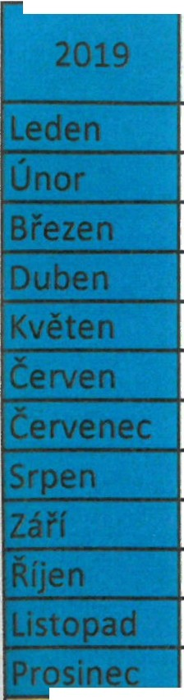

|  |  |  |  |  |  |
| --- | --- | --- | --- | --- | --- |
|  | Dnů celkem | Dny pracovní | Dny víkendy | Svátky víkend | Svátky pracovní |
| 31 | 22 | 8 |  | 1 |
| 28 | 20 | 8 |  |  |
| 31 | 20 | 10 |  | 1 |
| 30 | 20 | 8 |  | 2 |
| 31 | 21 | 8 |  | 2 |
| 30 | 20 | 10 |  |  |
| 31 | 22 | 7 | 1 | 1 |
| 31 | 22 | 9 |  |  |
| 30 | 21 | 8 | 1 |  |
| 31 | 22 | 8 |  | 1 |
| 30 | 21 | 8 | 1 |  |
| 31 | 19 | 9 |  | 3 |
| Hodiny | 6635 | 3875 | 2424 | 72 | 264 |
| **Sazba** | **xxxxxxx** | 125 | 125 | 250 | 250 |
| **Cena** | 871375 | 484375 | 303000 | 18000 | 66000 |

V Praze, dne 14.12.2018

,/

*/*

INT **a.s.**

**Slezská** 6 A, J 30 00 Praha 3

**teL** 272 735 843, fax 272 135 844

**IČO** 25635603 121

