|  |  |  |  |  |  |  |  |  |
| --- | --- | --- | --- | --- | --- | --- | --- | --- |
|  |  |  |  | **Cenová nabídka:** | | |  |  |
|  |  |  |  |  |  |  |  |  |
|  |  |  |  | **Zpracoval: Zdeněk Kunášek** | | | | |
|  |  |  |  |  |  |  |  |  |
|  |  |  |  |  |  |  |  |  |
| **Dodavatel:** | |  |  | **Odběratel:** | |  |  |  |
|  |  |  |  |  |  |  |  |  |
| Zdeněk Kunášek | |  |  |  | VÚM Buškovice | |  |  |
| Nerudova 49 | |  |  |  |  |  |  |  |
| Podbořany 441 01 | | |  |  |  |  |  |  |
| Tel.: XXXXXXXXXXX | | |  |  |  |  |  |  |
| [XXXXXXXXXXXXXXXXXXX](mailto:kunasek.zdenek@centrum.cz) | | | |  |  |  |  |  |
| IČ: 717 99 451 | |  |  |  |  |  |  |  |
|  |  |  | Datum vystavení dokladu: 21.10.2018 | | | |  |  |
|  |  |  | Předpokládaný termín dodání: 48.týden | | | |  |  |

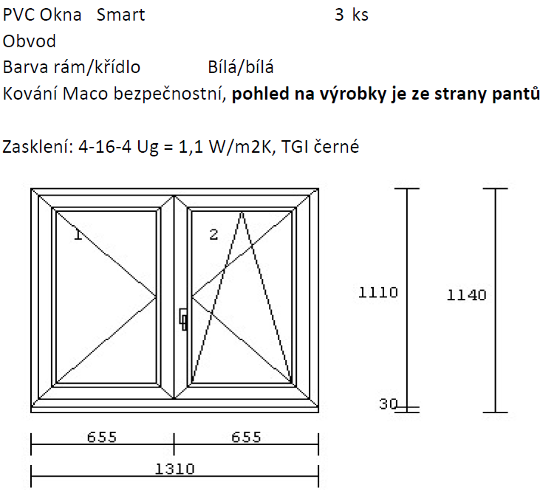

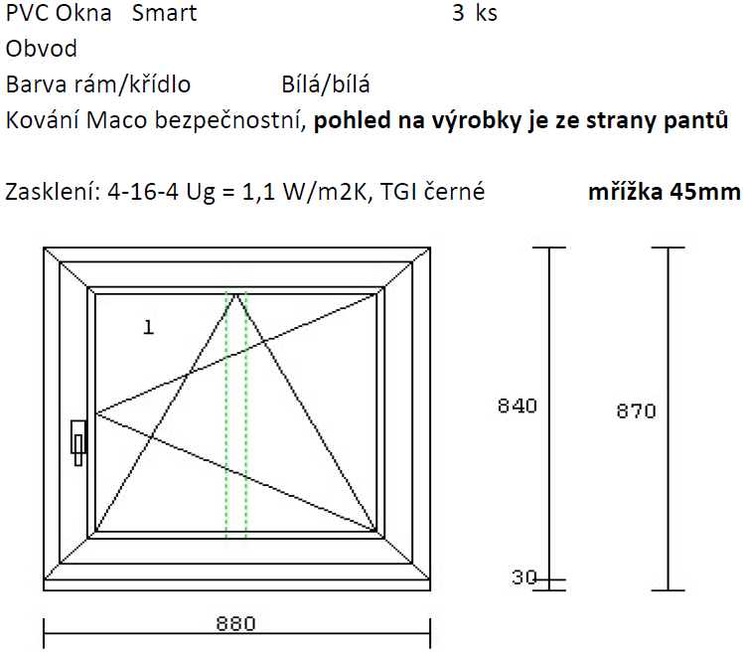

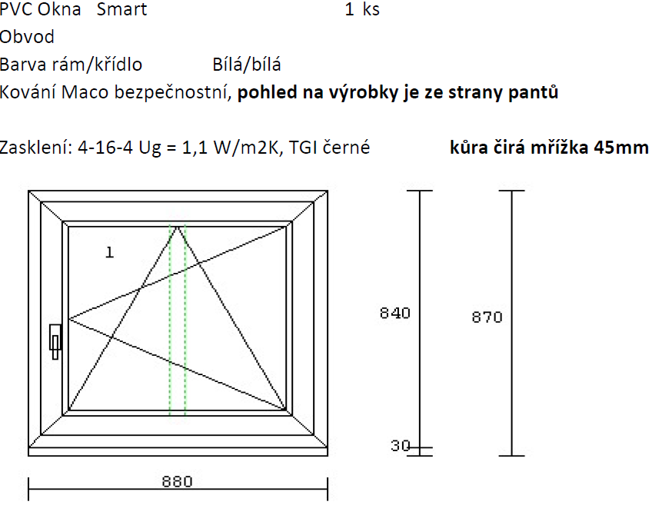

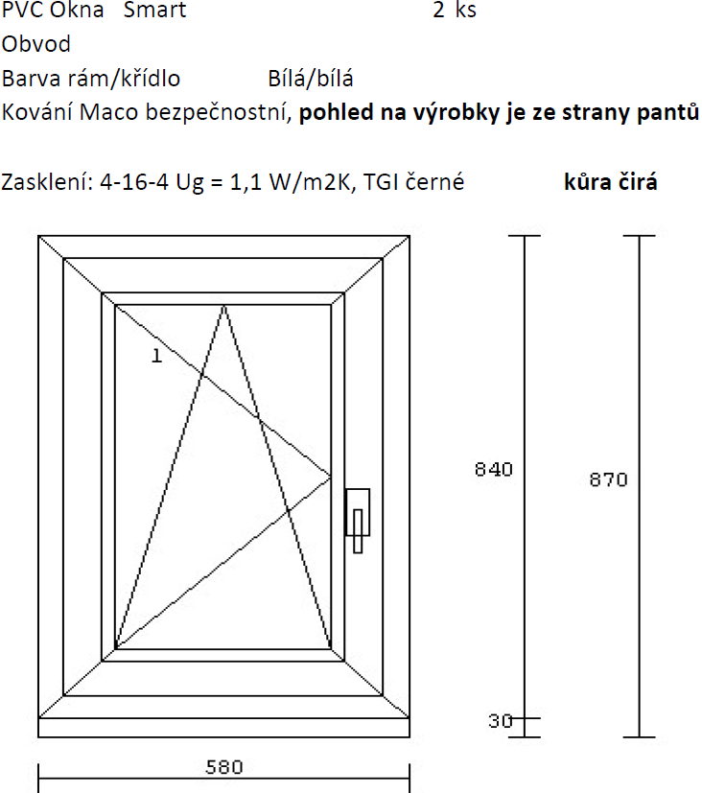

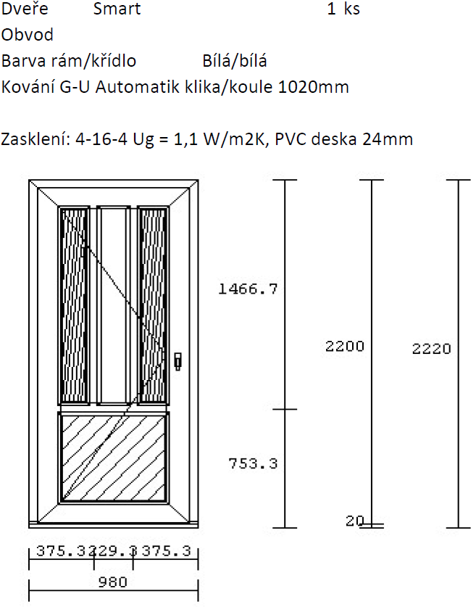

Cena výrobků………………………………………………………………59587,- Kč

Cena montáže…………………………………………………………….…5250,- Kč

Cena celkem…………………………………………..64837,-Kč