Purchase Contract

No. SML/7687/2018

concluded pursuant S. 2079 and Act No. 89/2012 Coll., Commercial Code.

- Contracting Parties

Buyer: Centrum dopravního výzkumu, v. v. i.
Registered office: Líšeňská 2657/33a, 636 00 Brno - Líšeň
Company Identification Number: 44994575
VAT Identification Number: CZ44994575
Registered: registered in the Register of Public Research Institutes established by the Ministry of Education, Youth and Sports
Authorized person: Ing. Jindřich Frič, Ph.D., director
Responsible person: xxxxxxxxxxxxxx
Phone: xxxxxxxxxxx
Email: xxxxxxxxxxxxxxxxxxx

(hereinafter referred as Buyer)

Seller: HR Kilns Ltd.
Registered office/place of business: Unit 5 & 7 Gorsey Place
Gillibrands, Skelmersdale.
Lancashire. WN8 9UP
United Kingdom
Company Identification Number: 5521521
VAT Identification Number: 8666 15786
Bank details: xxxxxxxxxxxxxxxxxxxxxxxxxxxxxxx
xxxxxxxxxxxxxxxxxxxx
Authorized person: Darren Weston
Responsible person: xxxxxxxxxxxxxxxxxxxxxxxxx
Phone: xxxxxxxxxxxxxxxxx
Email: sales@hrkilns.com
(hereinafter referred as Seller)

II. Contract subject matter

- Under conditions determined by this contract, seller undertakes to supply goods specified in Annex 2 and 3 of this contract and transfer ownership rights to the goods to buyer. Seller undertakes to duly supply the goods, including transport to place of performance and it´s installation (hereinafter referred to as “subject matter”).

- Seller shall install the goods in accordance with conditions stated by Správa železniční dopravní cesty (Railway Infrastructure Administration).

- Together with the supply of the subject matter, seller delivers to buyer certificates of warranty, operation manuals, licenses, and other documents necessary for the operation of the subject matter. Operation manuals shall be delivered in Czech or English language. Under conditions specified by this purchase contract, buyer undertakes to meet conditions of the subject matter, including accompanying documents, to accept and pay the purchase price for the subject matter to seller as specified in Section IV of this purchase contract and by the method specified in Section IV of this purchase contract.

III. Place and time of performance

- The Seller undertakes to deliver the subject matter until 15th December 2018. Seller is obliged to assure before the performance of this contract that the contract has been duly published in the contract register and has become effective.

- Seller undertakes to inform buyer of exact delivery date by email within 18 days prior delivery, through buyer’s responsible person, who is specified in Section I of this contract.

- Place of performance of this contract is train stop Dyje and railway level crossing Nesovice, as specified in Annex 1 of this contract.

IV. Price and payment terms

- Buyer undertakes to pay seller the agreed purchase price:

Total price: CZK 232.659.00 excl. VAT
(in words: two hundred thirty two thousand and six hundred nine CZK).

The price is the highest permissible price and may not be exceeded under any circumstances. The price includes all seller’s necessary costs.

- Invoicing shall take place on the basis of an invoice issued by seller after goods delivery in accordance with Section III (2) of this contract.

- Invoice is due within 14 calendar days of its delivery to buyer on condition that it is issued in compliance with payment terms and complies with all the above mentioned requirements concerning the issued invoice. In case invoice is not issued in compliance with payment terms or fails to comply with the requirements, buyer has the right to return such invoice to seller; such invoice expires upon return.

- Regarding the deadline for invoice due date, payment is considered settled on the day buyer’s account is debited.

V. Contractual penalties

- In case seller fails to meet goods delivery deadline agreed in accordance with Section III (1) of this contract, seller pays to buyer contractual penalty amounting to 0.05% of purchase price for each day of delay.

VI. Product liability

- Seller undertakes that the goods, delivered and received in accordance with this contract, is, on the day of goods acceptance, fully functional, without faults, complies with technical parameters specified in Annex 2 and 3 of this contract, and is of adequate quality and design. Seller bears full responsibility for this commitment.

- Seller undertakes to provide quality warranty for goods for 24 months. The Seller warrants to the Buyer that the Products will be free from defects of design, workmanship and manufacture. Warranty period commences on the day of delivery and reception of goods.

- Applying the rights for product liability shall not affect the right to damages.

- Seller undertakes to deal with the complaints within after-sales service free of charge. Any costs of such visits by HR Kilns Ltd or their nominated representatives (flights, accomm, etc) to be paid by the buyer at cost.

VII. Withdrawal from contract

- In case goods with fault are delivered, buyer has the right:
- to withdraw from contract
- for fault removal by delivery of new faultless goods, or by delivery of missing goods
- for fault removal by goods repair
- to an appropriate discount of purchase price.

- Buyer informs seller which of the rights they choose without undue delay after fault notification.

- Until the fault is removed, buyer is not obliged to pay the part of purchase price which is estimated to correspond with their right to discount.

- For the needs of this contract, goods are considered faulty for example:
- in case they fail to have properties or/and technical parameters required by this contract,
- the goods cannot be properly used due to their limited function,
- in case of delivery of different goods or discrepancy in documents necessary for the use of goods,

VIII. Conditions of delivery of subject matter

- The risk of damage of goods and ownership rights are transferred to buyer at the moment of approval of the installation by Správa železniční dopravní cesty.

IX. Final provisions

- Within the performance of the contract and after its termination, seller undertakes not to disclose any facts they come to know from buyer regarding the performance of the contract.

- Issues not specified in this contract are governed by provisions of the Act No. 89/2012 Coll., Commercial Code.

- Contract is made in four original copies and each of contracting parties keeps two copies.

- Contracting parties undertake to deal with potential disputes primarily by agreement. Potential litigations shall be applicable depending on buyer’s place of business, applicable law shall be the law of the Czech Republic.

- This contract enters into force on the date of signatures of authorized representatives of both contracting parties and publication in the register of contracts.

- This contract can be changed or cancelled only by mutual agreement of both contracting parties, only in writing by amendments numbered in ascending order signed by authorized representatives of seller and buyer. Contracting parties declare by their signatures that they are aware of the content of the contract and they conclude the contract based on their free will, neither at distress, nor at unequal terms and in witness whereof they add signatures of their authorized representatives.

- Contracting parties understand that this contract, together with potential amendments, shall be published on a publicly available contract register. The contract shall be published in the contract register by buyer. Seller declares that contract neither contains their trade secret, personal data of seller’s persons, nor any other information and facts that would prevent publishing.

The following annexes are integral parts of this contract:

Annex No. 1: Places of delivery
Annex No. 2: Technical specification of panels for Dyje
Annex No. 3: Technical specification of panels for Nesovice

In Skelmersdale on 26/11/18 In Brno on 6th Nov, 2018

……………………………………….. ………………………………………..
HR Kilns Ltd. Centrum dopravního výzkumu, v. v. i.
Darren Weston MD Ing. Jindřich Frič, Ph.D., director

Annex No. 1: Technical specification of the subject matter

- Train stop Dyje, GPS: 48.8499153N, 16.1196053E
At the train stop Dyje, the anti-trespass panel will be situated at the end of the platform (see photos) to prevent direct access from the platform to railroad track. Required size of the panel is 140 X 90 cm. The quotation must include also cost of the transport and installation, and specification of the fixture of the panel.
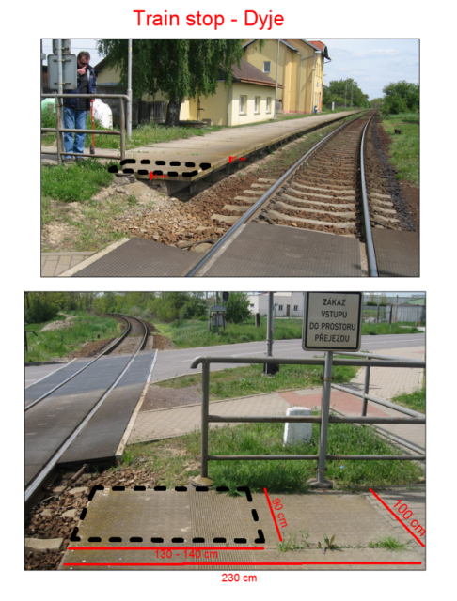

- Railway level crossing Nesovice, GPS: 49.1494572N, 17.0826392E
At the railway level crossing Nesovice, the anti-trespass panels will be situated along whole one side of the level crossing closer to the station, within the space between blue railings (see photos), to prevent pedestrians walking from the crossing to station through railroad. Total length is ca 10 m, the required width of the panels is at least 2 m. The gauge is standard, 1435 mm; the construction of the level crossing is STRAIL, with drawbars. The blue railing is anchored in concrete that is somewhat higher than ballast. The quotation must include also cost of the transport and installation, and specification of the fixture of the panels (to be secured against transverse movement).
